UNITED STATES

SECURITIES AND EXCHANGE COMMISSION

Washington, D.C. 20549

SCHEDULE 14A

Proxy Statement Pursuant to Section 14(a)

of the Securities Exchange Act of 1934
(Amendment No. )

Filed by the Registrant ☐ Filed by a Party other than the Registrant ☐

Check the appropriate box:

- Preliminary Proxy Statement

- Confidential, for Use of the Commission Only (as permitted by Rule 14a-6(e)(2))

- Definitive Proxy Statement

- Definitive Additional Materials

- Soliciting Material Pursuant to §240.14a-12

FEDERAL REALTY INVESTMENT TRUST

(Name of Registrant as Specified In Its Charter)

(Name of Person(s) Filing Proxy Statement, if other than the Registrant)

Payment of Filing Fee (Check the appropriate box):

- No fee required.

- Fee computed on table below per Exchange Act Rules 14a-6(i)(1) and 0-11.

  - Title of each class of securities to which the transaction applies:

  - Aggregate number of securities to which the transaction applies:

  - Per unit price or other underlying value of the transaction computed pursuant to Exchange Act Rule 0-11 (set forth the amount on which the filing fee is calculated and state how it was determined):

  - Proposed maximum aggregate value of the transaction:

  - Total fee paid:

- Fee paid previously with preliminary materials.

- Check box if any part of the fee is offset as provided by Exchange Act Rule 0-11(a)(2) and identify the filing for which the offsetting fee was paid previously. Identify the previous filing by registration statement number, or the Form or Schedule and the date of its filing.

  - Amount Previously Paid:

  - Form, Schedule or Registration Statement No.:

  - Filing Party:

  - Date Filed:

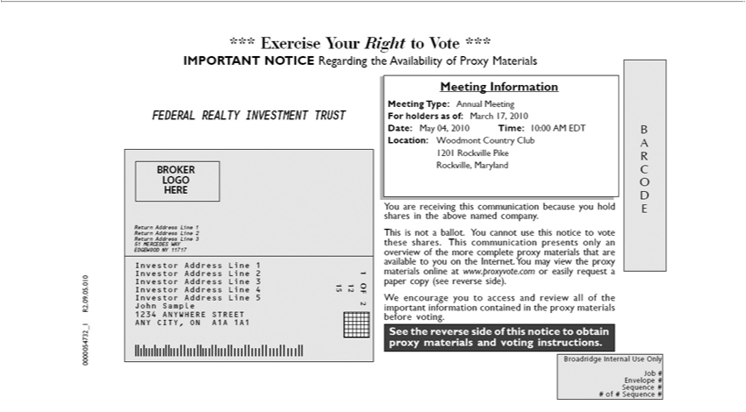

*** Exercise Your Right to Vote ***
IMPORTANT NOTICE Regarding the Availability of Proxy Materials
FEDERAL REALTY INVESTMENT TRUST
BROKER
LOGO |  | 1
HERE |  | 1
Return Address Line |  | 2
 |  | 3
51 MERCEDES WAY
EDGEWOOD NY 1₁₇₁₇
 |  | 2
 |  | 3
 |  | 4
Investor Address Line 5
John Sample
1234 ANYWHERE STREET
ANY CITY, ON A1A 1A1
₂OF 2 | Information
15 | Information
Meeting Type: Annual Meeting
For holders as of: March 17, 2010
Date: May 04, 2010 Time: 10:00 AM EDT
Location: Woodmont Country Club
1201 Rockville Pike
Rockville, Maryland
You are receiving this communication because you hold shares in the above named company.
This is not ballot. You cannot use this notice to vote these shares. This communication presents only an overview of the more complete proxy materials that are available to you on the Internet. You may view
the proxy materials online at www.proxyvote.com easily request paper copy (see reverse side).
W encourage you to access and review all of the important information contained in the proxy materials before voting.
See the reverse side of this notice to obtain proxy materials and voting instructions.
A R C O D E
Broadridge Internal Use Only
EnvelopeJob# #
0000054732#of#Sequence_1R2.09.05.010#

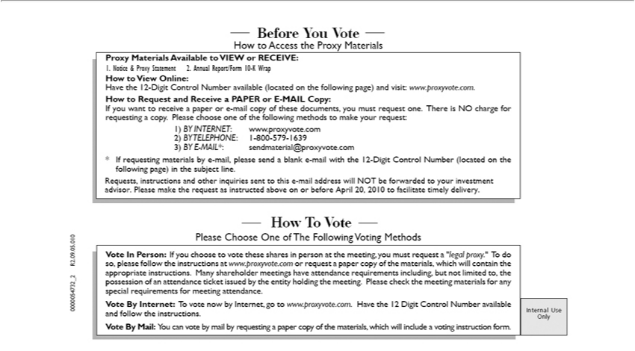

— Before You Vote —
How to Access the Proxy Materials
Proxy Materials Available to VIEW or RECEIVE:
1. Notice & Proxy Statement 2. Annual Report/Form 10-K Wrap
 | to View Online:
ave the 12-Digit Control Number available (located on the following page) and visit: www.proxyvote.com.
How to Request and Receive a PAPER or E-MAIL Copy:
If you want to receive a paper or |  |  | -mail copy of these documents, you must request one. There is NO charge for requesting a copy. Please choose one of the following methods to make your request:
1) | INTERNET www.proxyvote.com
2) |  | 1-800-579-1639 |  | .com
3) BYTELEPHONE:-MAIL*: |  |  |  | .com
* If requesting materialssendmaterial@proxyvoteby-mail,pleasesend a blank e-mail with the 12-Digit Control Number (located on the following page) in the subject line.
Requests, instructions and other inquiries sent to this e-mail address will NOT be forwarded to your investment advisor. Please make the request as instructed above on or before April 20, 2010 to facilitate
timely delivery.
— How T Vote —
Please Choose One of The Following Voting Methods
Vote In Person: If you choose to vote these shares person at the meeting, you must request “legal proxy.” To do so, please follow the instructions at www.proxyvote.com or request a paper copy of the
materials, which will contain the appropriate instructions. |  |  |  |  | shareholder meetings have attend | requirements including, but not limited to, the possession of an attendance ticket issued by the entity
holding the meeting. Please check the meeting materials forMany special requirements for meeting attendance.

Vote By
Mail:Internet:YouTocanvotevotenowbybymailInternet,byrequestinggotowww.proxyvote.com.apapercopyofthe materials,Havethe 12whichDigitwillControlincludeNumberavotingavailableinstructionand form.follow the instructions.
0000054732_2 R2.09.05.010

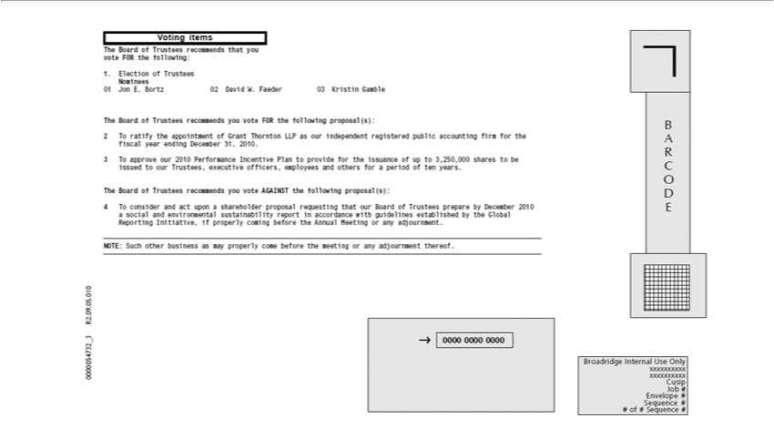

Voting items
The Board of Trustees recommends that you vote FOR the following:
Nominees1.Election of Trustees
01 Jon E. Bortz 02 David W. Faeder 03 Kristin Gamble
The Board of Trustees recommends you vote FOR the following proposal(s):
2 ^{To} ratify the appointment of Grant Thornton LLP as our independent registered public accounting firm for the fiscal year ending December 31, 2010.
3 approve our 2010 Performance Incentive Plan to provide for the issuance of up to 3,250,000 shares to be issued to our Trustees, executive officers, employees and others for a period of ten years.
^{The} Board of Trustees recommends you vote AGAINST the following proposal(s):
4 o consider and act _{Initiative,}uponshareholder proposal requesting that our Board of Trustees prepare by December 2010 a social and environmental sustainability report in accordance with guidelines established by
NOTE:theGlobalSuchReportingotherbusiness as mayifproperlyproperlycomingcome beforebefore thethe meetingAnnual Meetingoranyadjournmentoranyadjournment.thereof.
B A R C O D E
0000 0000 0000

Broadridge Internal Use Only xxxxxxxxxx xxxxxxxxxx Cusip Job # Envelope # Sequence # # of # Sequence # 0000054732_3 R2.09.05.010

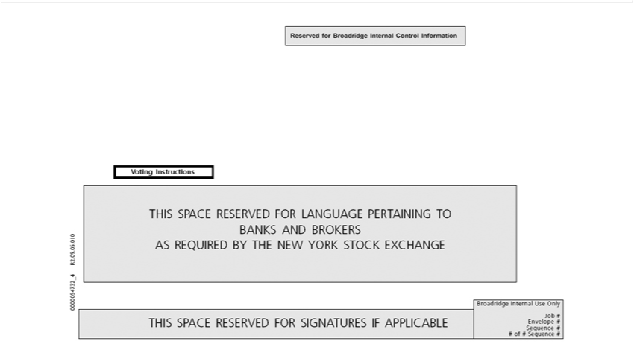

VotingReservedInstructionsforBroadridge Internal Control Information
ASTHISREQUIREDSPACERESERVEDBYTHENEWFOR YORKLANGUAGESTOCKPERTAININGEXCHANGETO BANKS AND BROKERS
BroadridgeTHISSPACEInternalRESERVEDUseOnlyFOR SIGNATURES IF APPLICABLE
Job #
Envelope #
Sequence #
# of # Sequence #

0000054732_4 R2.09.05.010

