UNITED STATES

SECURITIES AND EXCHANGE COMMISSION
Washington, D.C. 20549

SCHEDULE 14A INFORMATION

Proxy Statement Pursuant to Section 14(a) of the

Securities Exchange Act of 1934
(Amendment No. )

Filed by the Registrant ☐ Filed by a Party other than the Registrant ☐

Check the appropriate box:

- Preliminary Proxy Statement

- Confidential, for Use of the Commission Only (as permitted by Rule 14a-6(e)(2))

- Definitive Proxy Statement

- Definitive Additional Materials

- Soliciting Material under Rule 14a-12

FEDERAL REALTY INVESTMENT TRUST

(Name of registrant as specified in its charter)

(Name of person(s) filing proxy statement, if other than the registrant)

Payment of Filing Fee (Check the appropriate box):

- No fee required

- Fee computed on table below per Exchange Act Rules 14a-6(i)(4) and 0-11

  - Title of each class of securities to which transaction applies:

  - Aggregate number of securities to which transaction applies:

  - Per unit price or other underlying value of transaction computed pursuant to Exchange Act Rule 0-11 (set forth the amount on which the filing fee is calculated and state how it was determined):

  - Proposed maximum aggregate value of transaction:

  - Total fee paid:

- Fee paid previously with preliminary materials.

- Check box if any part of the fee is offset as provided by Exchange Act Rule 0-11(a)(2) and identify the filing for which the offsetting fee was paid previously. Identify the previous filing by registration statement number, or the Form or Schedule and the date of its filing.

  - Amount Previously Paid:

  - Form, Schedule or Registration Statement No.:

  - Filing Party:

  - Date Filed:

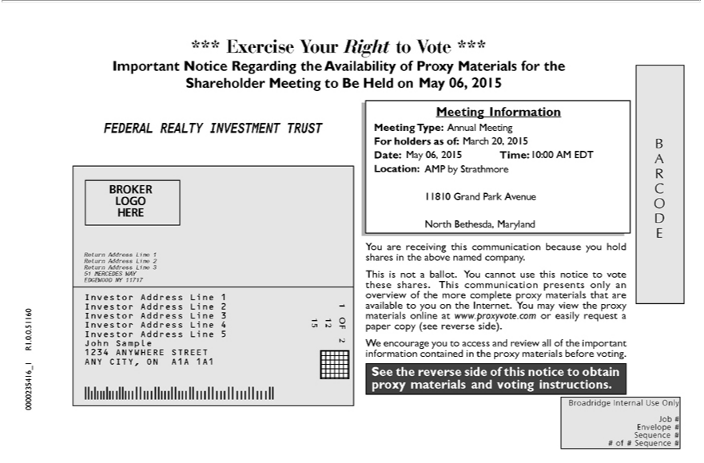

*** Exercise Your Right to Vote ***
Important Notice Regarding the Availability of Proxy Materials for the Shareholder Meeting to Be Held on May 06, 2015 Meeting Information
FEDERAL REALTY INVESTMENT TRUST Meeting Type: Annual Meeting For holders as of: March 20, 2015
[BROKER LOGO HERE] Date: May 06, 2015 Time: 10:00 AM EDT BARCODE Return Address Line 1 Return Address Line 2
Return Address Line 3 51 MERCEDES WAY EDGEWOOD NY 11717 Location: AMP by Strathmore
Investor Address Line 1 Investor Address Line 2 Investor Address Line 3 Investor Address Line 4 Investor Address Line 5 John Sample 1234 ANYWHERE STREET ANY CITY, ON A1A 1A1 11810 Grand Park Avenue

1 OF 2 12 15 North Bethesda, Maryland
You are receiving this communication because you hold shares in the above named company.
This is_{materials}notballot. You cannot use this notice to vote these shares. This communication pres_{side)}nts only an overview of the more complete proxy materials that are available to you on the Internet. You may view the
proxy online at www.proxyvote.com or easily request_{information}papercopy (see reverse .
^{See}
W encouragethereverseyousidetoofaccessthisnoticeandreviewtoobtainall proxyofthe importantmaterials and voting instructions.containedin the proxy materials before voting.
0000235416_1 R1.0.0.51160
Broadridge Internal Use Only Job # Envelope # Sequence # # of # Sequence #

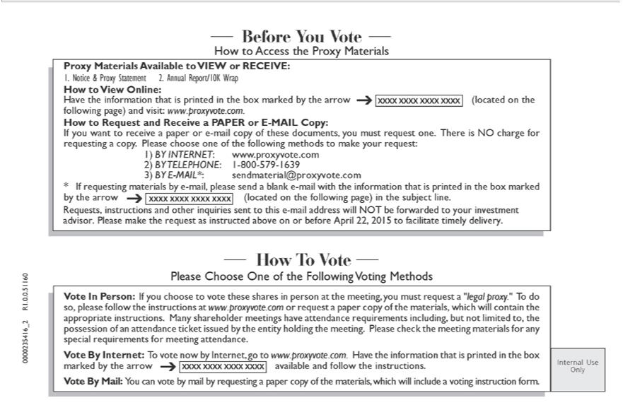

Before You Vote
How to Access the Proxy Materials
Proxy Materials Available to VIEW or RECEIVE:
1. Notice & Proxy Statement 2. Annual Report/10K Wrap
 | to View Online:
ave the information that is printed in the box marked by the arrow XXXX XXXX XXXX XXXX (located on the following page) and visit: www.proxyvote.com.
How to Request and Receive a PAPER or E-MAIL Copy:
If you want to receive a paper or -mail copy of these documents, you must request one. There is NO charge for requesting a copy. Please choose one of the following methods to make your request:
1) | INTERNET www.proxyvote.com
3) BY TELEPHONE:-MAIL*:sendmaterial@proxyvote.com
2) | 1-800-579-1639
* If requesting materials by_{other}-mail, please send a blank e-mail with the information that is printed in the box marked by the arrow XXXX XXXX XXXX XXXX (located on the following page) in the subject line.
Requests, instructions and inquiries sent to this e-mail address will NOT be forwarded to your investment advisor. Please make the request as instructed above on or before April 22, 2015 to facilitate timely delivery.
Please Choose One of the Following Voting Methods
Vote In Person: If you choose to vote these shares in person at the meeting, you must request a “legal proxy.” To do so, please follow the instructions at www.proxyvote.com or request a paper copy of the materials, which will contain the appropriate instructions. Many shareholder meetings have attendance requirements including, but not limited to, the possession of an attendance ticket issued by the entity holding the meeting. Please check the meeting materials for any special requirements for meeting attendance.
^{Vote By}
Mail:Internet:YouTocanvotevotenowbybymailInternet,byrequestinggotowww.proxyvote.com.apapercopyofthe materials,Havethe informationwhichwillincludethatisprintedavotingininstructiontheboxmarkedform. by the arrow XXXX XXXX XXXX XXXX available and follow the instructions.
Internal Use Only
0000235416_2 R1.0.0.51160

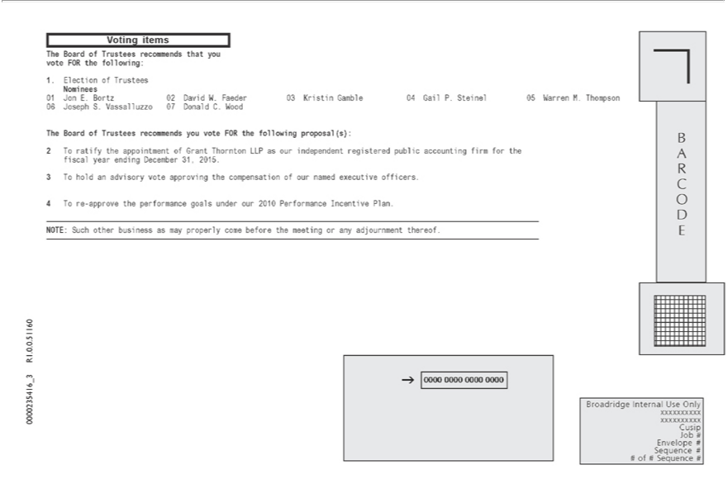

Voting items
01The.ElectionBoard ofof TrusteesTrustees recommendsNominees that you vote FOR the following:
Jon . Bortz 02 David W. Faeder 03 Kristin Gamble 04 Gail P. Steinel 05 Warren M. Thompson 06 Joseph S. Vassalluzzo 07 Donald C. Wood
2The Boardratify theofadvisoryTrusteesappintmentrecommendsofGrant youThorntonvoteFORLLPtheas ourfollowingindependentproposal(s):registered public accounting firm for the fiscal year ending December 31, 2015.
43 To rehold-approvean the performancevoteapprovinggoalstheundercompensationour2010PerformanceofournamedIncentiveexecutivePlan.officers.
BARCODENOTE:Such0000other0000business0000as0000mayBroadridgeproperlycomeInternalbeforeUsetheOnlymeetingxxxxxxxxxxoranyadjournmentxxxxxxxxxxthereof.

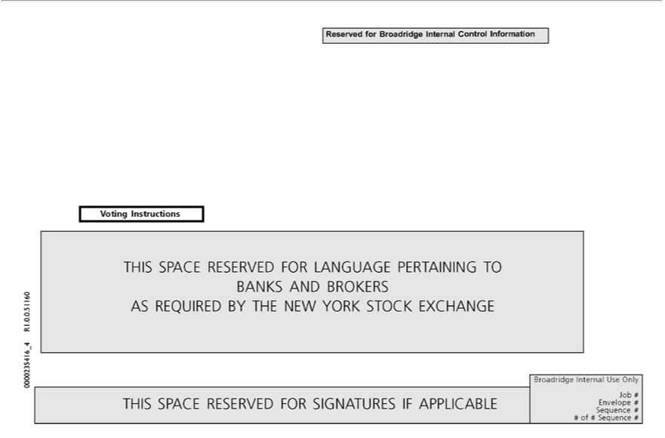

Reserved for Broadridge Internal Control Information Voting Instructions
_{THIS SPACE RESERVED FOR} LANGUAGE_{TURES}PERTAINING TO BANKS AND BROKERS AS REQUIRED BY THE NEW YORK STOCK EXCHANGE
SIGNA IF APPLICABLE
Broadridge Internal Use Only Job # Envelope # Sequence # # of # Sequence # 0000235416_4 R1.0.0.51160

