UNITED STATES

SECURITIES AND EXCHANGE COMMISSION
Washington, D.C. 20549

SCHEDULE 14A INFORMATION

Proxy Statement Pursuant to Section 14(a) of the

Securities Exchange Act of 1934
(Amendment No. )

Filed by the Registrant ☒ Filed by a Party other than the Registrant ☐

Check the appropriate box:

- Preliminary Proxy Statement

- Confidential, for Use of the Commission Only (as permitted by Rule 14a-6(e)(2))

- Definitive Proxy Statement

- Definitive Additional Materials

- Soliciting Material under Rule 14a-12

FEDERAL REALTY INVESTMENT TRUST

(Name of registrant as specified in its charter)

(Name of person(s) filing proxy statement, if other than the registrant)

Payment of Filing Fee (Check the appropriate box):

- No fee required

- Fee computed on table below per Exchange Act Rules 14a-6(i)(4) and 0-11

  - Title of each class of securities to which transaction applies:

  - Aggregate number of securities to which transaction applies:

  - Per unit price or other underlying value of transaction computed pursuant to Exchange Act Rule 0-11 (set forth the amount on which the filing fee is calculated and state how it was determined):

  - Proposed maximum aggregate value of transaction:

  - Total fee paid:

- Fee paid previously with preliminary materials.

- Check box if any part of the fee is offset as provided by Exchange Act Rule 0-11(a)(2) and identify the filing for which the offsetting fee was paid previously. Identify the previous filing by registration statement number, or the Form or Schedule and the date of its filing.

  - Amount Previously Paid:

  - Form, Schedule or Registration Statement No.:

  - Filing Party:

  - Date Filed:

Important Notice of Availability of Proxy Materials for the Shareholder Meeting of

FEDERAL REALTY INVESTMENT TRUST

To Be Held On:

May 6, 2020 at 9:00 a.m.

in the Executive Boardroom at Federal Realty Investment Trust,

1626 East Jefferson Street, Rockville, Maryland
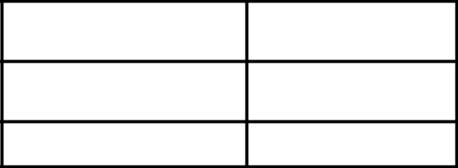

COMPANY NUMBER

ACCOUNT NUMBER

CONTROL NUMBER

This communication presents only an overview of the more complete proxy materials that are available to you on the Internet. We encourage you to access and review all of the important information contained in the proxy materials before voting.

If you want to receive a paper or e-mail copy of the proxy materials you must request one. There is no charge to you for requesting a copy. To facilitate timely delivery please make the request as instructed below before 04/24/20.

Please visit http://www.federalrealty.com/shareholder-meeting, where the following is available for view:

 | • Annual Report/Form 10-K/Notice & Proxy Statement
 | • Directions to the Annual Shareholder Meeting
TO REQUEST MATERIAL: | TELEPHONE: 888-Proxy-NA (888-776-9962) 718-921-8562 (for international callers)
 | E-MAIL: info@astfinancial.com
 | WEBSITE: https://us.astfinancial.com/OnlineProxyVoting/ProxyVoting/RequestMaterials
TO VOTE: | ONLINE: To access your online proxy card, please visit www.voteproxy.com and follow the on-screen instructions or
 | scan the QR code with your smartphone. You may enter your voting instructions at www.voteproxy.com up until 11:59 PM
 | Eastern Time the day before the cut-off or meeting date.
 | IN PERSON: You may vote your shares in person by attending the Annual Meeting.
 | TELEPHONE: To vote by telephone, please visit www.voteproxy.com to view the materials and to obtain the toll free
 | number to call.
 | MAIL: You may request a card by following the instructions above.



Please note that you cannot use this notice to vote by mail.

- To elect the following Trustees as set forth in the accompanying Proxy Statement: Jon E. Bortz

David W. Faeder Elizabeth I. Holland Mark S. Ordan Gail P. Steinel Joseph S. Vassalluzzo Donald C. Wood

- To hold an advisory vote approving the compensation of our named executive officers.

- To approve our 2020 Performance Incentive Plan.

- To ratify the appointment of Grant Thornton LLP as our independent registered public accounting firm for the fiscal year ending December 31, 2020.

- To consider and act upon any other matters properly coming before the meeting or any postponement or adjournment thereof.

*** Exercise Your Right to Vote ***

Important Notice Regarding the Availability of Proxy Materials for the

Shareholder Meeting to Be Held on May 06, 2020
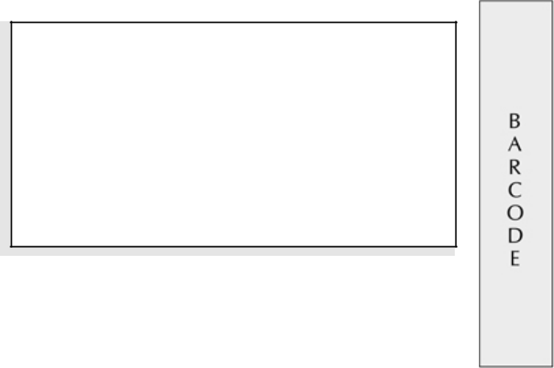

FEDERAL REALTY INVESTMENT TRUST
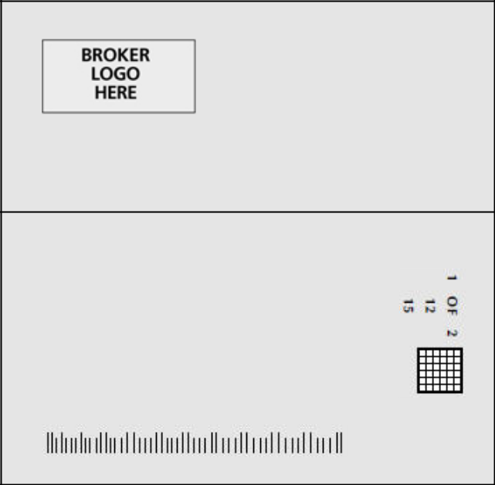

Return Address Line 1
Return Address Line 2
Return Address Line 3
51 MERCEDES WAY
EDGEWOOD NY 11717

Investor Address Line 1

Investor Address Line 2

Investor Address Line 3

Investor Address Line 4

Investor Address Line 5
John Sample

1234 ANYWHERE STREET

ANY CITY, ON A1A 1A1

Meeting Information

Meeting Type: Annual Meeting

For holders as of: March 16, 2020

Date: May 06, 2020 Time: 9:00 AM EDT

Location: Executive Boardroom at Federal Realty

Investment Trust

1626 East Jefferson Street

Rockville, MD

You are receiving this communication because you hold shares in the above named company.

This is not a ballot. You cannot use this notice to vote these shares. This communication presents only an overview of the more complete proxy materials that are available to you on the Internet. You may view the proxy materials online at www.proxyvote.com or easily request a paper copy (see reverse side).

We encourage you to access and review all of the important information contained in the proxy materials before voting.


See the reverse side of this notice to obtain proxy materials and voting instructions.

Broadridge Internal Use Only
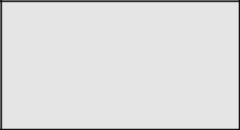

Job #

Envelope #

Sequence #

# of # Sequence #

— Before You Vote —

How to Access the Proxy Materials

Proxy Materials Available to VIEW or RECEIVE:


1. Annual Report/Form 10-K/Notice & Proxy Statement 2. Directions to Annual Meeting of Shareholders How to View Online:

Have the information that is printed in the box marked by the arrow (located on the following page) and visit:

www.proxyvote.com.

How to Request and Receive a PAPER or E-MAIL Copy:

If you want to receive a paper or e-mail copy of these documents, you must request one. There is NO charge for requesting a copy. Please choose one of the following methods to make your request:

1) BY INTERNET: www.proxyvote.com

  - BY TELEPHONE: 1-800-579-1639

  - BY E-MAIL*:sendmaterial@proxyvote.com

* If requesting materials by e-mail, please send a blank e-mail with the information that is printed in the box marked by the arrow

(located on the following page) in the subject line.

Requests, instructions and other inquiries sent to this e-mail address will NOT be forwarded to your investment advisor.

Please make the request as instructed above on or before April 22, 2020 to facilitate timely delivery.

— How To Vote —

Please Choose One of the Following Voting Methods

Vote In Person: If you choose to vote these shares in person at the meeting, you must request a “legal proxy.” To do so, please follow the instructions at www.proxyvote.com or request a paper copy of the materials, which will contain the appropriate instructions. Many shareholder meetings have attendance requirements including, but not limited to, the possession of an attendance ticket issued by the entity holding the meeting. Please check the meeting materials for any special requirements for meeting attendance.
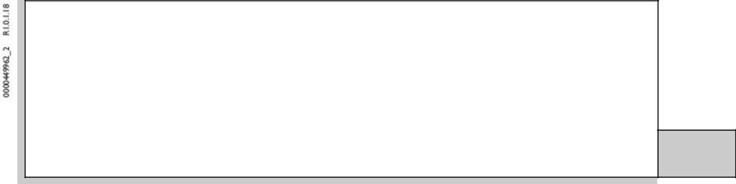

Vote By Internet: To vote now by Internet, go to www.proxyvote.com. Have the information that is printed in the box

marked by the arrow available and follow the instructions.

Vote By Mail: You can vote by mail by requesting a paper copy of the materials, which will include a voting instruction form.

Internal Use

Only

Voting items

The Board of Trustees recommends

you vote FOR the following

proposal(s):

- Election of Trustees

Nominees

1A Jon E. Bortz

1B David W. Faeder

1C Elizabeth I. Holland

1D Mark S. Ordan

1E Gail P. Steinel

1F Joseph S. Vassalluzzo

1G Donald C. Wood

The Board of Trustees recommends you vote FOR the

following proposal(s):

- To hold an advisory vote approving the compensation of our named executive officers.
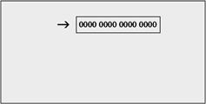

- To approve our 2020 Performance Incentive Plan.

- To ratify the appointment of Grant Thornton LLP as our independent registered public accounting firm for the fiscal year ending December 31, 2020.

Broadridge Internal Use Only
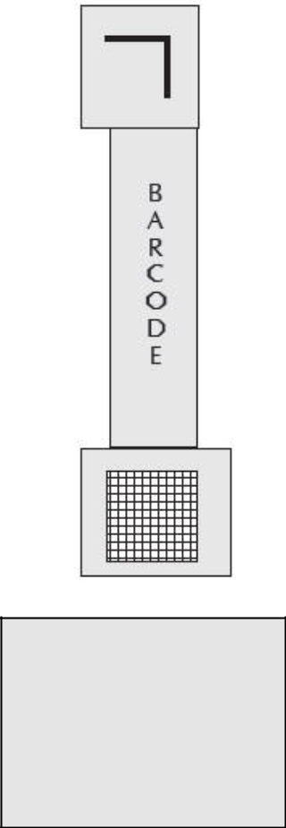

XXXXXXXXXX

XXXXXXXXXX

Cusip

Job #

Envelope #

Sequence #

# of # Sequence #


Voting items Continued

Reserved for Broadridge Internal Control Information

NOTE: Such other business as may properly come before the meeting or any adjournment thereof.


Voting Instructions


THIS SPACE RESERVED FOR LANGUAGE PERTAINING TO

BANKS AND BROKERS

AS REQUIRED BY THE NEW YORK STOCK EXCHANGE

THIS SPACE RESERVED FOR SIGNATURES IF APPLICABLE

Broadridge Internal Use Only

Job #

Envelope #

Sequence #

# of # Sequence #

