UNITED STATES

SECURITIES AND EXCHANGE COMMISSION

Washington, D.C. 20549

 | SCHEDULE 14A
 | Proxy Statement Pursuant to Section 14(a)
 | of the Securities Exchange Act of 1934
 | (Amendment No. )
Filed by the Registrant ☒
Filed by a Party other than the Registrant | ☐
Check the appropriate box:
☐ Preliminary Proxy Statement | ☐ Confidential, for Use of the Commission Only (as permitted by Rule
☐ Definitive Proxy Statement | 14a-6(e)(2))
☒ Definitive Additional Materials
- Soliciting Material Pursuant to §240.14a-12

FEDERAL REALTY INVESTMENT TRUST

(Name of Registrant as Specified In Its Charter)

Payment of Filing Fee (Check the appropriate box):

- No fee required.

- Fee computed on table below per Exchange Act Rules 14a-6(i)(1) and 0-11.

  - Title of each class of securities to which transaction applies:

  - Aggregate number of securities to which transaction applies:

  - Per unit price or other underlying value of transaction computed pursuant to Exchange Act Rule 0-11 (set forth the amount on which the filing fee is calculated and state how it was determined):

  - Proposed maximum aggregate value of transaction:

  - Total fee paid:

- Fee paid previously with preliminary materials.

- Check box if any part of the fee is offset as provided by Exchange Act Rule 0-11(a)(2) and identify the filing for which the offsetting fee was paid previously. Identify the previous filing by registration statement number, or the Form or Schedule and the date of its filing.

  - Amount Previously Paid:

  - Form, Schedule or Registration Statement No.:

  - Filing Party:

  - Date Filed:

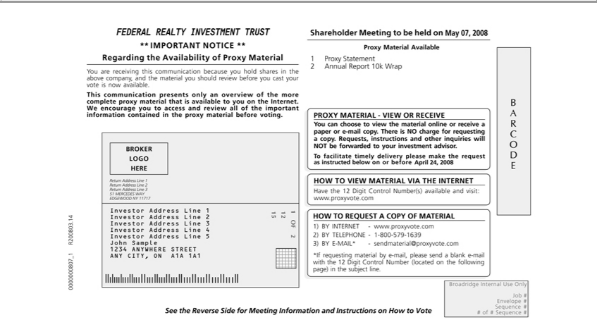

FEDERAL REALTY INVESTMENT TRUST
** IMPORT |  | NOTICE **
Regarding theANTvailability of Proxy Material |  |  |  |  | you cast | vote is now available.
You are receiving this communication because you hold shares in the above company, and the material you should review |  |  |  |  | you cast | vote is now available.
This communication presents only an overview of the more complete proxy material that is available to you on the Internet.beforeWencourageyour to access and review all of the important information contained in
the proxy material before voting.
BROKER LOGO HERE
 |  | 1
 |  | 2
Return Address Line 3
51 MERCEDES WAY
EDGEWOOD NY 1₁₇₁₇
 |  |  | 2
 |  |  | 3
Investor Address Line |  |  | 4
 |  |  | 5
John Sample
1234 ANYWHERE STREET
ANY CITY, ON A1A 1A1
₂OF 2
15
Shareholder Meeting to be held on May 07, 2008
Proxy Material Available
1 Proxy Statement
2 Annual Report 10k Wrap
 | MATERIAL - VIEW OR RECEIVE
PROXYoucan choose to view the material online or receive a paper or e-mail copy. There is NO charge for requesting a copy. Requests, instructions and other inquiries will NOT be forwarded to your investment
.
advisorTfacilitate timely delivery please make the request as instructed below on or before April 24, 2008
TO VIEW MATERIAL VIA THE INTERNET
ave the 12 Digit Control Number(s) available and visit: www.proxyvote.com
HOW TO REQUEST A COPY OF MATERIAL
1) BY INTERNET -
www.proxyvote.com
2) BY TELEPHONE -
1-800-579-1639 |  |  |  | .com
3) BY E-MAIL* - |  |  |  | .com
sendmaterial@proxyvote*lfrequestingby -mail, please send a blank e-mail with the 12 Digit Control Number (located on the following page) in the subject line.
See the Reverse Side for |  |  |  | Meeting Information and Instructions on How to Vote
Broadridge Internal Use Only
Job #
Envelope #
Sequence #

# of # Sequence #

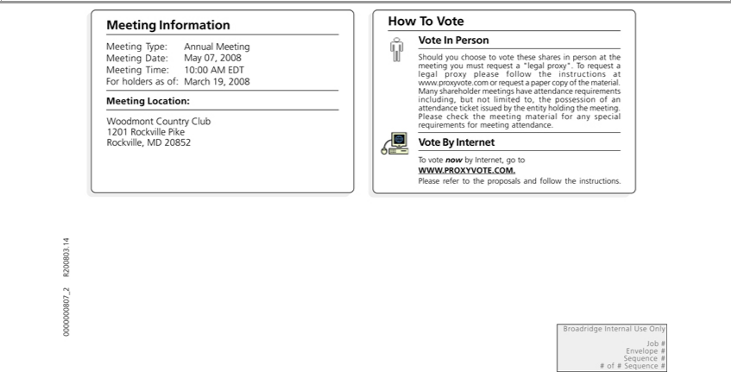

Information
_{Meeting} Date:Type: MayAnnual07,Meeting2008
Time: 10:00 AM EDT
MeetingForholdersLocation:asof:March 19, 2008
Woodmont Country Club
1201 Rockville Pike
Rockville, ^{MD 20852}
How T Vote
Vote In Person
Should you choose to vote these shares in person_{attendance}the meeting you must request a “legal proxy”. To request a legal proxy please follow the instructions at www.proxyvote.com or request a paper copy of the
material. Many shareholder meetings have requirements including, but not limited to, the possession of an attendance ticket issued by the entity holding the meeting. Please check the meeting material for any special requirements for meeting attendance.
Vote By Internet
To vote now by Internet, go to WWW.PROXYVOTE.COM.
BroadridgePleaserefer InternaltotheproposalsUseOnlyand follow the instructions.
Job #
Envelope #
Sequence #
# of # Sequence #

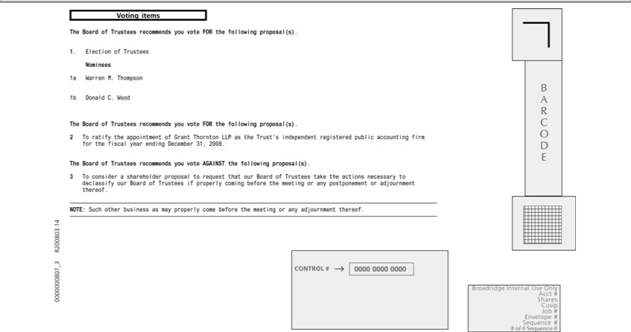

Voting items
The Board of Trustees recommends you vote FOR the following proposal(s).
Nominees1Election of Trustees
^{1b}a Warren M. Thompson
Don_{Board}ld C. Wood
^{The} of Trustees recommends you vote FOR the following proposal(s).
2 o Boardratify theofTrusteesappointmentrecommendsofGrant youThorntonvoteAGAINSTLLPasthetheTrust’sfollowingindependentproposal(s)registered. public accounting firm for the fiscal year ending December 31, 2008.

_{adjournment}3consider a shareholder proposal to request that our Board of Trustees take the actions necessary to declassify our Board of Trustees if properly coming before the meeting or any postponement or thereof.
CONTROL#NOTE:Such other0000 0000business0000as may properly come before the meeting or any adjournment thereof.
AcctBroadridge# Internal Use Only
Shares
Cusip
Job #
Envelope #
Sequence #
# of # Sequence #

BARCODE

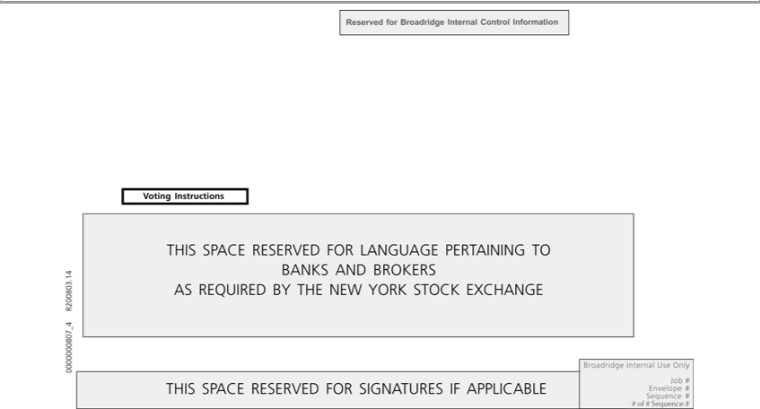

VotingReservedInstructionsforBroadridge Internal Control Information
BANKSTHISSPACEANDRESERVEDBROKERS FOR LANGUAGE PERTAINING TO
AS REQUIRED BY THE NEW YORK STOCK EXCHANGE
BroadridgeTHISSPACEInternalRESERVEDUseOnlyFOR SIGNATURES IF APPLICABLE
Job #
Envelope #
Sequence #
# of # Sequence #

