UNITED STATES

SECURITIES AND EXCHANGE COMMISSION
Washington, D.C. 20549

SCHEDULE 14A

(Rule 14a-101)
INFORMATION REQUIRED IN PROXY STATEMENT

SCHEDULE 14A INFORMATION

Proxy Statement Pursuant to Section 14(a) of the

Securities Exchange Act of 1934

Filed by the Registrant ☒ Filed by a party other than the Registrant ☐

Check the appropriate box:

- Preliminary Proxy Statement

- Confidential, for Use of the Commission Only (as permitted by Rule 14a-6(e)(2))

- Definitive Proxy Statement

- Definitive Additional Materials

- Soliciting Material Pursuant to §240.14a-12

FEDERAL REALTY INVESTMENT TRUST

(Name of Registrant as Specified in its Charter)

Not applicable.

(Name of Person(s) Filing Proxy Statement, if other than the Registrant)

Payment of Filing Fee (Check all boxes that apply):

- No fee required.

- Fee paid previously with preliminary materials.

- Fee computed on table in exhibit required by Item 25(b) per Exchange Act Rules 14a-6(i)(1) and 0-11.

Important Notice Regarding the Availability of Proxy Materials for the Shareholder Meeting of

FEDERAL REALTY INVESTMENT TRUST

To Be Held On:

May 7, 2025 at 9:00 a.m.

https://web.lumiconnect.com/202329683 (password: federal2025)
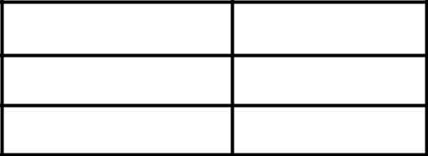

COMPANY NUMBER

ACCOUNT NUMBER

CONTROL NUMBER

This communication presents only an overview of the more completed proxy materials that are available to you on the Internet. We encourage you to access and review all of the important information contained in the proxy materials before voting.

If you want to receive a paper or e-mail copy of the proxy materials you must request one. There is no charge to you for requesting a copy. To facilitate timely delivery please make the request as instructed below before 04/28/25.

Please visit http://www.federalrealty.com/shareholder-meeting, where the following is available for view:

 | • | Annual Report/Form 10-K/Notice & Proxy Statement
 |  | (Including Instructions on How to Access and Participate in the Annual Shareholder Meeting)
TO REQUEST MATERIAL: | TELEPHONE: 888-Proxy-NA (888-776-9962) or 201-299-6210 (for international callers)
 | E-MAIL: help@equiniti.com
 | WEBSITE: https://us.astfinancial.com/OnlineProxyVoting/ProxyVoting/RequestMaterials
TO VOTE: | ONLINE: To access your online proxy card, please visit www.voteproxy.com and follow the on-screen
 | instructions or scan the QR code with your smartphone. You may enter your voting instructions at
 | www.voteproxy.com up until 11:59 PM Eastern Time the day before the cut-off or meeting date.
 | DURING THE MEETING: You may virtually attend the meeting and vote your shares through the internet. Go
 | to: https://web.lumiconnect.com/202329683 (password: federal2025).
 | TELEPHONE: To vote by telephone, please visit www.voteproxy.com to view the materials and to obtain the
 | toll free number to call.
 | MAIL: You may request a card by following the instructions above.
 |  |  | 1. To elect the following nominees as Trustees as set forth in our Proxy Statement:
 |  |  |  | David W. Faeder
 |  |  |  | Elizabeth I. Holland
 |  |  |  | Nicole Y. Lamb-Hale
 |  |  |  | Thomas A. McEachin
 |  |  |  | Anthony P. Nader, III
 |  |  |  | Gail P. Steinel
 |  |  |  | Donald C. Wood
 |  |  | 2. To approve, on a non-binding, advisory basis, the compensation of our named executive officers.
 |  |  | 3. To ratify the appointment of Grant Thornton LLP as our independent registered public accounting firm for
 |  |  |  | the fiscal year ending December 31, 2025.
 |  |  |  | To consider and act upon any other matters properly coming before the meeting or any postponement(s) or
 |  |  |  | adjournment(s) thereof.
Please note that you cannot use this notice to vote by mail. |  |  |  | THE BOARD OF TRUSTEES RECOMMENDS YOU VOTE “FOR” THE ELECTION OF ALL
 |  |  |  | THE NOMINEES AND “FOR” PROPOSALS 2 AND 3.


Your Vote Counts!
FEDERAL REALTY INVESTMENT TRUST
2025 Annual Meeting
Vote by May 06, 2025
11:59 PM ET
Hextone, Inc.
P.O. Box 9142
Farmingdale, NY 11735
30#
Ricky Campana
P.O. Box 123456
Suite 500
51 Mercedes Way
Edgewood, NY 11717



FLASHID-JOB#

You invested in FEDERAL REALTY INVESTMENT TRUST and it’s time to vote!

You have the right to vote on proposals being presented at the Annual Meeting. This is an important notice regarding the availability of proxy material for the shareholder meeting to be held on May 07, 2025.

Get informed before you vote

View the Annual Report/Form 10-K/Notice & Proxy Statement online OR you can receive a free paper or email copy of the material(s) by requesting prior to April 23, 2025. If you would like to request a copy of the material(s) for this and/or future shareholder meetings, you may (1) visit www.ProxyVote.com, (2) call 1-800-579-1639 or (3) send an email to sendmaterial@proxyvote.com. If sending an email, please include your control number (indicated below) in the subject line. Unless requested, you will not otherwise receive a paper or email copy.
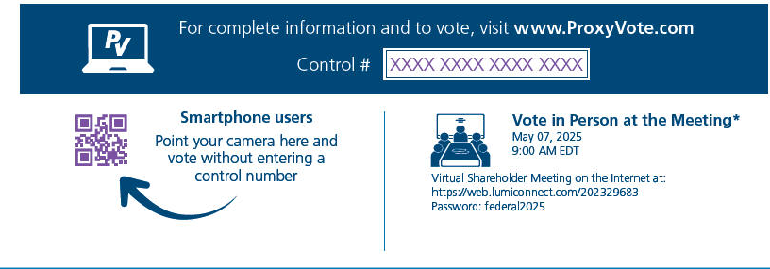

- If you choose to vote these shares in person at the meeting, you must request a “legal proxy.” To do so, please follow the instructions at www.ProxyVote.com or request a paper copy of the materials, which will contain the appropriate instructions. Please check the meeting materials for any special requirements for meeting attendance.

Vote at www.ProxyVote.com Control # XXXX XXXX XXXX XXXX

THIS IS NOT A VOTABLE BALLOT


This is an overview of the proposals being presented at the upcoming shareholder meeting. Please follow the instructions on the reverse side to vote these important matters.

 |  |  | Board
 | Voting Items |  | Recommends
 | 1. | Election of Trustees
 |  | Nominees:
 | 1A | David W. Faeder | For
 | 1B | Elizabeth I. Holland | For
 | 1C | Nicole Y. Lamb-Hale | For
 | 1D | Thomas A. McEachin | For
 | 1E | Anthony P. Nader, III | For
 | 1F | Gail P. Steinel | For
 | 1G | Donald C. Wood | For
 | 2. | To approve, on a non-binding, advisory basis, the compensation of our named executive officers. | For
 | 3. | To ratify the appointment of Grant Thornton LLP as our independent registered public accounting firm for the fiscal year | For
 |  | ending December 31, 2025. | For
 | NOTE: To consider and act upon any other matters properly coming before the meeting or any postponement(s) or adjournment(s) thereof.


Under New York Stock Exchange rules, brokers may vote “routine” matters at their discretion if your voting instructions are not communicated to us at least 10 days before the meeting. We will nevertheless follow your instructions, even if the broker’s discretionary vote has already been given, provided your instructions are received prior to the meeting date.

 | 1.00000
 | 322,224
FLASHID-JOB# | 148,294

