UNITED STATES

SECURITIES AND EXCHANGE COMMISSION

Washington, D.C. 20549

SCHEDULE 14A

Proxy Statement Pursuant to Section 14(a)

of the Securities Exchange Act of 1934
(Amendment No. )

Filed by the Registrant ☒ Filed by a Party other than the Registrant ☐

Check the appropriate box:

- Preliminary Proxy Statement

- Confidential, for Use of the Commission Only (as permitted by Rule 14a-6(e)(2))

- Definitive Proxy Statement

- Definitive Additional Materials

- Soliciting Material Pursuant to §240.14a-12

FEDERAL REALTY INVESTMENT TRUST

(Name of Registrant as Specified In Its Charter)

(Name of Person(s) Filing Proxy Statement, if other than the Registrant)

Payment of Filing Fee (Check the appropriate box):

- No fee required.

- Fee computed on table below per Exchange Act Rules 14a-6(i)(1) and 0-11.

  - Title of each class of securities to which the transaction applies:

  - Aggregate number of securities to which the transaction applies:

  - Per unit price or other underlying value of the transaction computed pursuant to Exchange Act Rule 0-11 (set forth the amount on which the filing fee is calculated and state how it was determined):

  - Proposed maximum aggregate value of the transaction:

  - Total fee paid:

- Fee paid previously with preliminary materials.

- Check box if any part of the fee is offset as provided by Exchange Act Rule 0-11(a)(2) and identify the filing for which the offsetting fee was paid previously. Identify the previous filing by registration statement number, or the Form or Schedule and the date of its filing.

  - Amount Previously Paid:

  - Form, Schedule or Registration Statement No.:

  - Filing Party:

  - Date Filed:

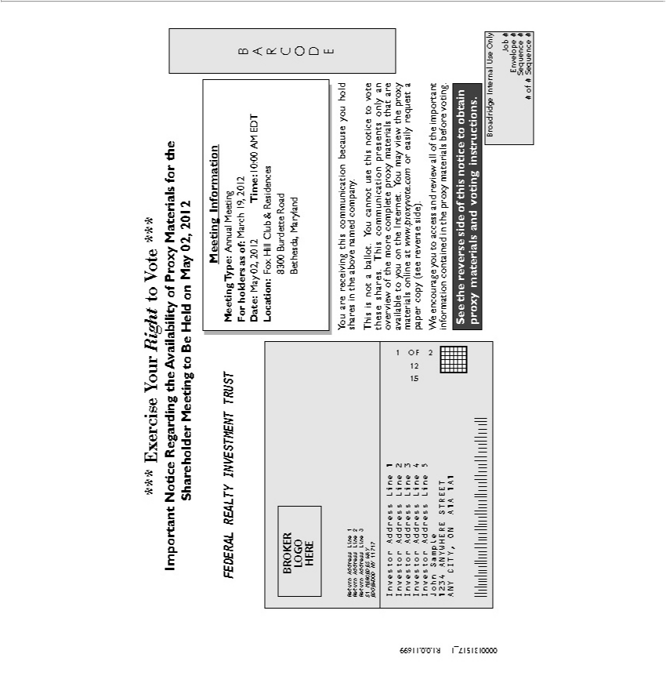

*** Exercise Your Right to Vote ***
Important Notice Regarding the Availability of Proxy Materials for the Shareholder Meeting to Be Held on <mtgdate>. May 02, 2012
*** Exercise Your Right to Vote ***
Important Notice Regarding the Availability of Proxy Materials for the Shareholder Meeting to Be Held on <mtgdate>. May 02, 2012 _{Meeting} Information
Type: Annual<mtgtype>Meeting
Date:ForholdersMay02,as of:2012March<recdate>19, 2012
Time: 10:00<mtgtime>AM EDT
8300Location:BurdetteFox_{Maryland}HillRoadClub & Residences
_{BARCODE}ethesda,
You are receiving this communication because you hold shares in the above named company.
This is not_{materials}ballot. You cannot use this notice to vote these shares. This communication presents only an overview of the more complete proxy materials that are available to you on the Internet. You may view
the proxy online_{access}at www.proxyvote.com_{important}easily request_{information}paper copy (see reverse side).
^{See}
W encouragethereverseyousidetoof this noticeandreviewtoobtainall proxyofthe materials and voting instructions.containedin the proxy materials before voting.
JobBroadridge# Internal Use Only
Envelope #
Sequence #
# of # Sequence #
0000131517_1 R1.0.0.11699

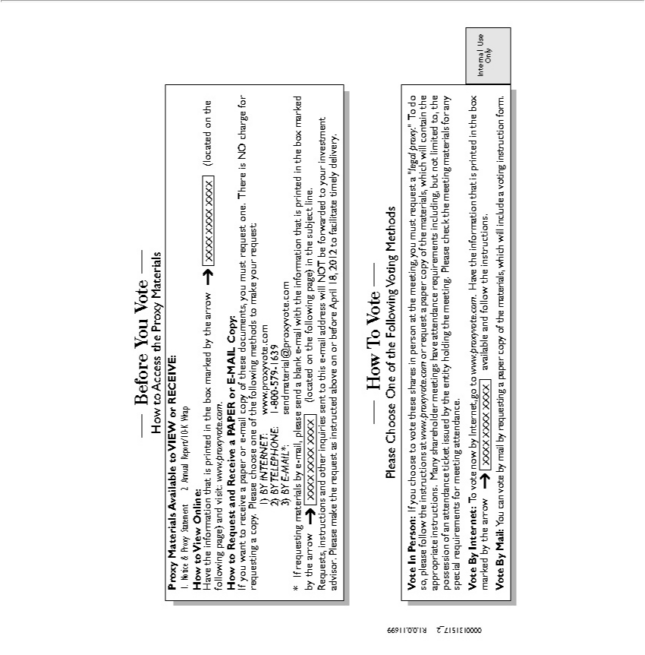

Before You Vote
ProxyHowtoMaterialsAccesstheAvailableProxyMaterialstoVIEW or RECEIVE:
1. Notice & Proxy Statement 2. Annual Report/10-K Wrap
Howave totheViewinformationOnline: that is printed in the box marked by the arrow XXXX XXXX XXXX (located on the following page) and visit: www.proxyvote.com.
to Request and Receive a PAPER or E-MAIL Copy:
1)If youBY wantINTERNET:toreceive a paper or e-mail copy of these documents, you must request one. There is NO charge for requesting a copy. Please choose one of the following methods to make your request:
www.proxyvote.com
12)-800BY-579TELEPHONE:-1639
3) BY E-MAIL*:
*sendmaterial@proxyvote.comIfrequestingmaterialsbypage)-mail, please send a blank e-mail with the information that is printed in the box marked by the arrow XXXX XXXX XXXX
Requests,(locatedoninstructionsthefollowingand other ininquiriesthesubjectsentline.tothis e-mail address will NOT be forwarded to your investment advisor. Please make the request as instructed above on or before April 18, 2012 to facilitate timely delivery.
PleaseHowToChooseVote One of the Following Voting Methods
materials,VoteInPerson:whichIfwillyoucontainchoose theto voteappropriatethesesharesinstructionsperson.Manyattheshareholdermeeting,youmeetingsmustrequesthaveattend“legalattendanceproxy.”requirementsTodoso,including,pleasefollowbutnotthelimitedinstructionsto,the atpossessionwww.proxyvote.comofanattendanceorrequestticket aissuedpaperbycopytheofentitythe holding the meeting. Please check the meeting materials for special requirements meeting .

Vote By Internet: To vote now by Internet, go to www.proxyvote.com. Have the information that is printed in the box marked by the arrow XXXX XXXX XXXX available and follow the instructions. Internal Use Only
Vote By Mail: You can vote by mail by requesting a paper copy of the materials, which will include a voting instruction form.

0000131517_2 R1.0.0.11699

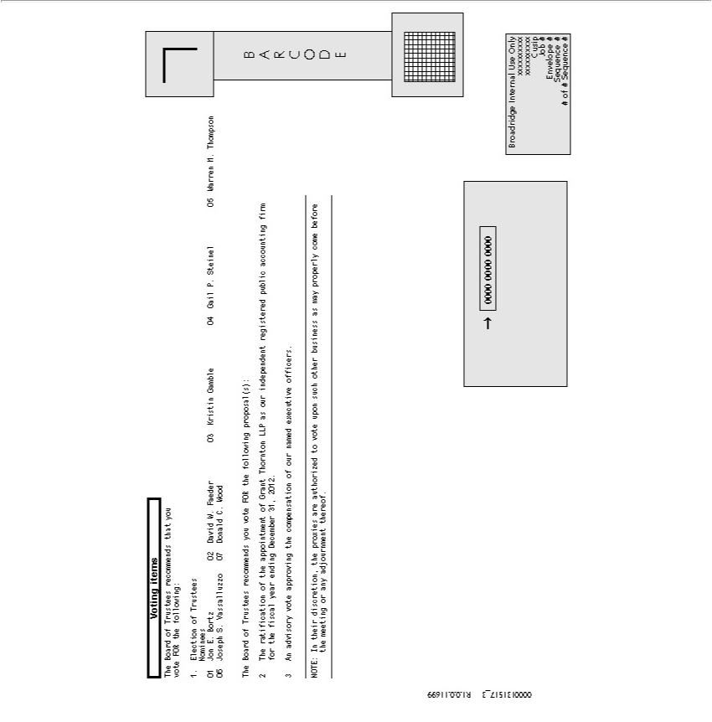

Voting items
1.The_{Election}Board ofof TrusteesTrustees recommendsNominees that you vote FOR the following:
²1 Jon . Bortz
³ David W. Faeder
⁴ Kristin Gamble
⁵ Gail P. Steinel
⁶ Warren M. Thompson
⁰⁷
DonJosephld S.C.VassalluzzoWood
The Board of Trustees recommends you vote FOR the following proposal(s):
32 AnTheadvisoryratificationvoteofapprovingtheappointmentthecompensationofGrantThorntonofournamedLLPasexecutiveourindependentofficers.registered public accounting firm for the fiscal year ending December 31, 2012.
NOTE: In their discretion, the proxies are authorized to vote upon such other business as may properly come before the meeting or any adjournment thereof.
BARCODE
0000 0000 0000
xxxxxxxxxxBroadridgeInternal Use Only
Cusip
Job #
Envelope #
Sequence #
# of # Sequence #

0000131517_3 R1.0.0.11699

VotingReservedInstructionsforBroadridge Internal Control Information
BANKSTHISSPACEANDRESERVEDBROKERS FOR LANGUAGE PERTAINING TO
BroadridgeASREQUIREDInternalBYUseTHEOnlyNEW YORK STOCK EXCHANGE
Job #
Envelope #
^{Sequence}Sequence#
# of #
0000131517THISSPACE_4RESERVEDR1.0.0.11699FOR SIGNATURES IF APPLICABLE

