UNITED STATES

SECURITIES AND EXCHANGE COMMISSION
Washington, D.C. 20549

SCHEDULE 14A INFORMATION

Proxy Statement Pursuant to Section 14(a) of the

Securities Exchange Act of 1934
(Amendment No. )

Filed by the Registrant ☒ Filed by a Party other than the Registrant ☐

Check the appropriate box:

- Preliminary Proxy Statement

- Confidential, for Use of the Commission Only (as permitted by Rule 14a-6(e)(2))

- Definitive Proxy Statement

- Definitive Additional Materials

- Soliciting Material under Rule 14a-12

FEDERAL REALTY INVESTMENT TRUST

(Name of registrant as specified in its charter)

(Name of person(s) filing proxy statement, if other than the registrant)

Payment of Filing Fee (Check the appropriate box):

- No fee required

- Fee computed on table below per Exchange Act Rules 14a-6(i)(4) and 0-11

  - Title of each class of securities to which transaction applies:

  - Aggregate number of securities to which transaction applies:

  - Per unit price or other underlying value of transaction computed pursuant to Exchange Act Rule 0-11 (set forth the amount on which the filing fee is calculated and state how it was determined):

  - Proposed maximum aggregate value of transaction:

  - Total fee paid:

- Fee paid previously with preliminary materials.

- Check box if any part of the fee is offset as provided by Exchange Act Rule 0-11(a)(2) and identify the filing for which the offsetting fee was paid previously. Identify the previous filing by registration statement number, or the Form or Schedule and the date of its filing.

  - Amount Previously Paid:

  - Form, Schedule or Registration Statement No.:

  - Filing Party:

  - Date Filed:

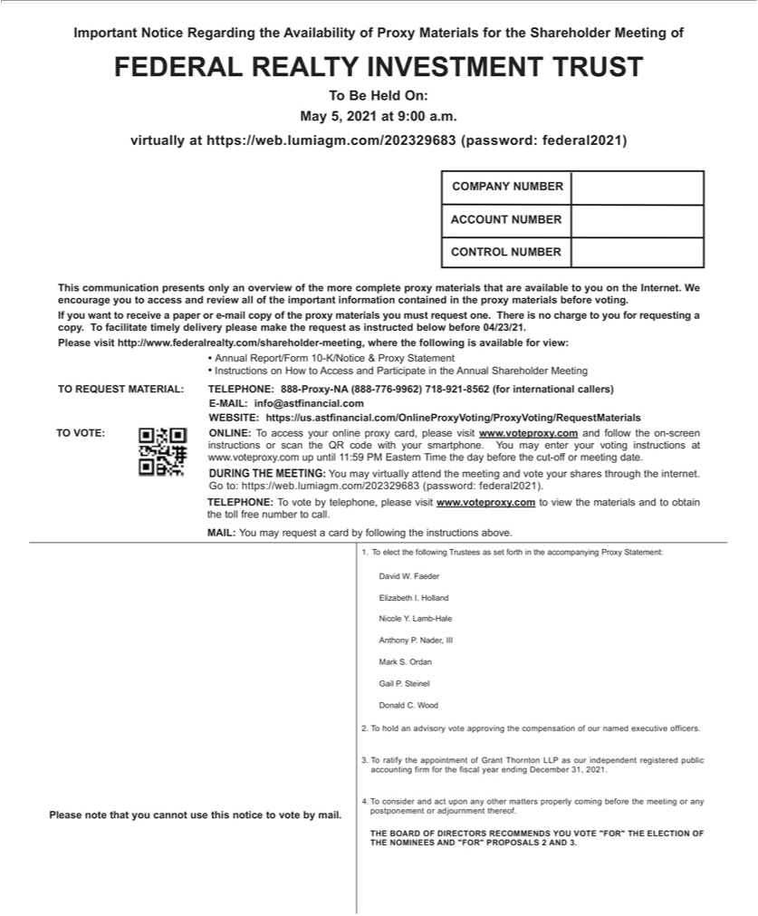

Important Notice Regarding the Availability of Proxy Materials for the Shareholder Meeting of FEDERAL REALTY INVESTMENT TRUST o Be Held On: May 5, 2021 at 9:00 a.m. virtually at
https://web.lumiagm.com/202329683 | federal2021) APT. 203 NEW YORK, NY 10038 1234 MAIN STREETJOHN SMITH ACCOUNT NUMBERCOMPANY NUMBER Please note that you
cannot use this notice to vote by mail. (password:1.Telectthe following Trustees as set forth the accompanying Proxy Statement David W. Faeder Elizabeth I. HollanNicole Y. Lamb-Hale Anthony P. Nader, III
Mark S. Ordan Gail P. Steinel Donald C. Wood .2. To hold an advisory vote approving the |  |  | of our named executive officers. 3.T ratify the appointment of Grant | LLP as our
independent registered public accounting firm for the fiscal year ending December 31, 2021.compensation4.consider and act upon any other matters properly coming before the meetingThorntonanypostponement or
adjournment thereof. THE BOARD OF DIRECTORS RECOMMENDS YOU VOTE “FOR” THE ELECTION OF THE NOMINEES AND “FOR” PROPORALS 2 AND 3. CONTROL NUMBER
encourage you to access and review all of the | information contained in the proxy materials before voting.This communication presents only an overview of the more complete proxy materials that
are available to you on the Internet. We copy. Timportantfacilitate timely delivery please make the request as instructed below before 04/23/21.If you want to receive a paper or e-mail copy of the proxy materials you
must request one. There is no charge to you for requesting Please visit http://www.federalrealty.com/shareholder-meeting, where the following is available for view: Annual Report/Form 10-K/Notice &
Proxy Statement Instructions How to Access and Participate |  | the Annual Shareholder Meeting TO VOTE:TO REQUEST MATERIAL: TELEPHONE: WEBSITE: E-MAIL:
info@astfinancial.cominstructions ONLINE: To access your online proxy card, please visit https://us.astfinancial.com/OnlineProxyVoting/ProxyVoting/RequestMaterialsor scan the QR code with your
smartphone888-Proxy-NA (888-776-9962) 718-921-8562 (for international callerswww.voteproxy. |  |  | . and follow the on-screen) www.voteproxy.com up until 11:59 PM Eastern Time the day before the cut-
off or meeting date.You may enter your voting instructions at Go to: https://web.lumiagm.com/202329683 (password: federal2021).DURING THE MEETING: You may virtually attend the meeting and vote
your shares through the internet. TELEPHONE: the toll free number to call.To vote by telephone, please visit www.voteproxy.com to view the materials and to obtain MAIL: You may request a card by following the instructions above.

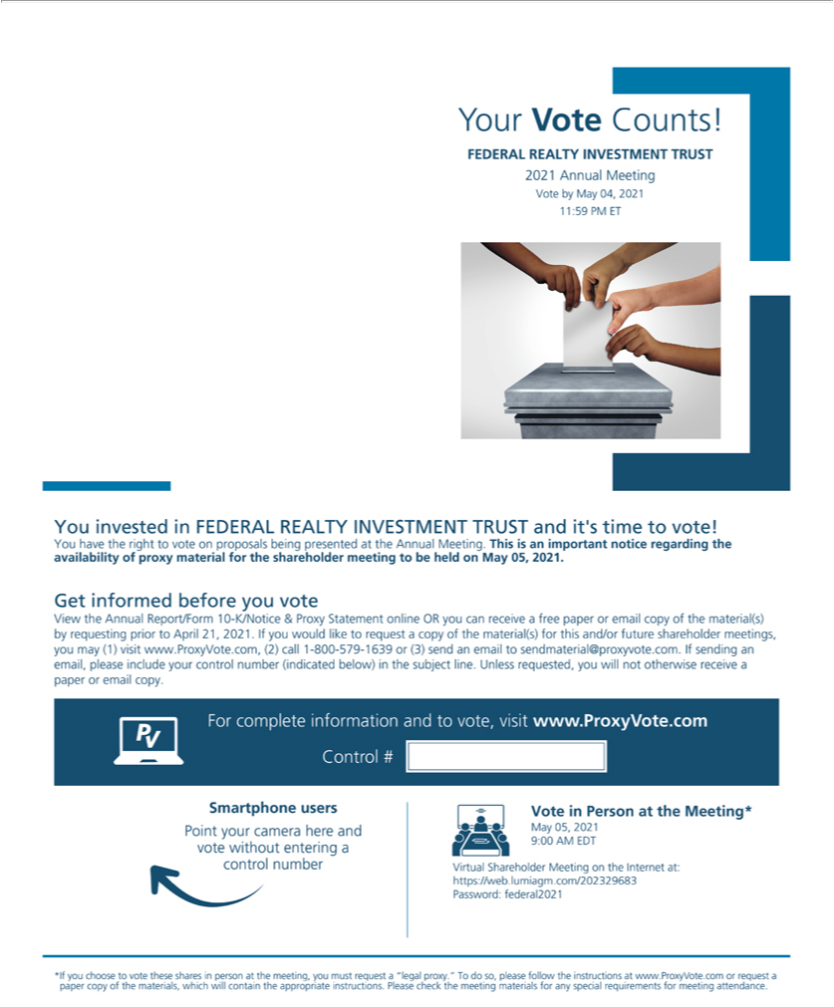

Your Vote Counts! FEDERAL REALTY INVESTMENT TRUST 2021 Annual Meeting Vote by May 04, 2021 1 1 •59 PM ET You invested in FEDERAL REALTY INVESTMENT TRUST and it’s time to vote! You have the right to vote on proposals being presented at the Annual Meeting. This is an important notice regarding the _{availability} of proxy material for the shareholder meeting to be held on May 05, ²⁰²¹. Get informed before you vote View the Annual Report/Form 10-K/Notice & Proxy Statement online OR you can receive free paper or email copy of the material(s) by requesting prior to April 21 ,
. If you would like to request a copy of the material(s) for this and/or future shareholder meetings, you may (1) visit www.ProxyVote.com, (2) call 1-800-579-1639 or (3) send an email to
sendmaterial@proxyvote.com. If sending an email, please include your control number (indicated below) in the subject line. Unless requested, you will not otherwise receive a paper or email copy. For
9:complete00AM EDTinformationVirtual andShareholdertovote,visitMeetingwww.ProxyVote.comontheInternetat:Controlhttps://web.lumiagm.com/202329683#SmartphoneusersPointyour Password:camersherefederal2021andvotewithoutSmartphoneenteringusersacontrolVoteinnumberPerson VoteattheinMeeting*PersonatPointtheMeeting*yourcameraMayhere05, and2021May
_{instructions}shares05,20219:00personAMat EDTthemeeting,votewithoutyoumustenteringrequestacontrola“legalnumberproxy.Virtual“TodoShareholderso,pleasefollowMeetingtheoninstructionstheInternetat at:www.ProxyVote.comhttps://web.lumiagm.com/202329683orrequestapaper copyPassword:ofthe federa12021materials,which*Ifyouwillchoosecontaintothevoteappropriatethese
. Please check the meeting materials for any special requirements for meeting attendance.

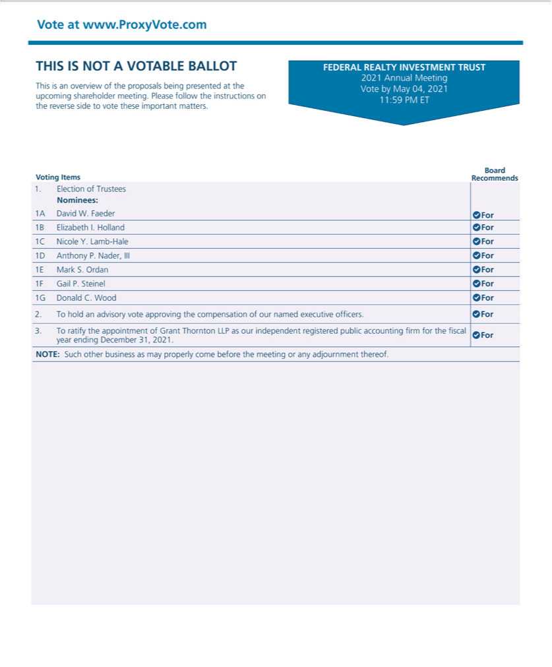

Vote at www.ProxyVote.com THIS IS NOT A VOTABLE BALLOT This is an overview of the proposals being presented at the upcoming _{shareholder} meeting. Please follow the instructions on the reverse side to vote these important matters. Board Voting Items Recommends IA Election of Trustees Nominees: David W. Faeder OFor 1 B Elizabeth . Holland OFor IC Nicole Y. Lamb-Hale OFor ID Anthony P. Nader, Ill OFor IE Mark S. Ordan OFor IF Gail P. Steinel OFor IG Donald C. Wood OFor 2. To hold an advisory vote approving the _{compensation} of our named executive officers._{properly}For3. _{come}Tratify the
appo_{meeting}tment of Grant Thornton I-LP as our independent registered public accounting firm for the fiscal year ending December 31, 2021 . For NOTE: Such other business as may before the or any adjournment thereof. FEDERAL REALITYINVESTMENT TRUST 2021 Annual Meeting Vote by May 04, 2021 11:59 PM ET

