Table of Contents

UNITED STATES

SECURITIES AND EXCHANGE COMMISSION
Washington, D.C. 20549

SCHEDULE 14A

(Rule 14a-101)
INFORMATION REQUIRED IN PROXY STATEMENT

SCHEDULE 14A INFORMATION

Proxy Statement Pursuant to Section 14(a) of the

Securities Exchange Act of 1934

Filed by the Registrant ☒ Filed by a party other than the Registrant ☐

Check the appropriate box:

- Preliminary Proxy Statement

- Confidential, for Use of the Commission Only (as permitted by Rule 14a-6(e)(2))

- Definitive Proxy Statement

- Definitive Additional Materials

- Soliciting Material Pursuant to §240.14a-12

FEDERAL REALTY INVESTMENT TRUST

(Name of Registrant as Specified in its Charter)

Not applicable.

(Name of Person(s) Filing Proxy Statement, if other than the Registrant)

Payment of Filing Fee (Check all boxes that apply):

- No fee required.

- Fee paid previously with preliminary materials.

- Fee computed on table in exhibit required by Item 25(b) per Exchange Act Rules 14a-6(i)(1) and 0-11.

Table of Contents
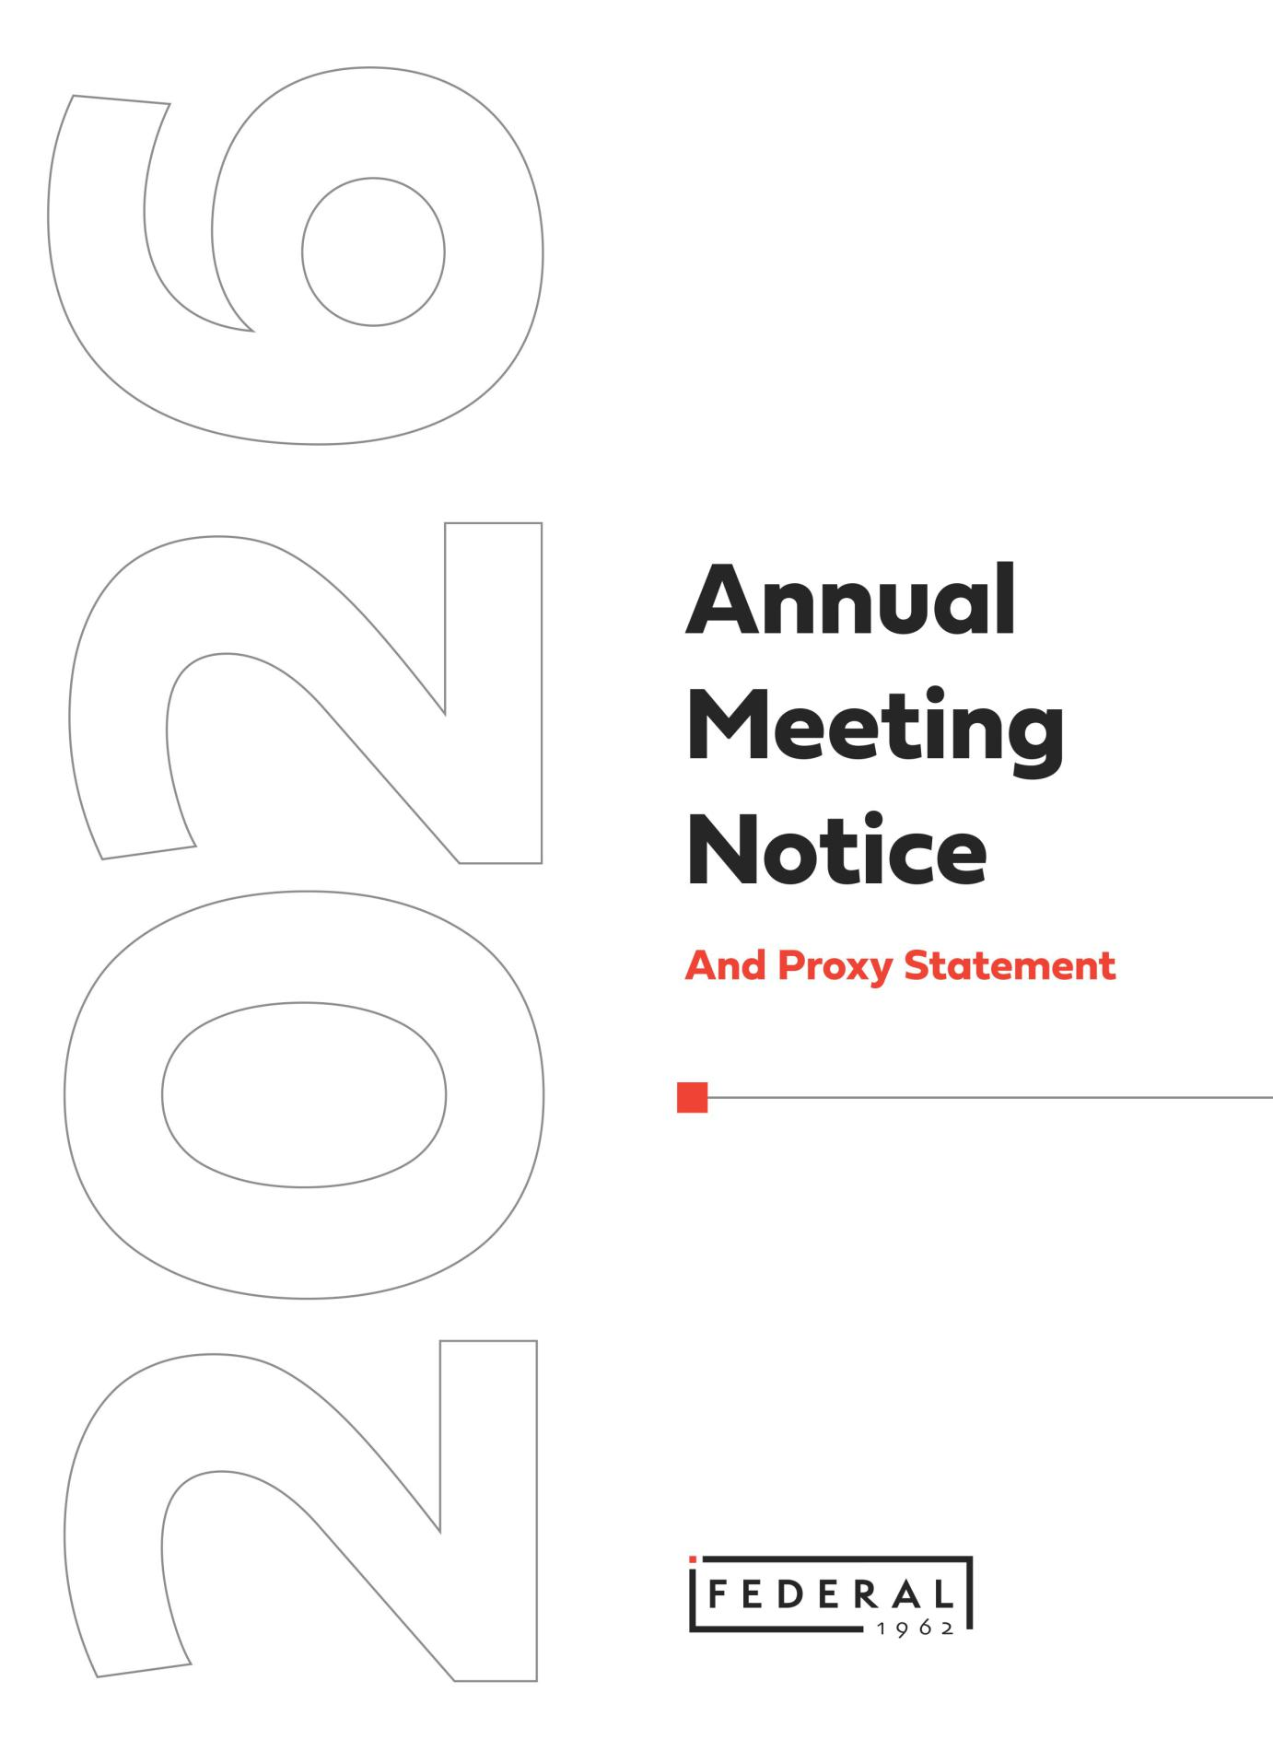

Table of Contents

Letter to Our Shareholders

March 27, 2026

To our Shareholders:

On behalf of the Board of Trustees and the entire Federal team, we invite you to join us for the 2026 Annual Meeting of Shareholders to be held virtually beginning at 9:00 a.m. eastern time on May 6, 2026. This proxy statement includes important information about how you can join and ask questions at the meeting and about the matters that will be voted on at the meeting.

Federal’s performance in 2025 was marked by a near record level of leasing activity demonstrating continued demand for our retail space and by a record level of new property acquisitions in existing markets as well as new markets that share the same key market characteristics. The strength of these activities combined with the ability to sell assets and realize the significant value that had been created over time allowed us to deliver record levels of revenue, net income and funds from operations for common shareholders in 2025. All parts of our business are working together to position us to be able to deliver strong results for years to come.

Our strong performance would not have been possible without the extraordinary efforts of our Board and each and every one of our employees. We are extremely proud of the work this team has accomplished.

Thank you for your continued support of Federal and we look forward to your participation in this year’s annual meeting.
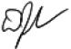
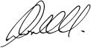

David W. Faeder

Non-Executive Chairman of the Board

Donald C. Wood

Chief Executive Officer

Table of Contents

Notice of Annual Meeting of Shareholders

ANNUAL MEETING PROPOSALS

Proposal 1 Election of 8 trustees for 1 year terms

Proposal 2 Non-binding advisory vote on 2025 executive compensation

Proposal 3 Ratification of Grant Thornton, LLC as our independent registered public accounting firm

Board Voting

Recommendation

FOR each nominee

FOR

FOR

Other business will be transacted as may properly come before the 2026 annual meeting of shareholders (“Annual Meeting”).

2026 ANNUAL MEETING INFORMATION

Date and Time | Location | Record Date
Wednesday, May 6, 2026 | Virtual Meeting | March 16, 2026
9:00 a.m., Eastern Time | https://edge.media-server.com/mmc/p/h5ru67ve

Only holders of record of our common shares of beneficial interest, $.01 par value per share, at the close of business on the record date are entitled to receive notice of, and to vote at, the Annual Meeting. References to “Common Shares”, “Shares”, “common shares” and “shares” in this proxy statement refer to our common shares of beneficial interest, $.01 par value per share.

Proxy Voting:

Whether or not you plan to attend the Annual Meeting and vote your Shares at the Annual Meeting, we urge you to vote your Shares as instructed in the proxy statement. If you received a copy of the proxy card by mail, you may sign, date and mail the proxy card in the postage-paid envelope provided. If your Shares are held by a broker, bank or other nominee, please follow the instructions you receive from your broker, bank or other nominee to have your Shares voted. Any proxy may be revoked at any time prior to its exercise at the Annual Meeting.


By Order of the Board of Trustees,

Dawn M. Becker

Executive Vice President
Chief Legal Officer And Secretary

March 27, 2026

Important Notice Regarding Internet Availability of Proxy Materials

The proxy statement and annual report to shareholders, including our annual report on Form 10-K for the year ended December 31, 2025, are available at www.federalrealty.com. References in this proxy statement to our website are provided for your convenience only and the content on our website does not constitute part of this proxy statement.

Table of Contents

Table of Contents

 | COMPANY INFORMATION |  |  |  |  |  |  | 1
 |  | Highlights of 2025 Company Performance |  |  |  |  |  | 1
 |  | Corporate Values |  |  |  |  |  | 2
 |  | Our Board |  |  |  |  |  | 2
 |  | Sustainability Snapshot |  |  |  |  |  | 3

 | GOVERNING THE COMPANY |  |  |  |  |  |  |  |  |  |  |  |  |  |  | 4
 |  | Governance Documents |  |  |  |  |  |  |  |  |  |  |  |  |  | 4
 |  | Governance Policies and Procedures |  |  |  |  |  |  |  |  |  |  |  |  |  | 5
 |  | Board Leadership |  |  |  |  |  |  |  |  |  |  |  |  |  | 5
 |  | Board and Committee Meetings |  |  |  |  |  |  |  |  |  |  |  |  |  | 5
 |  | Board Committees |  |  |  |  |  |  |  |  |  |  |  |  |  | 5
 |  | Board’s Role in Risk Oversight |  |  |  |  |  |  |  |  |  |  |  |  |  | 7
 |  | Board and Committee Evaluation Process |  |  |  |  |  |  |  |  |  |  |  |  |  | 8
 |  | Succession Planning |  |  |  |  |  |  |  |  |  |  |  |  |  | 9
 |  | Communications with the Board |  |  |  |  |  |  |  |  |  |  |  |  |  | 9
 |  | Compensation Committee Interlocks and Insider Participation |  |  |  |  |  |  |  |  |  |  |  |  |  | 10
 |  | Related Party Transactions |  |  |  |  |  |  |  |  |  |  |  |  |  | 10
 |  | Trustee Independence |  |  |  |  |  |  |  |  |  |  |  |  |  | 10

 | PROPOSAL 1: ELECTION OF TRUSTEES |  |  |  |  |  |  |  |  |  |  |  |  |  |  |  |  |  |  |  |  |  |  |  |  |  | 11
 |  | Vote Required and Majority Voting Standard |  |  |  |  |  |  |  |  |  |  |  |  |  |  |  |  |  |  |  |  |  |  |  |  | 11
 |  | Nominee Characteristics and Selection |  |  |  |  |  |  |  |  |  |  |  |  |  |  |  |  |  |  |  |  |  |  |  |  | 11
 |  | Nominee Diversity and Tenure |  |  |  |  |  |  |  |  |  |  |  |  |  |  |  |  |  |  |  |  |  |  |  |  | 13
 |  | Our Nominees |  |  |  |  |  |  |  |  |  |  |  |  |  |  |  |  |  |  |  |  |  |  |  |  | 13
 |  | Trustee Compensation |  |  |  |  |  |  |  |  |  |  |  |  |  |  |  |  |  |  |  |  |  |  |  |  | 18
 | PROPOSAL 2: APPROVING OUR EXECUTIVE |  |  |  |  |  |  |  |  |  |  |  |  |  |  |  |  |  |  |  |  |  |  |  |  |  | 19
 | COMPENSATION |  |  |  |  |  |  |  |  |  |  |  |  |  |  |  |  |  |  |  |  |  |  |  |  |  | 19
 | COMPENSATION DISCUSSION AND ANALYSIS |  |  |  |  |  |  |  |  |  |  |  |  |  |  |  |  |  |  |  |  |  |  |  |  |  | 20
 |  | Introduction |  |  |  |  |  |  |  |  |  |  |  |  |  |  |  |  |  |  |  |  |  |  |  |  | 21
 |  |  | 2025 Business Highlights supporting Compensation Decisions |  |  |  |  |  |  |  |  |  |  |  |  |  |  |  |  |  |  |  |  |  |  |  | 21
 |  |  | Program Philosophy and Objectives |  |  |  |  |  |  |  |  |  |  |  |  |  |  |  |  |  |  |  |  |  |  |  | 21
 |  |  | Executive Compensation Practices |  |  |  |  |  |  |  |  |  |  |  |  |  |  |  |  |  |  |  |  |  |  |  | 22
 |  |  | Components of Compensation |  |  |  |  |  |  |  |  |  |  |  |  |  |  |  |  |  |  |  |  |  |  |  | 22
 |  | Compensation Setting Process |  |  |  |  |  |  |  |  |  |  |  |  |  |  |  |  |  |  |  |  |  |  |  |  | 23
 |  |  | Annual Compensation Decision Making |  |  |  |  |  |  |  |  |  |  |  |  |  |  |  |  |  |  |  |  |  |  |  | 23
 |  |  | Role of the Compensation Committee |  |  |  |  |  |  |  |  |  |  |  |  |  |  |  |  |  |  |  |  |  |  |  | 23
 |  |  | Role of Management |  |  |  |  |  |  |  |  |  |  |  |  |  |  |  |  |  |  |  |  |  |  |  | 23
 |  |  | Role of Independent Compensation Consultant |  |  |  |  |  |  |  |  |  |  |  |  |  |  |  |  |  |  |  |  |  |  |  | 23
 |  | 2025 Compensation Decisions |  |  |  |  |  |  |  |  |  |  |  |  |  |  |  |  |  |  |  |  |  |  |  |  | 23
 |  |  | Setting 2025 Target Compensation |  |  |  |  |  |  |  |  |  |  |  |  |  |  |  |  |  |  |  |  |  |  |  | 23
 |  |  | Individual Elements of 2025 Pay |  |  |  |  |  |  |  |  |  |  |  |  |  |  |  |  |  |  |  |  |  |  |  | 24
 |  | 2025 NEO Performance Summary |  |  |  |  |  |  |  |  |  |  |  |  |  |  |  |  |  |  |  |  |  |  |  |  | 27

Other Compensation Practices and Policies |  |  |  |  |  |  |  |  |  |  |  |  | 28
 | Consideration of Say on Pay Vote |  |  |  |  |  |  |  |  |  |  |  | 28
 | No Hedging or Pledging of our Shares |  |  |  |  |  |  |  |  |  |  |  | 28
 | Severance and Change-in-Control Arrangements |  |  |  |  |  |  |  |  |  |  |  | 28
 | Clawback Policy |  |  |  |  |  |  |  |  |  |  |  | 29
 | Share Ownership Guidelines |  |  |  |  |  |  |  |  |  |  |  | 29
 | Risk Assessment of Compensation Programs |  |  |  |  |  |  |  |  |  |  |  | 29
 | Equity Grant Practices |  |  |  |  |  |  |  |  |  |  |  | 30
 | Insider Trading Policy |  |  |  |  |  |  |  |  |  |  |  | 30
 | Tax Deductibility of Executive Compensation |  |  |  |  |  |  |  |  |  |  |  | 30
 | Health and Welfare Benefits |  |  |  |  |  |  |  |  |  |  |  | 30
Compensation Committee Report |  |  |  |  |  |  |  |  |  |  |  |  | 31

 | COMPENSATION TABLES AND NARRATIVES |  |  |  |  |  |  |  |  |  |  |  |  |  |  |  |  |  |  |  |  |  |  |  |  |  |  |  |  |  |  | 32
 |  | Summary Compensation Table |  |  |  |  |  |  |  |  |  |  |  |  |  |  |  |  |  |  |  |  |  |  |  |  |  |  |  |  |  | 32
 |  | Grants of Plan Based Awards Table |  |  |  |  |  |  |  |  |  |  |  |  |  |  |  |  |  |  |  |  |  |  |  |  |  |  |  |  |  | 32
 |  | Outstanding Equity Awards at Fiscal Year End Table |  |  |  |  |  |  |  |  |  |  |  |  |  |  |  |  |  |  |  |  |  |  |  |  |  |  |  |  |  | 33
 |  | Options Exercised and Stock Vested in 2025 |  |  |  |  |  |  |  |  |  |  |  |  |  |  |  |  |  |  |  |  |  |  |  |  |  |  |  |  |  | 33
 |  | Non-Qualified Deferred Compensation |  |  |  |  |  |  |  |  |  |  |  |  |  |  |  |  |  |  |  |  |  |  |  |  |  |  |  |  |  | 34
 |  | Potential Payments on Termination of Employment and |  |  |  |  |  |  |  |  |  |  |  |  |  |  |  |  |  |  |  |  |  |  |  |  |  |  |  |  |  | 34
 |  |  | Change-in-Control
 |  | CEO Pay Ratio |  |  |  |  |  |  |  |  |  |  |  |  |  |  |  |  |  |  |  |  |  |  |  |  |  |  |  |  |  | 36
 |  | Pay Versus Performance Disclosure |  |  |  |  |  |  |  |  |  |  |  |  |  |  |  |  |  |  |  |  |  |  |  |  |  |  |  |  |  | 37
 |  | Equity Compensation Plan Information |  |  |  |  |  |  |  |  |  |  |  |  |  |  |  |  |  |  |  |  |  |  |  |  |  |  |  |  |  | 40
 | PROPOSAL 3: RATIFICATION OF INDEPENDENT |  |  |  |  |  |  |  |  |  |  |  |  |  |  |  |  |  |  |  |  |  |  |  |  |  |  |  |  |  |  | 40
 | REGISTERED PUBLIC ACCOUNTING FIRM |  |  |  |  |  |  |  |  |  |  |  |  |  |  |  |  |  |  |  |  |  |  |  |  |  |  |  |  |  |  | 40
 |  | Audit Committee Report |  |  |  |  |  |  |  |  |  |  |  |  |  |  |  |  |  |  |  |  |  |  |  |  |  |  |  |  |  | 41
 | BENEFICIAL OWNERSHIP |  |  |  |  |  |  |  |  |  |  |  |  |  |  |  |  |  |  |  |  |  |  |  |  |  |  |  |  |  |  | 43
 |  | Ownership of Principal Shareholders |  |  |  |  |  |  |  |  |  |  |  |  |  |  |  |  |  |  |  |  |  |  |  |  |  |  |  |  |  | 43
 |  | Ownership of Trustees and Executive Officers |  |  |  |  |  |  |  |  |  |  |  |  |  |  |  |  |  |  |  |  |  |  |  |  |  |  |  |  |  | 44
 | INFORMATION ABOUT THE ANNUAL MEETING |  |  |  |  |  |  |  |  |  |  |  |  |  |  |  |  |  |  |  |  |  |  |  |  |  |  |  |  |  |  | 44
 |  | Notice of Electronic Availability of Proxy Materials |  |  |  |  |  |  |  |  |  |  |  |  |  |  |  |  |  |  |  |  |  |  |  |  |  |  |  |  |  | 44
 |  | Why You are Receiving These Materials |  |  |  |  |  |  |  |  |  |  |  |  |  |  |  |  |  |  |  |  |  |  |  |  |  |  |  |  |  | 44
 |  | Accessing Materials |  |  |  |  |  |  |  |  |  |  |  |  |  |  |  |  |  |  |  |  |  |  |  |  |  |  |  |  |  | 45
 |  | How to Vote |  |  |  |  |  |  |  |  |  |  |  |  |  |  |  |  |  |  |  |  |  |  |  |  |  |  |  |  |  | 45
 |  | How to Participate in the Annual Meeting |  |  |  |  |  |  |  |  |  |  |  |  |  |  |  |  |  |  |  |  |  |  |  |  |  |  |  |  |  | 46
 |  | Eliminating Duplicative Proxy Materials |  |  |  |  |  |  |  |  |  |  |  |  |  |  |  |  |  |  |  |  |  |  |  |  |  |  |  |  |  | 46
 |  | Solicitation of Proxies |  |  |  |  |  |  |  |  |  |  |  |  |  |  |  |  |  |  |  |  |  |  |  |  |  |  |  |  |  | 47
 |  | Shareholder Proposals for the 2027 Annual Meeting |  |  |  |  |  |  |  |  |  |  |  |  |  |  |  |  |  |  |  |  |  |  |  |  |  |  |  |  |  | 47
 | APPENDIX A |  |  |  |  |  |  |  |  |  |  |  |  |  |  |  |  |  |  |  |  |  |  |  |  |  |  |  |  |  |  | A-1
 |  | Appendix A – Reconciliation of Non-GAAP Financial Measures |  |  |  |  |  |  |  |  |  |  |  |  |  |  |  |  |  |  |  |  |  |  |  |  |  |  |  |  |  | A-1

Table of Contents

Company Information

Following is basic information about the Company and summary highlights of information contained elsewhere in the proxy statement. This summary does not contain all of the information that you should consider, and you should read the entire proxy statement carefully before voting. References to “we,” “us,” “our,” “Federal” and the “Company” in this proxy statement refer to Federal Realty Investment Trust together with its subsidiaries, unless the context requires otherwise. References to the “Board” or “board” refer to our Board of Trustees, and references to “Trustees” and “trustees” refer to the members of our Board.

Federal Realty Investment Trust is an S&P 500 company headquartered in North Bethesda, Maryland that specializes in the ownership, management, and redevelopment of high quality retail and mixed-use properties located primarily in major coastal markets and select underserved markets that we believe have strong economic and demographic fundamentals.

Company Information | Our Properties* | Our Employees*
Established in 1962 | 104 Properties | 329 full-time employees
Member of the S&P 500 | ≈29M SF of commercial space | 6 primary offices
 | ≈2,700 residential units | Average tenure of more than 9 years

* Information as of December 31, 2025.

- HIGHLIGHTS OF 2025 COMPANY PERFORMANCE

Key business and financial achievements for 2025, in addition to net income available for common shareholders of $4.68 per diluted share, included:
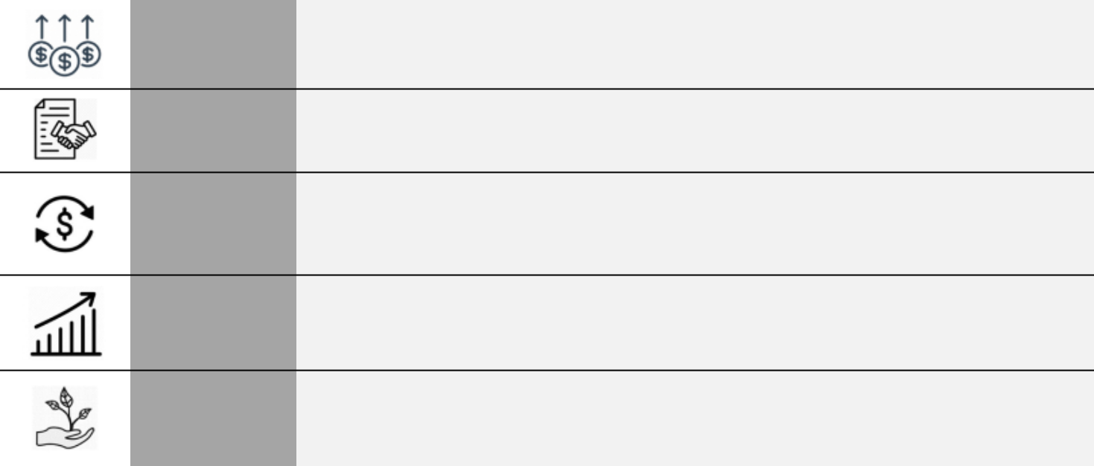

NAREIT NAREIT FFO per diluted share** of $7.22 representing growth of 6.6% over 2024 driven by record FFO Per Share levels of total revenue, positive impacts from capital investment, and overall continued strength in
Growth the broader retail real estate market

Strong Leasing Signed new and renewal comparable space leases covering more than 2.3 million square feet of

Activity space and approximately $88.9 million of year 1 revenue

Productive Investments in new acquisitions such as Del Monte Shopping Center, Town Center Plaza and

Capital Town Center Crossing, Annapolis Town Center and Village Pointe producing year over year Investments growth and positioning the company for continued growth

58th Year of Dividend Increases

Raised the dividend on our common shares for the 58th consecutive year, a record in the REIT industry, representing a compound annual growth rate of approximately 6.5% over that 58-year period

 | Achieved ≈ 35% decrease in Scope 1 and 2 GHG emissions through 2024 versus 2019 baseline
Sustainability | in alignment with our 2030 GHG reduction target set in accordance with the Science-Based Target
 | initiative

- NAREIT FFO per diluted share (“NAREIT FFO per share”) is a non-GAAP financial measure that we consider significant in our business. See Appendix A for a reconciliation of NAREIT FFO per share to net income.

Federal Realty 2026 Proxy Statement 1

Table of Contents

- CORPORATE VALUES

Our four core values drive the behaviors, actions and decisions we make towards achieving our business objectives and promote a unified approach to our individual jobs. We strive to achieve Excellence in all that we do as we operate, develop and redevelop properties to serve the needs of the local communities. Innovation is key to introducing new ways of conducting our business to continue to meet the evolving economic, environmental and social challenges the real estate industry must address both in the short- and long-term. We hold ourselves Accountable for our work and our results and always act with the highest level of Integrity in our dealings with our shareholders, our employees, our tenants, our business partners and our community partners. Living these values underpins our ability to successfully deliver results for all stakeholders.

- OUR BOARD

We have eight (8) trustees serving on our Board, all of whom are independent except for Mr. Wood who serves as our CEO. Each of these individuals has been nominated to stand for election at the 2026 annual shareholder meeting.

 |  | Trustee |  | Committee Memberships
Name and Principal Occupation | Age | Since | Independent | AC | CC | NC
David W. Faeder± | 69 | 2003 | Yes | ✓$ |  | ✓
Managing Partner/Fountain Square Properties and Managing
Member/Kensington Senior Living
Joseph. D. Fisher | 46 | 2026 | Yes | ✓$ | ✓
President, Chief Financial Officer/Public Storage
Elizabeth I. Holland | 60 | 2017 | Yes | ✓ | C
Chief Executive Officer/Abbell Credit Corporation and Abbell
Associates, LLC
Nicole Y. Lamb-Hale | 59 | 2020 | Yes |  | ✓ | ✓
Vice President, Chief Administrative Officer and Corporate
Secretary/Cummins Inc.
Thomas A. McEachin | 73 | 2022 | Yes |  | ✓ | ✓
Former Chief Financial Officer/Covidien Surgical Solutions
Anthony P. Nader, III | 62 | 2020 | Yes | ✓$ |  | C
Managing Director/SWaN & Legend Partners
Gail P. Steinel | 69 | 2006 | Yes | C$ | ✓
Owner/Executive Advisors
Donald C. Wood | 65 | 2003 | No
Chief Executive Officer/Federal Realty Investment Trust

Legend:

AC-Audit Committee; CC-Compensation and Human Capital Management Committee; NC-Nominating and Corporate Governance Committee

- Indicates Chairman of the Board C Indicates Committee Chair

$ Indicates Audit Committee Financial Expert

Federal Realty 2026 Proxy Statement 2

Table of Contents

- SUSTAINABILITY SNAPSHOT

Our sustainability initiatives are directly tied to supporting our business objective of using our real estate to create long-term value for all of our constituencies, including our shareholders. We have focused our efforts around the five areas that we believe are most impactful to supporting our business objectives.
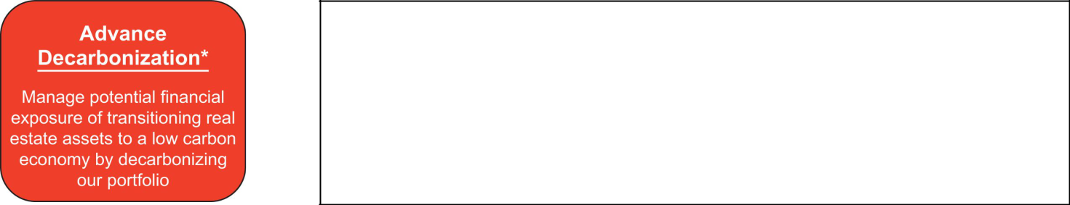

- Science Based Target to reduce Scope 1&2 emissions by 46% by 2030 (2019 baseline)

- ≈35% Scope 1&2 GHG emissions reduction from 2019 through 2024

- More than 5 million square feet of LEED certified buildings built or in process

- 51% of electric consumption in 2024 provided by zero carbon sources

- 15.3 MW solar power generating capacity in solar arrays at 28 properties

- Climate change scenario analysis using RCP 8.5 showing minimal financial risk over short-, medium- and long-term

- Management of water usage through technology and landscaping choices

- Focus on increasing waste diverted to recycling

- Physical risk exposures incorporated into property level capital planning and investment decisions
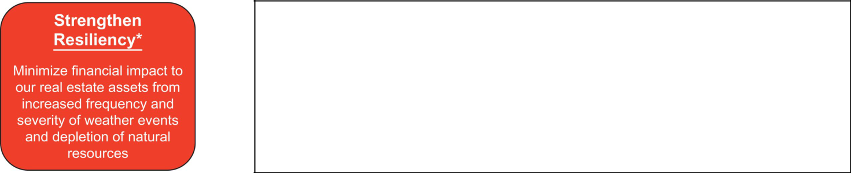

✓
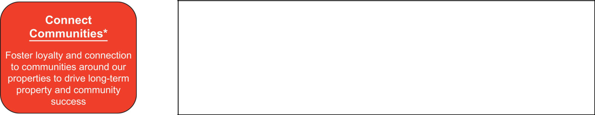

Local cultural programming and events at properties

- Support local philanthropic initiatives and tenants

- Feature work of local artists in art installations at our properties

- Significant contributions to tax base of communities

- Competitive pay and benefits

- Average tenure of 9.4 years

- Pay equity analysis shows no pay anomalies based on race or gender

- Women represented 54% of our workforce in 2025

- Minorities represented 48% of all new hires in 2025

- Comprehensive health and wellness programs through our Be Well at Federal program
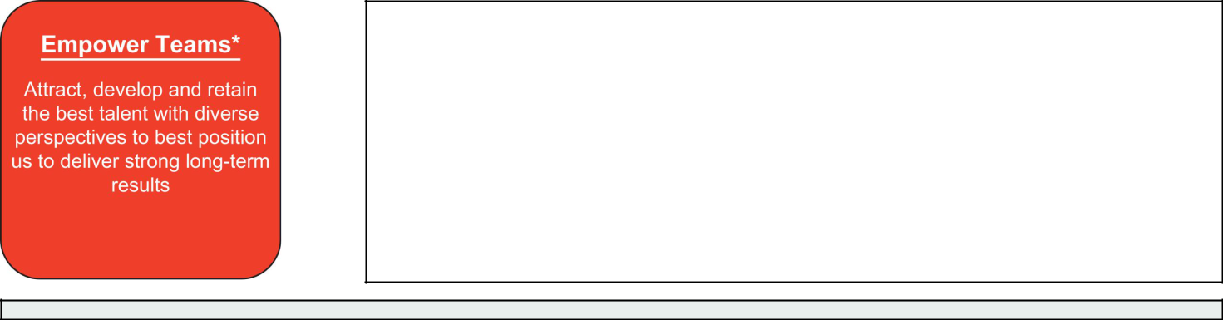

Federal Realty 2026 Proxy Statement 3

Table of Contents

    - Annual election of all trustees

  - Independent Non-Executive Chairman

  - Majority voting and proxy access for trustee elections

  - Prohibition on hedging and pledging our shares combined with clawback policy and equity hold requirements

  - Maintain a policy addressing the use of artificial intelligence

* All information provided is as of December 31, 2025 unless otherwise indicated.
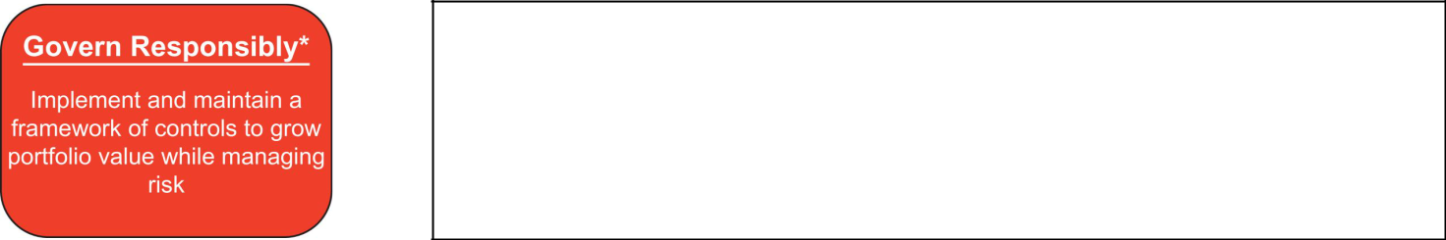

More information about our sustainability initiatives can be found in our 2024 Sustainability Report which is available under the Sustainability tab on our website and can be accessed by using this link frt-2024-sustainability-report.pdf. The report provides additional, detailed information in alignment with the frameworks established by the Global Reporting Initiative, Task Force for Climate Related Financial Disclosures and Sustainability Accounting Standards Board.

Our overall efforts on these 5 initiatives have earned us an AA rating from MSCI ESG ratings, best workplaces awards for our corporate headquarters and regional offices in San Jose, Northern Virginia and Philadelphia and wellness awards from the American Heart Association and Aetna.

Governing the Company

- GOVERNANCE DOCUMENTS

The Board is responsible for providing governance and oversight of the strategy, operations and management of the Company and has delegated to our senior management the authority to manage the day-to-day operations of the Company. The Board has adopted the following policies:

- Corporate Governance Guidelines

- Code of Business Conduct

- Code of Ethics for our Senior Financial Officers

These documents are reviewed periodically and revised when needed to reflect changing regulatory and governmental requirements and best practices. Complete copies of these documents are available in the Investor/Corporate Governance section of our website at www.federalrealty.com. Printed copies of these documents are available upon written request to our Investor Relations department at 909 Rose Avenue, Suite 200, North Bethesda, Maryland 20852.

Federal Realty 2026 Proxy Statement 4

Table of Contents

- GOVERNANCE POLICIES AND PROCEDURES

Our commitment to good governance is an integral part of our business. Highlights of our corporate governance practices include:

✓ Annual election of Trustees and annual | ✓ Independent non-executive chairman | ✓ Board oversight of sustainability, cyber
Board and Trustee evaluations | since 2003 | security, data protection, artificial
 |  | intelligence practices and human
 |  | resources
✓ Prohibition on Trustees serving on | ✓ Majority voting in uncontested elections | ✓ Proxy access for all shareholders
excessive numbers of other boards
✓ Prohibition on Trustees and | ✓ Shareholder approval required to classify | ✓ Robust share ownership guidelines in
management hedging and pledging our | our Board | place for Trustees and senior
shares |  | management

- BOARD LEADERSHIP

Our Board has been led by an independent, Non-Executive Chairman for more than 20 years. Mr. Faeder has filled that role since May 2021. The Board determined and continues to believe that separating the roles of Board chairman and CEO is the most effective way to govern the Company. The separation allows our Chairman to focus on Board administration, to facilitate communication among Trustees and to serve as a liaison to our CEO while allowing our chief executive to focus on the day-to-day management and implementation of long-term strategy of the Company.

- BOARD AND COMMITTEE MEETINGS

The Board met five (5) times in 2025 and our trustees collectively attended 99% of all of the meetings of the Board and the committees on which they serve. Our policy is for all
trustees to attend all meetings of each of the Board’s standing committees to ensure that

each Trustee is fully informed on all issues facing the Company and has the opportunity to participate in discussions surrounding those issues. Only trustees who are members of the

specific committee are entitled to vote on matters presented to that committee. At each quarterly meeting, the Trustees met in executive session with all Trustees and then with
just non-management Trustees, all of whom are independent. All Trustees are also

expected to attend our annual shareholder meeting and all Trustees attended the 2025 annual shareholder meeting.

- BOARD COMMITTEES

100%
Attendance at the annual shareholder

meeting

99%

Attendance by all Trustees of total Board

meetings and meetings of

Committees on which they serve

The Board has three standing committees – the Audit Committee, the Compensation and Human Capital Management Committee (“Compensation Committee”) and the Nominating and Corporate Governance Committee (“Nominating Committee”). Each committee operates under a written charter that is available in the Investors/Corporate Governance section of our website at www.federalrealty.com. Each committee consists entirely of independent, non-employee trustees.

Federal Realty 2026 Proxy Statement 5

Table of Contents

AUDIT COMMITTEE


Members

Gail P. Steinel (Chair)*
David W. Faeder*
Joseph D. Fisher*†
Elizabeth I. Holland
Anthony P. Nader, III*

Number of Meetings in 2025: 4

- Audit committee financial expert as defined by the SEC.

† Effective January 1, 2026

COMPENSATION COMMITTEE


Members

Elizabeth I. Holland (Chair)
Joseph D. Fisher†
Nicole Y. Lamb-Hale
Thomas A. McEachin
Gail P. Steinel

Number of Meetings in 2025: 2

† Effective January 1, 2026

The Audit Committee’s responsibilities include:

- Select and oversee our independent auditor

- Oversee our financial reporting including reviewing results with management and independent auditors

- Oversee internal audit function

- Oversee adequacy and integrity of financial statements, financial reporting and disclosures

- Oversee financial risks and risks related to cybersecurity, data security, artificial intelligence and information protection

- Review and approve any related party transactions requiring disclosure

Additional information on the Audit Committee is included in “Proposal 3: Ratification of Independent Registered Public Accounting Firm” and the Audit Committee Report.

The Compensation Committee’s responsibilities include:

- Evaluate performance of our CEO and recommend annual compensation and benefits for our CEO

- Review and approve compensation and benefits for our senior officers, including our NEOs

- Administer certain other benefit plans of the Company

- Review and approve employment related agreements for senior officers, including our NEOs

- Administer and make equity awards under our long-term plan

- Oversee key strategies and human resource policies and practices for all employees

The Compensation Committee report is included below and more detail on the work of the Compensation Committee is included in the “Compensation Discussion and Analysis”.

Federal Realty 2026 Proxy Statement 6

Table of Contents

NOMINATING COMMITTEE

The Nominating Committee’s responsibilities include:


- Identify and recommend individuals to stand for election to the Board

- Develop and oversee corporate governance policies and procedures

Members

Anthony P. Nader, III (Chair)
David W. Faeder
Nicole Y. Lamb-Hale

Thomas A. McEachin

Number of Meetings in 2025: 2

- BOARD’S ROLE IN RISK OVERSIGHT

- Oversee annual trustee evaluation process

- Recommend members of the Board to serve on its committees and in leadership roles

- Oversee corporate responsibility and sustainability efforts and monitor priorities and progress on goals

The full Board has overall responsibility for risk oversight which it accomplishes directly and through its committees. The Board’s committees are primarily responsible for certain matters relating to the risks inherent in the committees’ respective areas of oversight as set forth in the committee charters. One of the primary ways the Board and its committees discharge their risk oversight responsibilities is through regular reporting from management which identifies key risks to enable the Board and management to identify and implement appropriate measures to manage and mitigate those risks. The chart below provides more detail on how the Board oversees risk management for the Company. The Board believes that this structure and division of responsibility is the most effective way to monitor and manage the Company’s risk.

Federal Realty 2026 Proxy Statement 7

Table of Contents
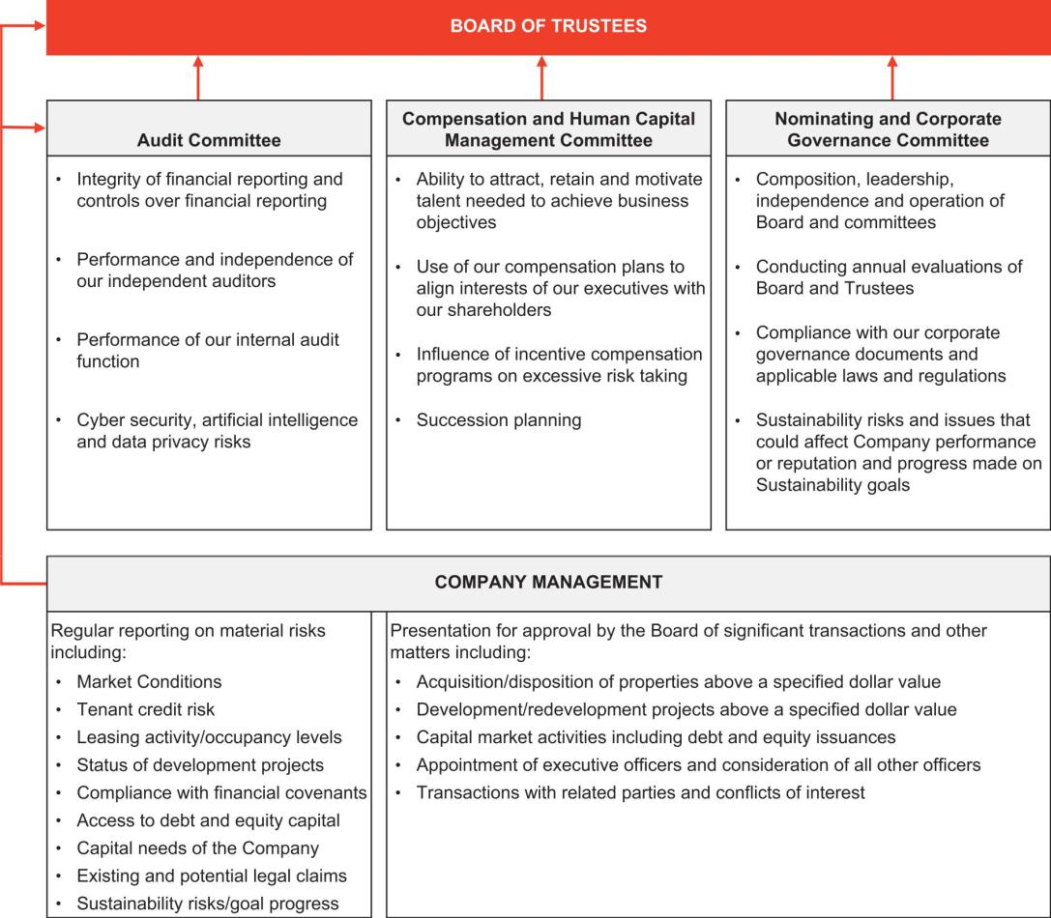

- BOARD AND COMMITTEE EVALUATION PROCESS

Our Board and each standing committee conducts annual evaluations that cover overall effectiveness of the Board and the committee as well as the effectiveness of each individual trustee. The Nominating Committee leads the process for the evaluation of the overall Board and each individual trustee and each committee chair leads the evaluation process for his or her committee. Results of the evaluations are taken into account in determining trustees to stand for election at the next annual meeting and in determining committee assignments and leadership roles.

Federal Realty 2026 Proxy Statement 8

Table of Contents

COMMITTEE ASSESSMENTS


Annual assessment by each committee of its effectiveness using a committee specific list of topics to guide an in-depth discussion of performance.

Topics include:

- Skills and expertise of committee members

- Adherence to committee charter

- Committee specific topics

- Information provided by and access to management


CONTINUAL FEEDBACK

The Board and the committees provide ongoing feedback on Board and Trustee performance throughout the year outside the formal evaluation process through executive session discussions.

TRUSTEE EVALUATIONS


Each Trustee completes a confidential questionnaire evaluating the performance of each other trustee with the results provided to the chair of the Nominating Committee.

Topics include:

- Preparedness for meetings and understanding company business

- Overall contributions to Board and Committees

- Skill set

- Effectiveness in leadership roles (if applicable)

One-on-One Discussions

The chair of the Nominating Committee discusses the individual assessments and overall Board effectiveness with each trustee. The Board chairman conducts the same process for the Nominating Committee chair.

Results Summary and Action Taken

Results of the assessments are provided to and discussed by the full Board. Identified issues are addressed with changes incorporated into Board policies and governance as needed.

- SUCCESSION PLANNING

The Board is responsible for ensuring that we have a high performing management team in place. The Board regularly conducts a detailed review of management development and succession planning activities to ensure that top management positions, including the CEO role, can be filled without significant interruption both in an emergency situation as well as on a longer-term basis.

- COMMUNICATIONS WITH THE BOARD

Shareholders and other interested parties may communicate with the Board or any Trustee by sending the communication to the intended recipient at c/o Corporate Secretary, 909 Rose Avenue, Suite 200, North Bethesda, Maryland 20852. Any communication which indicates it is for the Board of Trustees or fails to identify a particular Trustee will be deemed to be a communication intended for our Non-Executive Chairman of the Board. Our Secretary will promptly forward to the appropriate Trustee all communications received for the Board or any individual Trustee which relate to our business, operations, financial condition, management, employees or similar matters. Our Secretary will not forward to any Trustee any advertising, solicitation or similar materials as she determines.

Federal Realty 2026 Proxy Statement 9

Table of Contents

- COMPENSATION COMMITTEE INTERLOCKS AND INSIDER PARTICIPATION

The Compensation Committee consists of Ms. Holland, Mr. Fisher (joined January 1, 2026), Ms. Lamb-Hale, Mr. McEachin and Ms. Steinel. There are no Compensation Committee interlocks and no member of the Compensation Committee serves, or has in the past served, as an employee or officer of the Company.

- RELATED PARTY TRANSACTIONS

Our Trustees and employees are required to deal with the Company on an arms-length basis in any related party transaction. Transactions between us and any of our Trustees or corporate officers must be approved in advance by the Audit Committee. Audit Committee approval is not required for us to enter into a lease with an entity in which any of our Trustees is a director, employee or owner so long as the lease is entered into in the ordinary course of business and is negotiated at arms-length and on market terms.

We have no related party transactions with any of our Trustees that are required to be disclosed. None of our named executive officers (“NEOs”) has any indebtedness to the Company or any relationship with the Company other than as an employee, shareholder or Trustee. Employment and change-in-control arrangements between the Company and the NEOs are described in the “Potential Payments on Termination of Employment and Change-in-Control” section below.

- TRUSTEE INDEPENDENCE

The Board has adopted a standard designed to assist the Board in assessing trustee independence. This standard, included in our Corporate Governance Guidelines, states that a Trustee’s position as a director, officer or owner of a company with which we do business does not constitute a material relationship impacting independence so long as payments made by or to that company do not account for more than five percent (5%) of our gross revenues or more than ten percent (10%) of the gross revenues of that company. The Board performs an annual review of independence of all trustees and nominees. In order to make a determination that an individual is independent, the Board has to affirmatively conclude that the individual does not have any direct or indirect material relationship with the Company. This independence determination takes into account the requirements of our Corporate Governance Guidelines and any additional requirements imposed by law, regulation or the New York Stock Exchange (“NYSE”) listing standards and is only made after a thorough review of all relationships that exist between the Company and a trustee.

Based on this review process, the Nominating Committee recommended, and the Board concluded, that all of our Trustees, other than Mr. Wood, our chief executive officer, are independent under all applicable standards for service on the Board and each of its committees. In making this determination, the Board considered certain indirect passive investments Mr. Nader has directly and indirectly in three of the Company’s small shop tenants. The Board determined that Mr. Nader’s passive investment in these three small shop tenants did not constitute a material relationship with the Company and would not interfere with Mr. Nader’s ability to exercise independent judgment.

Federal Realty 2026 Proxy Statement 10

Table of Contents

Proposal 1: Election of Trustees

On recommendation of the Nominating Committee, our Board has nominated eight (8) candidates for election as trustees at the Annual Meeting. All of the nominees are incumbent trustees and all other than Mr. Fisher were elected as trustees by our shareholders in May 2025. Mr. Fisher was appointed to the Board effective as of January 1, 2026 to fill a newly created trustee position. More detailed biographical information on each nominee can be found in the following pages.

At the Annual Meeting, each trustee will be elected to hold office for a one-year term expiring at the 2027 annual meeting of shareholders and until his or her successor is elected and qualified.

- VOTE REQUIRED AND MAJORITY VOTING STANDARD

You are entitled to cast one vote per share for each of the eight nominees. Proxies may not be voted for more than eight individuals. In an uncontested election such as this one, our Bylaws require that a nominee receive a majority of votes cast with respect to that nominee in order to be elected. Accordingly, any nominee who does not receive a majority of votes cast will be required to resign from the Board within ninety (90) days. Broker non-votes and abstentions, if any, will not be treated as votes cast and as a result, will have no effect on the outcome of the vote for this proposal. Over the past 5 years, our nominees who have stood for election have received, on average, nearly 97% votes “for” at each shareholder meeting.

Our Board recommends a vote FOR each of the eight nominees

- NOMINEE CHARACTERISTICS AND SELECTION

The Nominating Committee has primary responsibility for identifying and recommending individuals to be added to the Board and to stand for election by shareholders. Individuals identified must have the highest personal and professional integrity, demonstrated exceptional intelligence and judgment, have proven leadership skills, be committed to our success, have the requisite skills necessary to advance our long-term strategy, and have the ability to work effectively with our Chief Executive Officer and other members of the Board. In addition, the Nominating Committee assesses the contribution that a particular candidate’s skills and expertise will make with respect to guiding our strategy and management when considered as a whole with the skills and expertise of other trustees.

The chart below highlights some of the key qualifications and experience that our Board believes are relevant to the effective oversight of the Company and the execution of our long-term strategy and were considered as relevant for each nominee. The absence of a mark for an attribute for any nominee does not necessarily mean that the nominee does not possess that attribute; it means only that when the Board considered that nominee in the overall context of the composition of our Board, that attribute was not a key factor in the determination to nominate that individual. Further information on each nominee’s qualifications and relevant experience is provided in the individual biographical descriptions included below.

Federal Realty 2026 Proxy Statement 11

Table of Contents

NOMINEE QUALIFICATIONS AND EXPERIENCE

Qualification/Experience |  | Faeder | Fisher | Holland | Lamb-Hale | McEachin | Nader | Steinel | Wood
 | Strategic Planning and Leadership | ● | ● | ● | ● | ● | ● | ● | ●
 | CEO/Executive Management | ● | ● | ● | ● | ● | ● | ● | ●
 | REIT/Public Company Executive | ● | ● |  | ● |  |  |  | ●
 | Public Company Board Service | ● | ● | ● | ● | ● | ● | ● | ●
 | Financial Expertise/Literacy | ● | ● | ● |  | ● | ● | ● | ●
 | Real Estate Investing/Finance | ● | ● | ● |  |  | ● |  | ●
 | Retail Industry |  |  | ● |  |  | ●
 | Risk Management | ● | ● | ● | ● | ● | ● | ● | ●
 | Human Capital Management | ● | ● | ● | ● | ● | ● | ● | ●
 | Corporate Governance | ● | ● | ● | ● | ● | ● | ● | ●
 | Sustainability | ● | ● | ● |  |  |  |  | ●
 |  | DEMOGRAPHICS
Race/Ethnicity |  | Faeder | Fisher | Holland | Lamb-Hale | McEachin | Nader | Steinel | Wood
Black or African American |  |  |  |  | ● | ●
 | White | ● | ● | ● |  |  | ● | ● | ●
Gender
 | Female |  |  | ● | ● |  |  | ●
 | Male | ● | ● |  |  | ● | ● |  | ●








The Company’s Corporate Governance Guidelines provide that no trustee who is the CEO of a publicly traded company can serve on more than two public company boards, including the Board of the Company, and no other trustee who is not the CEO or a named executive officer of a public company can serve on more than four public company boards, including the Board of the Company. These limitations were considered before nominating our existing trustees to stand for reelection in 2026.

To identify, recruit and evaluate qualified candidates for the Board, the Board first looks to individuals known to current Board members through business and other relationships. If the Board is not able to identify qualified candidates in the foregoing way, the services of a professional search firm would be used. In addition, any shareholder, or a group of up to 20 shareholders, that has continuously owned for 3 years at least 3% of the Company’s outstanding Common Shares can nominate and include in the Company’s annual meeting proxy materials up to the greater of two trustees or 20% of the number of trustees serving on the Board, provided that the shareholder(s) and the nominee(s) satisfy the requirements set forth in our Bylaws. For further information regarding submission of a trustee nominee using the Company’s proxy access Bylaw provision or otherwise, see the “Shareholder Proposals for the 2027 Annual Meeting” section later in this proxy statement.

Federal Realty 2026 Proxy Statement 12

Table of Contents

- NOMINEE DIVERSITY AND TENURE

The Board believes that a mix of skills, qualifications, ages, tenure and diversity are important considerations in identifying nominees so that the Board as a whole has the different viewpoints needed to provide appropriate oversight of the Company’s business. Among the many items the Board takes into account, the Board specifically considers the gender and race/ethnicity of prospective nominees in order to ensure diverse representation on the Board.

AGE TENURE GENDER & ETHNIC DIVERSITY
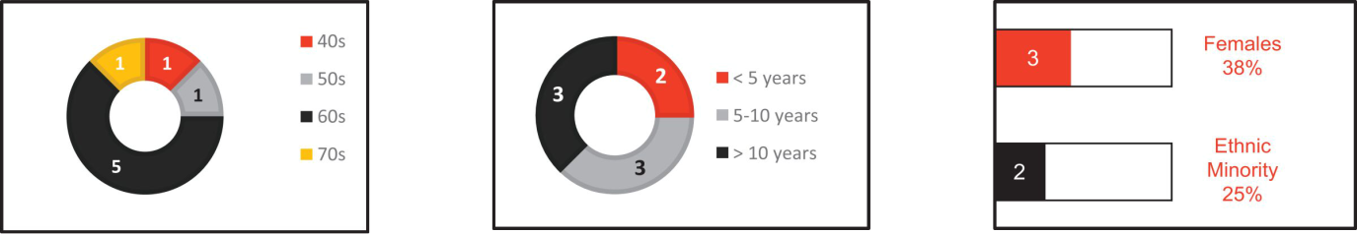

Average age of independent trustees

Average tenure of independent trustees

Committees chaired by women

62.6 years

9.7 years

67%

- OUR NOMINEES

The following biographical descriptions set forth certain information with respect to each nominee for election at the Annual Meeting as well as the specific experience, qualifications, attributes and skills that led to our Board’s conclusion that each nominee should serve as a trustee of our Company.

Federal Realty 2026 Proxy Statement 13

Table of Contents

DAVID W. FAEDER

Age: 69
Trustee Since: 2003
Non-Executive Chairman
Managing Partner of Fountain
Square Properties and
Managing Member of
Kensington Senior Living

Mr. Faeder has been the managing partner of Fountain Square Properties since 2003 and managing member of Kensington Senior Living since 2011, both of which are focused on the ownership, operation and development of senior housing. Prior to that, he held various positions at Sunrise Senior Living from 1993 to 2003. Those positions included Vice Chairman, President and Executive Vice President-Chief Financial Officer. Mr. Faeder began his career in public accounting before moving into investment banking immediately prior to joining Sunrise. Mr. Faeder received a BS in Business Administration from Old Dominion University and an MBA from the Colgate Darden Graduate School of Business at the University of Virginia. Mr. Faeder has been designated by the Board as an audit committee financial expert in accordance with the SEC definition.

Skills and Qualifications

Mr. Faeder has deep levels of experience in leadership, real estate investment and development as well as finance and accounting acquired from his time as a private investor and as a public company real estate CFO coupled with his public company and accounting background. This experience provides valuable perspective on our investment decisions, alignment of our capital structure to support those investments and on our financial reporting. His experience in senior living also provides valuable insights for a growing area that could be a source of additional value creation at a number of our properties.

Prior Public Company Directorships:

Arlington Asset Investment Corp. (until 2023)

Committees:

Audit Committee
Nominating Committee

JOSEPH D. FISHER
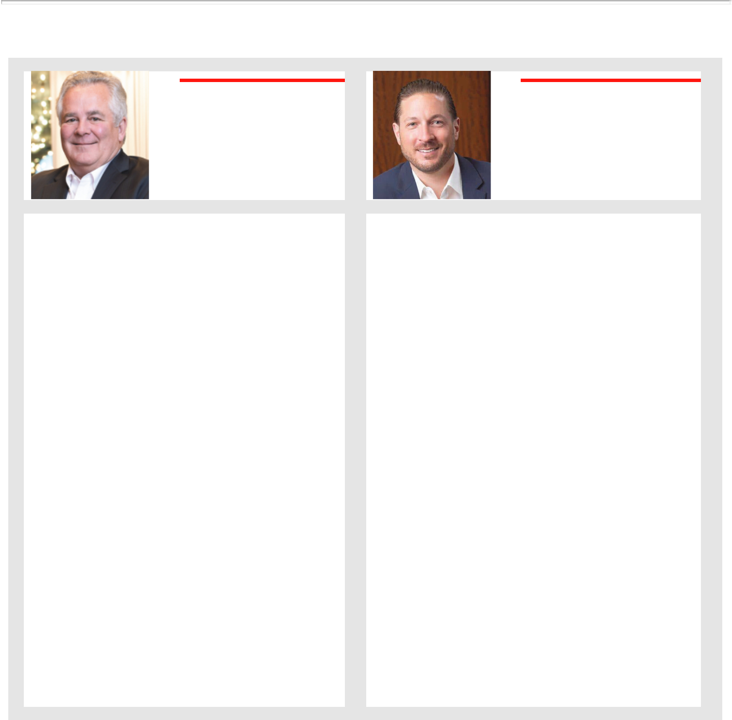
Age: 46
Trustee Since: 2026
President, Chief Financial Officer

of Public Storage

Mr. Fisher is the President, Chief Financial Officer of Public Storage (2026 to present), a publicly traded real estate investment trust that primarily acquires, develops, owns, and operates self-storage facilities. Prior to that, Mr. Fisher served as the President (2022 – 2025), Chief Financial Officer (2017 – 2025) and Chief Investment officer (2025) of UDR, Inc., a publicly traded real estate investment trust focused on managing, buying, selling, developing and redeveloping multifamily properties in targeted U.S. markets. Before joining UDR, Mr. Fisher held various positions at Deutsche Asset and Wealth Management (now known as DWS), a global asset management firm, where he held various roles, including Co-Head of the Americas and Co-Lead Portfolio Manager (2007 – 2016), Associate, Structured Debt Investments (2005 – 2007) and Portfolio Analyst, Portfolio Management Group (2004 – 2006). Mr. Fisher began his career as an Asset Management Analyst for Principal Real Estate Advisors (2003 – 2004). Mr. Fisher received a Bachelor of Business Administration from the University of Iowa and an MBA from the Kellogg School of Management at Northwestern University. Mr. Fisher has been designated by the Board as an audit committee financial expert in accordance with the SEC definition.

Skills and Qualifications

Mr. Fisher has extensive experience in public company and real estate financing and investment and expertise in the multifamily apartment industry. His financial and investment acumen, experience as a public real estate investment trust executive and deep knowledge of the multifamily industry provide a multitude of valuable insights into areas critical for our success.

Committees:

Audit Committee
Compensation Committee

Federal Realty 2026 Proxy Statement 14

Table of Contents


ELIZABETH I. HOLLAND

Age: 60
Trustee Since: 2017

Chief Executive Officer of Abbell

Credit Corporation and Abbell
Associates, LLC

Ms. Holland is the Chief Executive Officer of Abbell Credit Corporation and Abbell Associates, LLC, a private retail real estate company. She has held that position since 1997. Ms. Holland is also Chief Executive Officer of Consortial Technologies, L.L.C., a software development company since 2017. Prior to that, she served as a senior staff attorney on the Congressional Bankruptcy Review Commission (1996-1997), as a business reorganization attorney at Skadden, Arps, Slate, Meagher & Flom (1993-1996) and as a fixed income portfolio manager at Brown Brothers Harriman & Company from (1989-1990). From 2016-2017, Ms. Holland served as the Chairman of the Board of Trustees for ICSC (f/k/a International Council of Shopping Centers) and has served as a trustee for that organization since 2004. Ms. Holland earned a BA from Hamilton College and a JD from Brooklyn Law School. In addition to her public board service, Ms. Holland serves on the boards of The Village Bank & Trust, a Chicago based owner, manager and developer of multi-family properties, and Primo Center for Women & Children, a non-profit organization whose mission is to provide family shelter and permanent supportive housing and other supportive services to homeless families in Chicago.

Skills and Qualifications

Ms. Holland brings valuable insights into retailers and the retail industry in general from her time in leadership positions with ICSC and her own investing experience in retail real estate as well as a wealth of business and leadership experience from running a private real estate company. Those perspectives are invaluable for a retail based real estate company.

Current Public Company Directorships:

VICI Properties, Inc.

Committees:

Audit Committee

Compensation Committee (Chair)

NICOLE Y. LAMB HALE

Age: 59
Trustee Since: 2020
Vice President, Chief
Administrative Officer and
Corporate Secretary of Cummins,

Inc.

Ms. Lamb-Hale currently serves as the Vice President, Chief Administrative Officer and Corporate Secretary of Cummins Inc., a position she has held since 2025 overseeing multiple global functions including product compliance and regulatory affairs, communications, marketing, government relations, corporate responsibility, facilities, security, global enterprise risk, ethics and compliance and the company’s global shared services organization. She also serves as Corporate Secretary advising the company’s board of directors and executive management on corporate governance and compliance with SEC reporting requirements and NYSE rules. While at Cummins Inc., Ms. Lamb-Hale has also held the titles Vice President and Chief Legal Officer (2023-2025) and Vice President and General Counsel (2021-2022). Prior to that time, she was a Managing Director at Kroll, a global governance, risk and transparency consultant (2016-2021), a Senior Vice President at Albright Stonebridge Group (2013-2016), a global strategy consultancy, and served as the Assistant Secretary of Commerce for Manufacturing and Services in the International Trade Administration of the U.S. Department of Commerce (2010-2013) and as the Deputy General Counsel for the U.S. Department of Commerce (2009-2010). Ms. Lamb-Hale is a licensed attorney who began her career at law firms (1991-2009) where she practiced in the areas of business restructuring and public finance. Ms. Lamb-Hale earned an AB in Political Science from the University of Michigan and a JD from Harvard Law School. In addition to her service on Federal’s Board, Ms. Lamb-Hale serves on the board of Delta Parent Holdings, Inc. as well as the boards of several non-profit groups including the Cummins Foundation and the U.S. Chamber of Commerce Foundation.

Skills and Qualifications

Ms. Lamb-Hale’s 30 years of experience, spanning the private and public sectors, in law, executive level risk management and mitigation, and restructuring, coupled with her leadership skills gained from her varied executive roles, provides the company with diverse and valuable insights as it develops and implements its current and long-term business strategies.

Committees:

Compensation Committee

Nominating Committee

Federal Realty 2026 Proxy Statement 15

Table of Contents
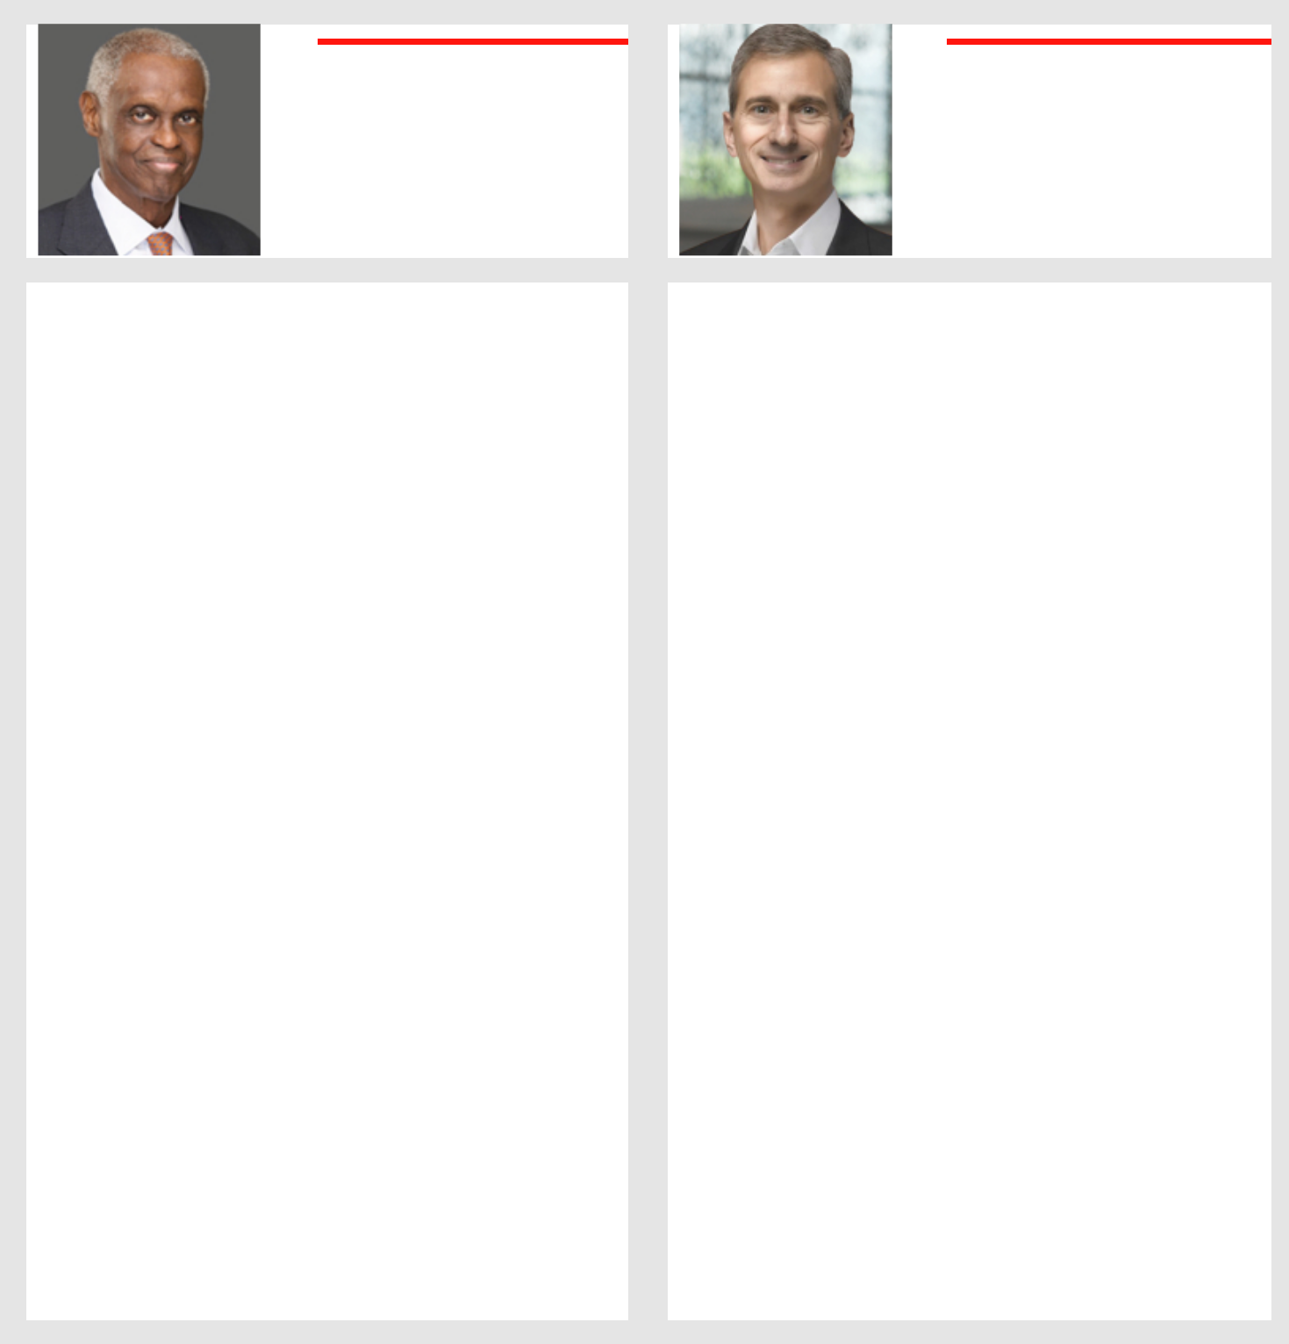

THOMAS A. McEACHIN

Age: 73
Trustee Since: 2022
Retired Vice President and

Group Chief Financial Officer of

Covidien Surgical Solutions

Mr. McEachin has served as Vice President and Group Chief Financial Officer (2008-2012) at Covidien Surgical Solutions, a division of Covidien plc, a global health care products company and manufacturer of medical devices and supplies. From 1997 to 2008, Mr. McEachin served in various finance capacities at United Technologies Corporation, a global leader in the aerospace and building industries, and its subsidiaries, including as chief Investor Relations officer, Vice President and Controller of Pratt & Whitney, and Vice President and Chief Financial Officer of UTC Power. Prior to that, he held several executive positions with Digital Equipment Corporation, a vendor of computer systems, including computers, software, and peripherals, from 1986 to 1997. Mr. McEachin was with Xerox Corporation, a global corporation that sells print and digital document products and services, from 1975 to 1986, serving as Controller of the procurement organization. Mr. McEachin formerly served as a trustee and officer of the Wadsworth Atheneum (Hartford, CT), the oldest public art institution in the United States, serving on their executive, finance and investment committees. He also is a past board member of the Connecticut Science Center and chair of the audit committee. Mr. McEachin holds a B.S. from New York University School of Engineering, an MBA from Stanford University and completed the Advanced Management Program at University of Pennsylvania’s Wharton School.

Skills and Qualifications

Mr. McEachin’s history as a CFO plus his extensive finance and executive management experience and in-depth knowledge as a CFO of financial reporting, compliance, accounting and controls and corporate governance matters provides the company with important skills.

Current Public Company Directorships:

Pediatrix Medical Group, Inc.

Prior Public Company Directorships:

Surgalign Holdings, Inc. (until 2023)

Committees:

Compensation Committee
Nominating Committee

ANTHONY P. NADER, III

Age: 62
Trustee Since: 2020
Managing Director of SWaN &

Legend Venture Partners

Mr. Nader is a Managing Director of SWaN & Legend Venture Partners, an investment firm that Mr. Nader co-founded in 2006, making investments in growth-oriented companies. Mr. Nader served as Vice Chairman of Asurion, a privately held company with over 19,000 employees that provides technology protection to approximately 300 million customers worldwide until the end of 2025. In 2008, Mr. Nader successfully merged his prior company, National Electronics Warranty (“NEW”) with Asurion. Mr. Nader joined NEW in 1990 as Chief Operating Officer, was named President in 1999 and Chief Executive Officer in 2006, a position he held until 2013. Under his leadership, NEW grew to be the largest global provider of extended service plans for the consumer electronics and appliance industry. Mr. Nader earned a BSBA in Finance from John Carroll University and an MBA from Weatherhead School of Management at Case Western Reserve University. Mr. Nader also served as the Chairman of the Inova Health System Board of Trustees until December 31 2023. Mr. Nader has been designated by the Board as an audit committee financial expert in accordance with the SEC definition.

Skills and Qualifications

Mr. Nader provides our Board with more than 30 years of business and leadership experience as well as a deep investment background in both real estate and growth-oriented companies including retailers. This background complements others on our Board and adds to our depth of financial and investing expertise that is so critical to the success of the Company.

Prior Public Company Directorships:

Arlington Asset Investment Corp. (until 2023)

Committees:

Audit Committee
Nominating Committee (Chair)

Federal Realty 2026 Proxy Statement 16

Table of Contents


GAIL P. STEINEL

Age: 69
Trustee Since: 2006

Owner of Executive Advisors

Ms. Steinel is the owner of Executive Advisors (2007-present), a business that provides consulting services to chief executives and senior officers and leadership seminars/speeches to various organizations. Prior to creating her own consulting firm, Ms. Steinel was the Executive Vice President of Global Commercial Services of Bearing Point (2002-2007) and a global managing partner for Arthur Andersen’s Business Consulting Practice (1984-2002) after beginning her career as an auditor at Arthur Andersen (1977-1984). Ms. Steinel received a BA in Accounting from Rutgers University. Ms. Steinel’s public company board service experience includes MTS Systems Corporation (2009-2020). In addition, Ms. Steinel serves as the lead independent director since 2024 of Invesque, Inc., a Toronto stock exchange company that invests in a highly diversified portfolio of properties across the health care spectrum throughout the US and Canada, and serves on the board of DAI, an international development company that tackles fundamental social and economic development problems caused by inefficient markets, ineffective governance, and instability, and the Center for Hope & Safety, a nonprofit that assists women and children suffering from domestic violence. Ms. Steinel has been designated by the Board as an audit committee financial expert in accordance with the SEC definition.

Skills and Qualifications

Ms. Steinel’s history as a CPA combined with her more than 35 years of experience in auditing, leadership, leadership development and financial systems provides us with valuable insights on leadership, leadership development, risk management and systems operations.

Prior Public Company Directorships:

MTS Systems Corporation (until 2020)

Committees:

Audit Committee (Chair)
Compensation Committee

DONALD C. WOOD

Age: 65
Trustee Since: 2003
Chief Executive Officer of

Federal Realty Investment Trust

Mr. Wood currently serves as our Chief Executive Officer, a role he has held since 2003. Before assuming that role, he served as our President (2001-2003) and held the titles of Chief Operating Officer and Chief Financial Officer at various points from 1998-2003. Prior to joining Federal, Mr. Wood served as the Chief Financial Officer for Caesers World, Inc. (1996-1998), the Assistant/Deputy Controller of ITT Corporation (1990-1996), the VP of Finance for Trump Taj Mahal Associates (1989-1990) and as an audit manager with Arthur Andersen (1982-1989). Mr. Wood is a CPA and received a BS in Business Administration from Montclair State College. Mr. Wood previously served as a director of public companies Quality Care Properties (2016-2018) and Post Properties (2011-2016). In addition to his public company board service, Mr. Wood served as Chairman of the Board of Trustees of the National Association of Real Estate Investment Trusts (2011-2012) and previously served on the Board of Governors of ICSC (f/k/a International Council of Shopping Centers).

Skills and Qualifications

Mr. Wood’s more than 27 years of experience with Federal, including his responsibilities as chief executive officer and as a REIT CFO, provide the Board with familiarity and details on all aspects of the operations and financial condition of the Company.

Current Public Company Directorships:

Healthcare Realty Trust Incorporated

Prior Public Company Directorships:

Quality Care Properties (until 2018)
Post Properties (until 2016)

Federal Realty 2026 Proxy Statement 17

Table of Contents

- TRUSTEE COMPENSATION

As of December 31, 2025, our standard arrangement for compensation for our non-management trustees included the following:

Trustee Compensation Element | Amount |  | Payment Form
Board Service
Annual Retainer | $ | 225,000 | 40% cash; 60% equity
Annual Retainer Non-Executive Chairman | $ | 275,000 | 60% cash; 40% equity
Committee Chairs
Audit Committee | $ | 25,000 | Cash
Compensation Committee | $ | 15,000 | Cash
Nominating Committee | $ | 15,000 | Cash

All amounts are prorated for any partial years of service and shares issued are fully vested on the grant date.

Our non-management Trustees are required to maintain ownership of our shares having a value equal to at least 5 times the amount of their annual cash retainer. This requirement must be met within 5 years after joining the Board. As of December 31, 2025, all of our Trustees were in full compliance with this ownership requirement except for Mr. McEachin who joined the Board in 2022. We expect Mr. McEachin to be in compliance with this equity ownership requirement within the 5-year time frame.

The actual compensation awarded to our Trustees for service in 2025 was as set forth in the table below. Mr. Fisher did not serve as a Trustee in 2025 and accordingly received no compensation for 2025.

 |  | Annual Retainer |  |  |  |  | Committee
Name |  | Paid in Cash | Paid in Shares⁽¹⁾ |  |  |  | Chair Fees |  | Total
David W. Faeder | $ | 165,000 | $ |  | 110,000 | $ | - | $ | 275,000
Elizabeth I. Holland | $ | 90,000 | $ |  | 135,000 | $ | 15,000 | $ | 240,000
Nicole Y. Lamb-Hale | $ | 90,000 | $ |  | 135,000 | $ | - | $ | 225,000
Thomas A. McEachin | $ | 90,000 | $ |  | 135,000 | $ | - | $ | 225,000
Anthony P. Nader, III | $ | 90,000 | $ |  | 135,000 | $ | 15,000 | $ | 240,000
Gail P. Steinel | $ | 90,000 | $ |  | 135,000 | $ | 25,000 | $ | 250,000
Total | $ | 615,000 | $ |  | 785,000 | $ | 55,000 | $ | 1,455,000

- Shares were issued on January 2, 2026 with the number of shares received by each Trustee determined by dividing the amount to be paid in shares by $100.80, the closing price of our shares on the NYSE on December 31, 2025.

Federal Realty 2026 Proxy Statement 18

Table of Contents

Proposal 2: Approving our Executive Compensation

We are seeking an advisory vote to approve our executive compensation for 2025. We have always held our “Say on Pay” vote annually and in 2023, a majority of our shareholders voted to continue to hold this vote annually. Although this “Say on Pay” vote is advisory and is not binding on our Board, our Compensation Committee will take into consideration the outcome of this vote when making future executive compensation decisions.

The text of the resolution if Proposal 2 is passed is:

RESOLVED, that the shareholders of the Company hereby approve, on an advisory basis, the compensation of our NEOs as described in the CD&A and the Executive Compensation section that follows as required by Item 402 of Regulation S-K.

The affirmative vote of a majority of votes cast at the Annual Meeting, in person or by proxy, is required to approve this proposal. An “abstention” or “broker non-vote” will have no effect on the outcome of the vote for this proposal.

Our Board has designed our current executive compensation program to appropriately link compensation realized by our NEOs to our performance and properly align the interests of our NEOs with those of our shareholders. The details of this compensation for 2025, and the reasons we awarded it, are described in the “Compensation Discussion and Analysis,” starting below.



Our Board recommends a vote FOR the compensation of our NEOs

Federal Realty 2026 Proxy Statement 19

Table of Contents

Compensation Discussion and Analysis

CD&A TABLE OF CONTENTS |  |  |  |  |  |  |  |  |  |  |  |  |  |  |  |  |  |  |  |  |  |  |  |  |  |  |  |  |  | Page #
Introduction |  |  |  |  |  |  |  |  |  |  |  |  |  |  |  |  |  |  |  |  |  |  |  |  |  |  |  |  |  | 21
2025 Business Highlights Supporting |  |  |  |  |  |  |  |  |  |  |  |  |  |  |  |  |  |  |  |  |  |  |  |  |  |  |  |  |  | 21
 | Compensation Decisions |  |  |  |  |  |  |  |  |  |  |  |  |  |  |  |  |  |  |  |  |  |  |  |  |  |  |  |  | 21
Program Philosophy and |  |  |  |  |  |  |  |  | Objectives |  |  |  |  |  |  |  |  |  |  |  |  |  |  |  |  |  |  |  |  | 21
Executive Compensation Practices |  |  |  |  |  |  |  |  |  |  |  |  |  |  |  |  |  |  |  |  |  |  |  |  |  |  |  |  |  | 22
Components of Compensation |  |  |  |  |  |  |  |  |  |  |  |  |  |  |  |  |  |  |  |  |  |  |  |  |  |  |  |  |  | 22
Compensation Setting Process |  |  |  |  |  |  |  |  |  |  |  |  |  |  |  |  |  |  |  |  |  |  |  |  |  |  |  |  |  | 23
Annual Compensation Decision Making |  |  |  |  |  |  |  |  |  |  |  |  |  |  |  |  |  |  |  |  |  |  |  |  |  |  |  |  |  | 23
Role of the Compensation Committee |  |  |  |  |  |  |  |  |  |  |  |  |  |  |  |  |  |  |  |  |  |  |  |  |  |  |  |  |  | 23
Role of Management |  |  |  |  |  |  |  |  |  |  |  |  |  |  |  |  |  |  |  |  |  |  |  |  |  |  |  |  |  | 23
Role of Independent |  |  |  |  |  | Compensation Consultant |  |  |  |  |  |  |  |  |  |  |  |  |  |  |  |  |  |  |  |  |  |  |  | 23
2025 Compensation Decisions |  |  |  |  |  |  |  |  |  |  |  |  |  |  |  |  |  |  |  |  |  |  |  |  |  |  |  |  |  | 23
Setting 2025 Target Compensation |  |  |  |  |  |  |  |  |  |  |  |  |  |  |  |  |  |  |  |  |  |  |  |  |  |  |  |  |  | 23
Individual Elements of 2025 Pay |  |  |  |  |  |  |  |  |  |  |  |  |  |  |  |  |  |  |  |  |  |  |  |  |  |  |  |  |  | 24
 |  | Base Pay |  |  |  |  |  |  |  |  |  |  |  |  |  |  |  |  |  |  |  |  |  |  |  |  |  |  |  | 24
 |  | Annual Bonus Program |  |  |  |  |  |  |  |  |  |  |  |  |  |  |  |  |  |  |  |  |  |  |  |  |  |  |  | 24
 |  |  |  |  |  |  |  |  |  |  |  |  |  |  |  |  |  |  |  |  |  |  |  |  |  |  |  |  |  | 25
 |  | Long-Term Incentive Program |  |  |  |  |  |  |  |  |  |  |  |  |  |  |  |  |  |  |  |  |  |  |  |  |  |  |  | 25
2025 NEO Performance Summary |  |  |  |  |  |  |  |  |  |  |  |  |  |  |  |  |  |  |  |  |  |  |  |  |  |  |  |  |  | 27
Other Compensation Practices and Policies |  |  |  |  |  |  |  |  |  |  |  |  |  |  |  |  |  |  |  |  |  |  |  |  |  |  |  |  |  | 28
Consideration of Say on Pay Vote |  |  |  |  |  |  |  |  |  |  |  |  |  |  |  |  |  |  |  |  |  |  |  |  |  |  |  |  |  | 28
No Hedging or Pledging of Our Shares |  |  |  |  |  |  |  |  |  |  |  |  |  |  |  |  |  |  |  |  |  |  |  |  |  |  |  |  |  | 28
 |  |  |  |  |  |  |  |  |  |  |  |  |  |  |  |  |  |  |  |  |  |  |  |  |  |  |  |  |  | 28
Severance and Change-in-Control Arrangements |  |  |  |  |  |  |  |  |  |  |  |  |  |  |  |  |  |  |  |  |  |  |  |  |  |  |  |  |  | 28
Clawback Policy |  |  |  |  |  |  |  |  |  |  |  |  |  |  |  |  |  |  |  |  |  |  |  |  |  |  |  |  |  | 29
Share Ownership |  |  |  |  | Guidelines |  |  |  |  |  |  |  |  |  |  |  |  |  |  |  |  |  |  |  |  |  |  |  |  | 29
Risk Assessment of Compensation Programs |  |  |  |  |  |  |  |  |  |  |  |  |  |  |  |  |  |  |  |  |  |  |  |  |  |  |  |  |  | 29
Equity Grant Practices |  |  |  |  |  |  |  |  |  |  |  |  |  |  |  |  |  |  |  |  |  |  |  |  |  |  |  |  |  | 30
Insider Trading Policy |  |  |  |  |  |  |  |  |  |  |  |  |  |  |  |  |  |  |  |  |  |  |  |  |  |  |  |  |  | 30
Tax Deductibility of |  |  |  |  |  |  | Executive Compensation |  |  |  |  |  |  |  |  |  |  |  |  |  |  |  |  |  |  |  |  |  |  | 30
Health and Welfare Benefits |  |  |  |  |  |  |  |  |  |  |  |  |  |  |  |  |  |  |  |  |  |  |  |  |  |  |  |  |  | 30
Compensation Committee Report |  |  |  |  |  |  |  |  |  |  |  |  |  |  |  |  |  |  |  |  |  |  |  |  |  |  |  |  |  | 31

Current NEOs DONALD C. WOOD

Chief Executive Officer and President Age: 65 Joined Federal: 1998

In position since: 2003

DANIEL GUGLIELMONE

EVP-Chief Financial Officer and Treasurer Age: 59 Joined Federal: 2016

In position since: 2016

DAWN M. BECKER

EVP-Chief Legal Officer and Secretary Age: 62 Joined Federal: 1997 In position since: 2002

Federal Realty 2026 Proxy Statement 20

Table of Contents

- INTRODUCTION

- 2025 BUSINESS HIGHLIGHTS SUPPORTING COMPENSATION DECISIONS:

Business accomplishments for the year ended December 31, 2025 that were considered as part of compensation decisions included, without limitation, the following:
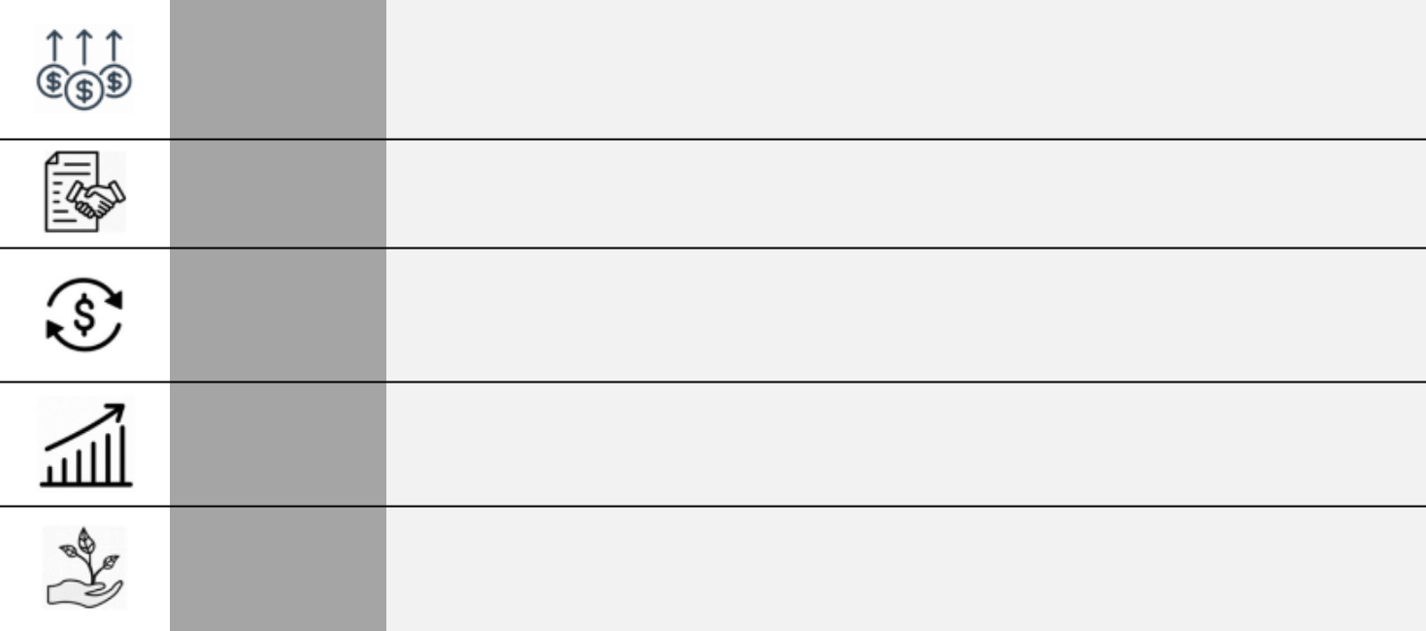

NAREIT FFO Per Share Growth

NAREIT FFO per diluted share* of $7.22 representing growth of 6.6% over 2024 driven by record levels of total revenue, positive impacts from capital investment, and overall continued strength in the broader retail real estate market

Strong Leasing Signed new and renewal comparable space leases covering more than 2.3 million square feet of

Activity space and approximately $88.9 million of year 1 revenue

Productive Investments in new acquisitions such as Del Monte Shopping Center, Town Center Plaza and

Capital Town Center Crossing, Annapolis Town Center and Village Pointe producing year over year Investments growth and positioning the company for continued growth

58th Year of Dividend Increases

Raised the dividend on our common shares for the 58th consecutive year, a record in the REIT industry, representing a compound annual growth rate of approximately 6.5% over that 58-year period

 | Achieved ≈ 35% decrease in Scope 1 and 2 GHG emissions through 2024 versus 2019 baseline
Sustainability | in alignment with our 2030 GHG reduction target set in accordance with the Science-Based Target
 | initiative

- NAREIT FFO per share is a non-GAAP financial measure that we consider significant in our business. See Appendix A for a reconciliation of NAREIT FFO per share to net income.

- PROGRAM PHILOSOPHY AND OBJECTIVES

Our executive compensation philosophy and practices reflect a commitment to paying for performance – both short-term and long-term. Our programs are designed to attract, retain, motivate and reward talented, experienced executives to successfully manage our business, execute our strategy and drive shareholder value. We have three key objectives within this philosophy:

- Establish a strong link between pay and performance

- Align the financial interest of our NEOs with our shareholders, particularly over the longer term
- Reinforce business strategies and objectives and drive sustained shareholder value

Federal Realty 2026 Proxy Statement 21

Table of Contents

- EXECUTIVE COMPENSATION PRACTICES

The following table summarizes key governance elements related to our compensation programs:

What We Do |  | What We Don’t Do
 | Maintain a pay mix that is heavily performance-based | Have employment agreements with our NEOs with
 | Maintain a pay mix that is heavily performance-based | required fixed compensation increases
 | Align compensation with company and individual | Grant options below fair market value or reprice options
 | performance | Grant options below fair market value or reprice options
 | Seek annual shareholder advisory approval of | Permit hedging or pledging of our shares
 | executive compensation | Permit hedging or pledging of our shares
 | Maintain strong share ownership guidelines of 7x base | Provide perquisites that are not made available to all of
 | salary for our CEO and 2.5x base salary plus annual | Provide perquisites that are not made available to all of
 | salary for our CEO and 2.5x base salary plus annual | our employees
 | bonus for our other NEOs
 | Maintain incentive compensation clawback policy
 | Conduct annual compensation risk assessment

- COMPONENTS OF COMPENSATION

The following table sets out the three components of our compensation plan as well as key information about each component.

 | Pay Component | Time | Metric | Purpose | Impact
Annual / | Base Pay | 1 year | Individual performance | To provide fair and competitive | Attract and retain talent
Short-Term |  |  |  | compensation for individual
 |  |  |  | performance and level of
 |  |  |  | responsibility of position held
 | Annual Performance | 1 year | NAREIT FFO per Share* | To provide performance based | Drive near-term corporate
 | Bonus |  | Individual performance | annual cash awards to motivate | and individual performance
 |  |  |  | and reward employees for | goals
 |  |  |  | achieving our short-term
 |  |  |  | business objectives
Long-Term | Equity Incentive | 3 years | Relative total shareholder | To provide performance-based | Drive medium and long-
 |  |  | return (34%) | equity compensation in the form | term performance goals
 |  |  | NAREIT FFO multiple | of restricted shares to drive | and retain talent
 |  |  | premium (33%) | medium and longer-term
 |  |  | Return on invested capital | business objectives
 |  |  | (33%)

Fixed

Variable / At risk


- NAREIT FFO per share is a non-GAAP financial measure that we consider significant in our business. See Appendix A for a reconciliation of NAREIT FFO per share to net income.

Federal Realty 2026 Proxy Statement 22

Table of Contents

- COMPENSATION SETTING PROCESS

- ANNUAL COMPENSATION DECISION MAKING

Our Compensation Committee develops and executes our executive compensation program on behalf of the Board, including creating compensation programs and policies, setting target compensation levels for our NEOs, setting performance metrics for incentive compensation plans, establishing expectations for individual NEO performance and determining payouts of incentive compensation for completed performance periods.

In setting NEO compensation, the Compensation Committee considers competitive market data for similar jobs and job levels in the market, Company performance measured against financial metrics and targets established by the Compensation Committee, general business climate and each individual’s experience, knowledge, skills and personal contributions.

- ROLE OF THE COMPENSATION COMMITTEE

The Compensation Committee approves all final compensation arrangements for our NEOs including final payouts under our incentive compensation programs. It also oversees an annual evaluation of our CEO’s performance by all of our independent Trustees.

- ROLE OF MANAGEMENT

Our CEO makes recommendations to the Compensation Committee regarding compensation for our NEOs (other than himself) taking into account Company performance, each executive’s personal contributions to the Company’s accomplishments and relevant market data.

- ROLE OF INDEPENDENT COMPENSATION CONSULTANT

The Compensation Committee retains consultants periodically to assist with setting compensation. For 2025 compensation, we did not use any compensation consultant; however, we did ask Semler Brossy Consulting Group (“SBCG”) to identify acceptable ways to calculate long-term incentive awards for a 3-year performance period when the third party measuring index used in the calculation is discontinued approximately 2.5 years into the 3-year performance period. See “Long-Term Incentive Program” below for a discussion of the discontinuation of the BBRESHOP.

- 2025 COMPENSATION DECISIONS

- SETTING 2025 TARGET COMPENSATION

The Compensation Committee determined target compensation for each NEO by considering numerous individual factors, including job responsibilities and skill sets, performance in their position, importance to achieving our corporate objectives, retention risk, ability to replace the role, previously issued equity awards and tenure with the company. The Compensation Committee then reviewed the annual NAREIT compensation survey that gathers data from more than 100 REITs for the market compensation information for our NEOs. Applying their individual judgments to our NEOs after consulting the NAREIT survey, the Compensation Committee established the following target compensation for our NEOs in 2025.

 |  |  | Target Annual Bonus |  |  | Target Long- |  |  | Total
 |  | Base Pay | % of Base |  | Amount | Term Incentive |  | 2025 Target
Mr. Wood | $ | 1,000,000 | 150% | $ | 1,500,000 | $ | 6,000,000 | $ | 8,500,000
Mr. Guglielmone | $ | 650,000 | 150% | $ | 975,000 | $ | 1,500,000 | $ | 3,125,000
Ms. Becker | $ | 575,000 | 100% | $ | 575,000 | $ | 1,000,000 | $ | 2,150,000

Federal Realty 2026 Proxy Statement 23

Table of Contents

The 2025 target compensation set for Mr. Wood and Ms. Becker was unchanged from 2024. The 2025 compensation for Mr. Guglielmone included a base pay increase and a change to his target bonus percentage. The target pay packages for all of our NEOs are heavily weighted to components that are paid based on both company and individual performance which creates significant alignment between our NEOs and shareholders.

CEO Pay | Base Pay |  | Annual Bonus |  |  |  | Long-Term
Mix | 12% |  | 18% |  |  | 70%
Mix |  |  |  |  | 88% Performance-Based At Risk
Average |  | Base Pay |  |  | Annual Bonus |  | Long-Term
Other NEOs |  | 23% |  |  | 29% |  | 48%
Pay Mix |  |  |  |  |  | 77% Performance-Based At Risk

- INDIVIDUAL ELEMENTS OF 2025 PAY

Base Pay

The base pay level established for each of our NEOs represents a modest portion of each individual’s total compensation package and the Compensation Committee believes them to be competitive and appropriate based on market data.

Annual Bonus Program

Our bonus plan is an annual cash incentive program designed to reward achievement for the current year based on achieving a level of NAREIT FFO per share that the Compensation Committee has determined is necessary for the Company to achieve its business objectives for the year. The Compensation Committee has determined that NAREIT FFO per share is the appropriate measure to use for our annual bonus program because it is a key annual metric used by investors, the Board and management to evaluate the Company’s annual performance and it reflects the full range of decision making and execution for the Company for the year. The Compensation Committee sets the required performance level for NAREIT FFO per share at the beginning of each year with levels reflecting performance that ranges from acceptable at the threshold level to exceptional at the stretch level based on budgets reviewed by the entire Board. Approximately 96% of our employees participate in this annual bonus plan.

 |  | Performance Levels
Performance Goal |  | Threshold | Target | Stretch |  | Actual
Payout as Percentage of Target |  | 75% | 100% | 125%
NAREIT FFO per diluted Share |  | $7.04 | $7.14 | $7.24 |  | $7.22
 |  |  |  | Final Payout | 120.0%

The required achievement levels of NAREIT FFO per share were consistent with the annual budget approved by the Board in February 2025.

Each NEO had a maximum potential bonus opportunity established as a percentage of base pay combined with the performance level achieved by the Company. Our NEOs are entitled to receive 25% of the final bonus amount solely based on Company performance. The remaining 75% is earned based on the Compensation Committee’s assessment of each individual’s performance and whether that NEO achieved the objectives set out by the Company within that NEO’s area of responsibility. Based on a review of each individual’s performance and the considerations outlined in detail below, the Compensation Committee elected to award each of our NEOs the full amount of the individual performance portion of his/her bonus potential.

Federal Realty 2026 Proxy Statement 24

Table of Contents

 |  |  |  |  |  |  | Potential |  |  |  | Actual Earned
 |  | Target |  | Target |  |  | Maximum |  |  | Company |  | Individual |  | Total
NEO |  | (% Base Pay) |  | ($) |  |  | Payout |  | Performance |  | Performance |  |  | Paid
Mr. Wood |  | 150% | $ | 1,500,000 |  | $ | 1,800,000 |  | $ | 450,000 | $ | 1,350,000 | $ | 1,800,000
Mr. Guglielmone |  | 150% | $ | 975,000 | $ |  | 1,170,000 | $ |  | 292,500 | $ | 877,500 | $ | 1,170,000
Ms. Becker |  | 100% | $ | 575,000 | $ |  | 690,000 | $ |  | 172,500 | $ | 517,500 | $ | 690,000

Our NEOs have the option to receive up to 25% of the final bonus payout in the form of shares that vest equally over three years with accelerated vesting on death, disability, change in control and termination without cause. In consideration of the extended payment period for this portion of the bonus already earned, the employee receives shares valued at 120% of the portion of the annual bonus he/she elects to receive in shares. This option is made available to all participants in our annual bonus plan at the level of Director and above. The cash portion of the 2025 annual bonus is reflected in the “Non-Equity Incentive Plan Compensation” column in the Summary Compensation Table in this proxy statement. The portion of the annual bonus paid in shares will be included in the “Stock Awards” column in the Summary Compensation Table and the Grants of Plan-Based Awards Table in next year’s proxy statement.

Long-Term Incentive Program

The largest portion of compensation for each of our NEOs comes from our equity based long-term incentive program that aligns the interests of our NEOs with shareholders by incentivizing our NEOs to identify and accomplish medium and longer-term business objectives that generate value through share price appreciation, dividend growth and prudent capital allocation decisions. Performance for purposes of our long-term incentive program is measured against the following preset metrics.

Plan Metric

- Relative Total Shareholder Return

- (34% weighting)

- NAREIT FFO Multiple Premium

- (33% weighting)

- Return on Invested Capital

- (33% weighting)


Description

Compares our total shareholder return, taking into account share price appreciation and assuming reinvestment of dividends, against the total return achieved by the Bloomberg REIT Shopping Center Index (“BBRESHOP”) which is comprised of publicly traded companies that own and operate open air shopping centers. The Compensation Committee believes that the BBRESHOP provides an appropriate basis to compare our performance against similarly situated companies.*
Compares the NAREIT FFO multiple at which the Company is trading at the end of the performance period against the average NAREIT FFO multiple at which all other public shopping center companies (other than the Company) are trading at that time. The NAREIT FFO multiples are provided by a third party investment bank and serve as measures of investor expectations of our long-term growth potential and confidence in our management team versus other publicly traded open air shopping center companies.
Reflects how effectively we have allocated our shareholders’ capital during the 3-year performance period and incentivizes sound, long-term investment decisions focused on generating strong future shareholder returns. The metric encompasses all aspects of capital allocation decisions. Required performance levels are established to reflect changing market expectations as we acquire, sell and develop assets.

- The BBRESHOP was discontinued on July 18, 2025. On the recommendation of SBCG, we retained an independent third party consultant to complete the calculation of the index performance for the last 5.5 months of the 3-year performance period ending December 31, 2025. The Compensation Committee is considering alternatives for the BBRESHOP going forward.

Federal Realty 2026 Proxy Statement 25

Table of Contents

The required performance levels for each of these metrics and the actual performance achieved for the 3-year performance period from 2023 through 2025 is set forth below.

 |  |  | Performance Targets |  |  |  | Payout Factor
Performance Goal | Weighting |  | Threshold | Target | Stretch |  | Unweighted | Weighted
Payout as Percentage of Target |  |  | 50% | 100% | 150%
Relative Total TSR | 34% |  | 5% < Index | Index | 5% > Index | 103.7% |  | 35.3%
NAREIT FFO Multiple Premium | 33% |  | 5% Premium | 15% Premium | 20% Premium | 60.0% |  | 19.8%
Return on Invested Capital | 33% | 6.75% |  | 7.00% | 7.25% | 150.0% |  | 49.5%
 |  |  |  |  |  |  | Final Payout | 104.6%

The Compensation Committee has the right to increase or decrease each NEO’s award under our long-term incentive program by up to 20% to reflect individual performance and chose not to exercise that discretion for any of our NEOs. See the discussions below for the factors considered by the Compensation Committee in determining the final long-term incentive awards payable to our NEOs for the 2023 through 2025 performance period.

The equity awards under our long-term incentive program are paid in the form of restricted shares that are issued after completion of the 3-year performance period and then vest equally over an additional period of 3 years from the date they are earned and issued. As a result, each NEO is required to hold all of their earned shares for 1 year after they have been earned, two-thirds of their earned shares for 2 years after they are earned and one-third of their earned shares for 3 years after they are earned.

Performance Period Award Earned Shares Vest

The actual number of shares awarded to each of our NEOs is determined by dividing the amount of the award by the closing price of our shares on the NYSE on the date the awards are made.

There is no amount included in the Summary Compensation Table or Grants of Plan-Based Awards Table in this proxy statement for long-term incentive awards earned for the 2023-2025 performance period. Those amounts will be included in next year’s proxy statement. The long-term incentive awards included in the Summary Compensation Table and the Grants of Plan-Based Awards Table for our NEOs in this proxy statement relate to awards made in February 2025 for the 3-year performance period ending December 31, 2024.

Federal Realty 2026 Proxy Statement 26

Table of Contents

- 2025 NEO PERFORMANCE SUMMARY

Listed below are the individual performance achievements for each of our NEOs that the Compensation Committee considered to be instrumental in its determination to award each of our NEO’s the full amount of compensation he or she was eligible to receive for 2025.
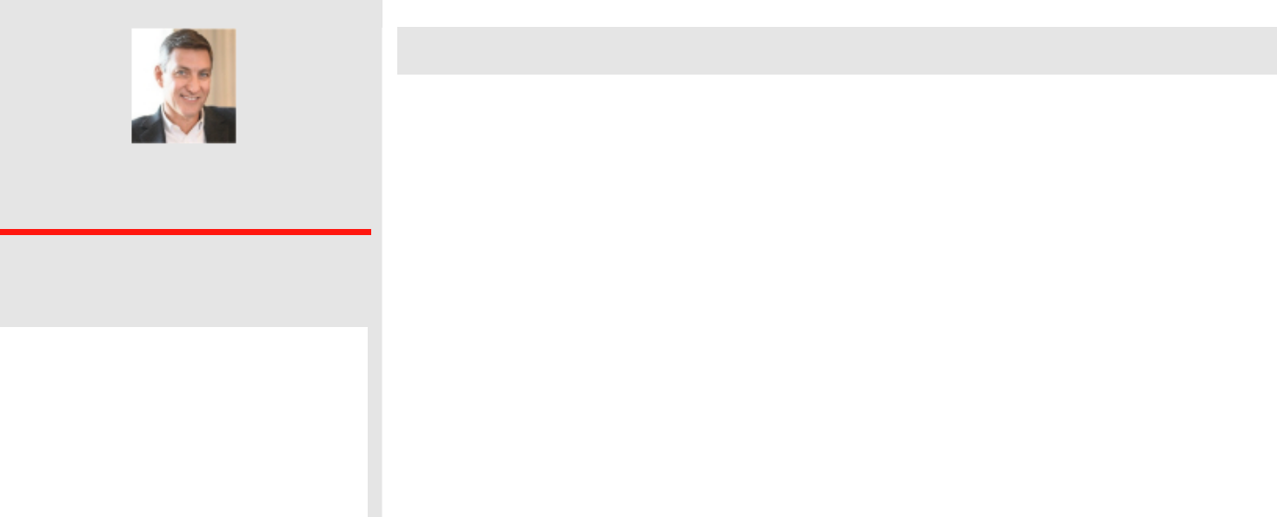

Donald C. Wood

Chief Executive Officer

2025 Compensation (in 000s)

 | Base Pay | $1,000
 | Annual Bonus |  | $1,800
 | Long-Term Equity |  | $6,274
 | Total |  | $9,074
 | Total as % of Target |  | 107%
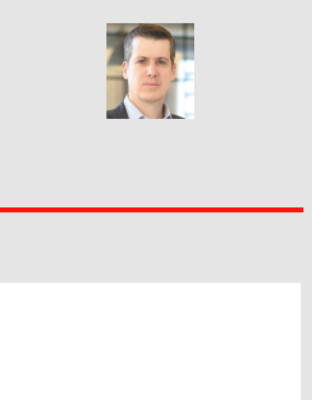

Key Responsibilities

Mr. Wood is responsible for setting and overseeing the Company’s strategic direction and priorities, delivering both short- and long-term financial results, setting the culture for the Company and setting direction for all aspects of corporate responsibility.

2025 Achievements

✓ Led the Company’s efforts that delivered record levels of NAREIT FFO per share, record top line revenue and near record levels of comparable space leasing

✓ Led increased focus on acquisitions that resulted in more than $750 million invested in newly acquired assets with strong growth potential, a company record

✓ Led continued focus on sustainability initiatives relating to decarbonization and resilience ✓ Led decisions on reinvestment in our assets to position them for continued growth

✓ Led efforts that resulted in a near fully-leased mixed-use office portfolio as of year-end

Daniel Guglielmone

Executive Vice President
Chief Financial Officer

2025 Compensation (in 000s)

 | Base Pay |  | $ 650
 | Annual Bonus |  | $1,170
 | Long-Term Equity |  | $1,568
 | Total |  | $3,388
 | Total as % of Target |  | 108%

Key Responsibilities

Mr. Guglielmone has overall responsibility for all Company related financial activity including forecasting, reporting and capital allocation, in addition to management of investor relations activities and East Coast property transactions.

2025 Achievements

✓ Co-led the Company’s capital recycling efforts that resulted in the acquisition of five assets for more than $750 million totaling more than 2.1 million square feet and the disposition of two non-core retail assets and two peripheral residential buildings generating proceeds of nearly $315 million, positioning the Company for better long-term growth

✓ Improved the Company’s borrowing flexibility with an increase in capacity of one term loan and a new term loan facility

✓ Led financial efforts enabling the Company to increase our annual dividend rate to common shareholders for the 58th consecutive year

Federal Realty 2026 Proxy Statement 27

Table of Contents


Dawn M. Becker

Executive Vice President
Chief Legal Officer

2025 Compensation (in 000s)

 | Base Pay |  | $ 575
 | Annual Bonus |  | $ 690
 | Long-Term Equity |  | $1,046
 | Total |  | $2,311
 | Total as % of Target |  | 107%

Key Responsibilities

Ms. Becker has overall responsibility for all legal functions within the Company and heads all of our sustainability efforts in addition to overseeing our Human Resources, Information Technology and other administrative functions.

2025 Achievements

✓ Led the Company’s sustainability efforts

✓ Led the Company’s progress to date on reducing Scope 1 and 2 GHG emissions, on pace to achieve our established science-based emission reduction target

✓ Guided the Company’s legal efforts that contributed to strong leasing volumes and a record year of acquisition and disposition activity

✓ Oversaw efforts that resulted in continued strong employee engagement results and improved succession planning in the Company

✓ Led continued technology system improvements and reporting to drive Company-wide efficiency and data availability, advance efforts around use of artificial intelligence and improve cyber security readiness

- OTHER COMPENSATION PRACTICES AND POLICIES

- CONSIDERATION OF SAY ON PAY VOTE

The Company conducts an annual “say on pay” vote to approve executive compensation. At the 2025 annual meeting of shareholders, more than 92% of the shares voted were in support of the compensation paid to our NEOs. Although the vote is advisory and non-binding on the Board, the Compensation Committee regularly considers the results of this vote in evaluating the Company’s compensation programs, including for 2025 compensation. In light of the feedback from our shareholders and the Compensation Committee’s evaluation, the Compensation Committee concluded that the Company provides executive competitive programs that effectively attract, motivate, reward and retain executives in a manner aligned with our shareholder interests and made no material changes to our executive compensation programs for 2026.

- NO HEDGING OR PLEDGING OF OUR SHARES

The Company prohibits all officers and Trustees from engaging in short sales of our securities, establishing margin accounts, pledging our securities as collateral for a loan, buying or selling puts or calls on our securities or otherwise engaging in hedging transactions (such as zero-cost dollars, exchange funds, and forward sale contracts) involving our securities.

- SEVERANCE AND CHANGE-IN-CONTROL ARRANGEMENTS

We do not have employment agreements in place with any of our NEOs or any other employee which provides the Compensation Committee with maximum flexibility to modify compensation as warranted based on market conditions and Company considerations. We do, however, have in place with each of our NEOs a severance

Federal Realty 2026 Proxy Statement 28

Table of Contents

agreement that provides for certain payments and benefits to be provided to the NEO if he/she is terminated from employment under the conditions set forth in those agreements. The circumstances in which payments may be made and the potential amounts of those payments are described in more detail in the “Potential Payments on Termination of Employment and Change-in-Control” section below. We believe that the payments provided for in these agreements are consistent with market and important as part of the total compensation packages available for our NEOs.

- CLAWBACK POLICY

We have a clawback policy that provides for the return from an NEO of performance based compensation if we issue a restatement of financial results to correct material non-compliance with reporting requirements and the performance compensation paid to that NEO is more than it would have been based on the restated financial results. This clawback policy complies with the most current NYSE requirements.

- SHARE OWNERSHIP GUIDELINES

We maintain guidelines requiring each of our NEOs as well as other executive vice presidents to maintain a specific level of ownership of our shares as shown below. These guidelines are intended to link the interests of our NEOs and other executive vice presidents with the interests of our shareholders. Each individual subject to these guidelines has five years to achieve the required level of ownership after becoming subject to the guidelines.

Compliance with our ownership guidelines gets measured and reviewed by the Board at the end of each fiscal year and the ownership level of each of our NEOs as of December 31, 2025 is shown below based on the closing price of our shares on December 31, 2025.

Our current NEOs were in compliance with our equity ownership requirements as of December 31, 2025.
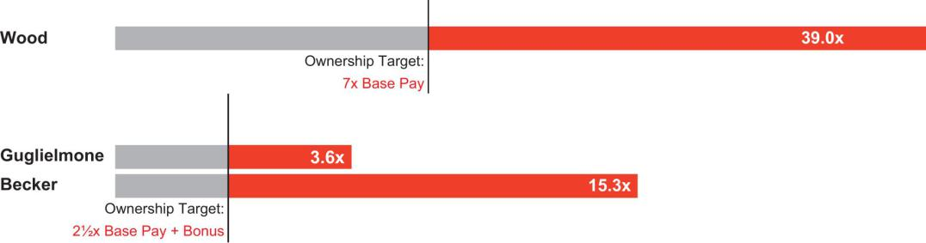

- RISK ASSESSMENT OF COMPENSATION PROGRAMS

The Compensation Committee completed its last annual review of our compensation programs and policies from a risk perspective in February 2026. The Compensation Committee does not believe that our programs encourage unnecessary or excessive risk or are likely to have a material adverse effect on the Company. Our compensation programs use both short- and long-term incentives with different metrics driven by corporate performance, and have differing performance requirements. Further, we have in place policies to mitigate risk including robust share ownership requirements and vesting periods on equity awards made as part of our compensation programs.

Federal Realty 2026 Proxy Statement 29

Table of Contents

- EQUITY GRANT PRACTICES

We do not grant equity awards in anticipation of the release of material non-public information and we do not time the release of material non-public information based on equity award grant dates or for the purpose of affecting the value of executive compensation. In addition, we do not take material non-public information into account when determining the timing and terms of such awards. Although we do not have a formal policy with respect to the timing of our equity award grants, the Compensation Committee has historically granted such awards on a predetermined annual schedule. In 2025, we did not grant new awards of stock options, stock appreciation rights, or similar option-like instruments to our NEOs. All of our options have an exercise price equal to the closing price of our shares on the date of grant and our 2020 Performance Incentive Plan (“2020 Plan”) expressly prohibits any repricing of options. The Compensation Committee has delegated to our CEO, in his capacity as a Trustee, authority to make equity awards to non-executive officers, subject to various limitations set forth in the delegation.

- INSIDER TRADING POLICY

We have adopted an insider trading policy the governs the purchase, sale and/or other dispositions of our securities by our trustees and all employees, including our NEOs and other corporate officers, that is reasonably designed to promote compliance with insider trading laws, rules and regulations as well as New York Stock Exchange listing standards.

- TAX DEDUCTIBILITY OF EXECUTIVE COMPENSATION

Section 162(m) of the Internal Revenue Code generally limits deductibility of compensation paid to our NEOs to $1 million. Although the Compensation Committee considers the impact of Section 162(m) in structuring compensation programs, the primary focus is on creating programs and compensation packages that address the needs and objectives of the Company regardless of the impact of Section 162(m). As a result, the Compensation Committee has made and may continue to make awards and to structure programs that are non-deductible under Section 162(m).

- HEALTH AND WELFARE BENEFITS

We provide health and welfare perquisites to our NEOs on the same basis as we provide those benefits to all employees. These benefits are competitive with those offered by companies with whom we compete for talent and provide another tool that allows us to attract and retain talented executives. Since 2005, we have agreed to provide to Mr. Wood, his spouse and one of his children continuation of health coverage after Mr. Wood’s termination upon death, disability, retirement, change in control or otherwise (other than a termination with cause or resignation). This coverage will continue as to Mr. Wood and his spouse until their death, or with respect to his spouse until divorce, if earlier, and coverage continues for one of Mr. Wood’s children until death. We are required to provide coverage of at least the same level as provided to Mr. Wood and his family at the time of his termination and such coverage will be secondary to certain other coverages that may be available to Mr. Wood and his family.

Federal Realty 2026 Proxy Statement 30

Table of Contents

- COMPENSATION COMMITTEE REPORT

The Compensation Committee of the Board has reviewed and discussed the CD&A required by Item 402(b) of Regulation S-K with management and, based on such review and discussion, the Compensation Committee recommended to the Board that the CD&A be included in this Proxy Statement. Mr. Fisher did not participate in such recommendation because he was not a member of the Board or the Compensation Committee in 2025.

Submitted by:

Elizabeth I. Holland, Chairperson

Joseph D. Fisher (joined the Compensation Committee on January 1, 2026)
Nicole Y. Lamb-Hale
Thomas A. McEachin

Gail P. Steinel

Federal Realty 2026 Proxy Statement 31

Table of Contents

Compensation Tables and Narratives

➣ SUMMARY COMPENSATION TABLE

The table below summarizes the total compensation earned by or paid to the individuals who were NEOs for the fiscal years ended December 31, 2025, 2024 and 2023. All amounts are calculated in accordance with current SEC rules.

 |  |  |  |  |  |  |  |  |  |  | Non-Equity |  | All Other
 |  |  |  |  |  |  |  |  |  |  | Incentive |  | All Other
Name and Principal Position |  | Year |  | Salary⁽¹⁾ |  | Bonus⁽²⁾ | Stock Awards⁽³⁾ |  |  | Plan Compensation⁽⁴⁾ |  | Compensation⁽⁵⁾ |  |  | Total
Donald C. Wood (PEO) |  | 2025 | $ | 1,000,000 | $ | - | $ |  | 7,554,434 | $ | 1,350,000 | $ | 24,712 | $ | 9,929,147
Chief Executive Officer and |  | 2024 | $ | 1,000,000 | $ | - | $ |  | 6,946,529 | $ | 1,265,625 | $ | 28,376 | $ | 9,240,530
President |  | 2023 | $ | 1,000,000 | $ | - | $ |  | 6,502,565 | $ | 1,406,250 | $ | 33,005 | $ | 8,941,820
Daniel Guglielmone (PFO) |  | 2025 | $ | 650,000 | $ | - | $ |  | 1,762,056 | $ | 877,500 | $ | 13,118 | $ | 3,302,674
Executive Vice President- |  | 2024 | $ | 575,000 | $ | - | $ |  | 1,063,974 | $ | 646,875 | $ | 13,340 | $ | 2,299,188
Chief Financial Officer & Treasurer |  | 2023 | $ | 575,000 | $ | 150,000 | $ |  | 989,990 | $ | 718,750 | $ | 12,389 | $ | 2,446,128
Dawn M. Becker |  | 2025 | $ | 575,000 | $ | - | $ |  | 1,368,720 | $ | 517,500 | $ | 14,391 | $ | 2,475,611
Executive Vice President- |  | 2024 | $ | 575,000 | $ | - | $ |  | 1,279,594 | $ | 485,156 | $ | 18,868 | $ | 2,358,619
Chief Legal Officer & Secretary |  | 2023 | $ | 575,000 | $ | - | $ |  | 1,205,597 | $ | 539,063 | $ | 17,644 | $ | 2,337,304
- Amounts shown in the Salary column include all amounts deferred at the election of the NEOs into our non-qualified deferred compensation plan.
- Amounts represent a one-time cash bonus.
- Amounts shown in this column reflect the aggregate grant date fair value of the awards calculated in accordance with FASB ASC Topic 718 that were issued in the year shown.
- Amounts shown in this column represent the cash amount paid under our annual bonus plan and include amounts deferred by our NEOs into our non-qualified deferred compensation plan.
- The amounts shown in this column for the most recent fiscal year include: (a) Company contributions to our 401(k) plan of $8,750 for each of our NEOs; and (b) payments for various life, long-term disability and other medical related insurance of $15,962 for Mr. Wood, $4,368 for Mr. Guglielmone, and $5,641 for Ms. Becker.

- GRANTS OF PLAN BASED AWARDS TABLE

The following equity awards were made in 2025 to our NEOs.

 |  | All Other Stock Awards: | Grant Date
 | Grant | Number of Shares of |  | Fair
Name | Date | Stock or Units⁽³⁾ |  | Value⁽⁴⁾
Donald C. Wood | 2/12/2025 ⁽¹⁾ | 4,579 | $ | 506,208
 | 2/12/2025 ⁽²⁾ | 63,756 | $ | 7,048,226
Daniel Guglielmone | 2/12/2025 ⁽²⁾ | 15,939 | $ | 1,762,056
Dawn M. Becker | 2/12/2025 ⁽¹⁾ | 1,755 | $ | 194,015
 | 2/12/2025 ⁽²⁾ | 10,626 | $ | 1,174,704

- Issued under our annual bonus plan for the 1-year performance period ending December 31, 2024. These shares vest equally over 3 years.
- Issued under our long-term incentive award program for the 3-year performance period ending December 31, 2024. These shares vest equally over 3 years.
- Dividends are paid on these shares issued at the same rate and time as paid to all other holders of our shares as declared by our Board from time to time.
- Represents the grant date fair value of share awards as computed in accordance with FASB ASC Topic 718.

Federal Realty 2026 Proxy Statement 32

Table of Contents

➣ OUTSTANDING EQUITY AWARDS AT FISCAL YEAR END TABLE

The following table sets forth information about outstanding equity awards held by our NEOs as of December 31, 2025:

 |  | Share Awards
 |  | Number of Shares or | Market Value of Shares or
 |  | Units of Shares That |  | Units of Shares That
Name |  | Have Not Vested |  | Have Not Vested⁽⁵⁾
Donald C. Wood |  | 4,579 ⁽¹⁾ | $ | 461,563
 |  | 63,756 ⁽¹⁾ | $ | 6,426,605
 |  | 3,689 ⁽²⁾ | $ | 371,851
 |  | 41,865 ⁽²⁾ | $ | 4,219,992
 |  | 1,704 ⁽³⁾ | $ | 171,763
 |  | 17,990 ⁽³⁾ | $ | 1,813,392
Daniel Guglielmone |  | 15,939 ⁽¹⁾ | $ | 1,606,651
 |  | 6,977 ⁽²⁾ | $ | 703,282
 |  | 2,998 ⁽³⁾ | $ | 302,198
 |  | 1,714 ⁽⁴⁾ | $ | 172,771
Dawn M. Becker |  | 1,755 ⁽¹⁾ | $ | 176,904
 |  | 10,626 ⁽¹⁾ | $ | 1,071,101
 |  | 1,414 ⁽²⁾ | $ | 142,531
 |  | 6,977 ⁽²⁾ | $ | 703,282
 |  | 653 ⁽³⁾ | $ | 65,822
 |  | 2,998 ⁽³⁾ | $ | 302,198
- One-third of these shares vested on February 12, 2026 and the remaining shares will vest equally on February 12 of each of 2027 and 2028.
- One-half of these shares vested on February 12, 2026 and the remaining shares will vest on February 12, 2027.
- These shares vested on February 12, 2026.
- These shares will vest on August 3, 2026.
- The value of shares is calculated based on $100.80, the closing price of our shares on the NYSE on December 31, 2025.

➣ OPTIONS EXERCISED AND STOCK VESTED IN 2025

The following table includes information with respect to shares held by our NEOs that vested in 2025. None of our NEOs holds any options or exercised any options during 2025.

 | Stock Awards
 | Number of Shares | Value Realized
Name | Acquired on Vesting |  | on Vesting⁽¹⁾
Donald C. Wood | 59,532 | $ | 6,581,263
Daniel Guglielmone | 10,550 | $ | 1,132,125
Dawn M. Becker | 9,765 | $ | 1,079,521

- The amounts in this column were calculated using the closing price of a share on the date the shares vested.

Federal Realty 2026 Proxy Statement 33

Table of Contents

➣ NON-QUALIFIED DEFERRED COMPENSATION

We maintain a non-qualified deferred compensation plan that is open to participation by 43 members of our management team, including our NEOs. Each participant can elect to defer up to 100% of his or her base salary and cash payment under our annual bonus plan with deferral elections made in December of each year for amounts to be earned in the following year. A number of widely available investment options are made available to each plan participant who then decides how to allocate amounts deferred among those investment options. The amount earned by plan participants on their deferrals is calculated by our third party plan administrator as if the amounts deferred had actually been invested in the investment options selected by each participant. We do not make any contributions to the deferred compensation plan for any individual nor do we guarantee any rate of return on amounts deferred. Amounts deferred into the plan, including amounts earned on the deferrals, are generally payable to the participant shortly after he or she retires or is otherwise no longer employed by us; however, there are a few other alternatives where amounts may be paid to a participant sooner. Both Mr. Wood and Ms. Becker participate in our deferred compensation plan. 2025 activity for the participants in our plan is described below.

 |  | Executive |  | Registrant |  | Aggregate |  | Aggregate |  | Aggregate
 |  | Contributions in | Contributions in Last |  |  | Earnings in | Withdrawals/ |  | Balance at Last
Name | Last Fiscal Year⁽¹⁾ |  |  | Fiscal Year | Last Fiscal Year |  | Distributions |  | Fiscal Year-End
Donald C. Wood | $ | 250,000 | $ | - | $ | 2,397,039 | $ | - | $ | 15,473,689
Dawn M. Becker | $ | 57,500 | $ | - | $ | 478,073 | $ | - | $ | 3,309,104

- All amounts in this column are included in either the “Salary” or “Non-Equity Incentive Plan Compensation” column of the Summary Compensation Table for 2025.

➣ POTENTIAL PAYMENTS ON TERMINATION OF EMPLOYMENT AND CHANGE-IN-CONTROL

We have entered into severance agreements with each of our NEOs that require us to make certain payments and provide certain benefits to them in the event of a termination of employment, whether following a change in control of the Company or in connection with other circumstances. Regardless of the reason for an NEO’s termination of employment, he or she will be entitled to receive upon termination a distribution of any amounts in our non-qualified deferred compensation plan as described in the “Non-Qualified Deferred Compensation” section above. No NEO is entitled to receive a new award under the annual bonus plan or our long-term incentive plan for the year in which the termination occurs. The agreements with each of our NEOs contain provisions restricting the executive from engaging in competing behavior and soliciting and/or hiring our employees for a period of time after termination. The payments that will be made to an NEO on termination vary depending on the reason for termination and may be conditioned on the signing of a release in favor of the Company.

Federal Realty 2026 Proxy Statement 34

Table of Contents

The amount of compensation payable to each of our NEOs under various termination scenarios is reflected below assuming that the separation of service was effective on December 31, 2025.

 |  |  |  |  |  |  | Change-in-
 |  |  | For Cause |  | Termination |  | Control | Termination |  | Termination on
Name | Type of Compensation | Termination⁽¹⁾ |  | Without Cause⁽¹⁾ |  | Termination⁽¹⁾⁽⁵⁾ |  | on Death⁽¹⁾ |  |  | Disability⁽¹⁾
Donald C. Wood | Cash Benefits (multiple) |  | 6 months |  | 1.5x |  | 3.0x |  | N/A |  | N/A
 | Cash Benefits (amount) | $ | 500,000 | $ | 4,312,500 | $ | 8,625,000 | $ | - | $ | 1,350,633
 | Medical Benefits⁽²⁾ | $ | 20,403 | $ | 1,764,605 | $ | 1,856,418 | $ | 1,485,000 | $ | 1,722,806
 | Accelerated Equity⁽³⁾ | $ | - | $ | 13,465,166 | $ | 13,465,166 | $ | 13,465,166 | $ | 13,465,166
 | Other Benefits⁽⁴⁾ | $ | - | $ | 60,000 | $ | 166,665 | $ | - | $ | -
 | Excise Tax Gross-Up |  | N/A |  | N/A | $ | - |  | N/A |  | N/A
Total |  | $ | 520,403 | $ | 19,602,271 | $ | 24,113,250 | $ | 14,950,166 | $ | 16,538,606
Daniel Guglielmone | Cash Benefits (multiple) |  | 4 months |  | 1.0x |  | 2.0x |  | N/A |  | N/A
 | Cash Benefits (amount) | $ | 216,667 | $ | 1,368,750 | $ | 2,737,500 | $ | - | $ | 778,812
 | Medical Benefits⁽²⁾ | $ | 16,222 | $ | 48,666 | $ | 97,332 | $ | - | $ | 48,666
 | Accelerated Equity⁽³⁾ | $ | - | $ | 2,784,902 | $ | 2,784,902 | $ | 2,784,902 | $ | 2,784,902
 | Other Benefits⁽⁴⁾ | $ | - | $ | 60,000 | $ | 90,000 | $ | - | $ | -
 | Excise Tax Gross-Up |  | N/A |  | N/A |  | N/A |  | N/A |  | N/A
Total |  | $ | 232,889 | $ | 4,262,319 | $ | 5,709,735 | $ | 2,784,902 | $ | 3,612,380
Dawn M. Becker | Cash Benefits (multiple) |  | 6 months |  | 1.0x |  | 2.0x |  | N/A |  | N/A
 | Cash Benefits (amount) | $ | 287,500 | $ | 1,293,750 | $ | 2,587,500 | $ | - | $ | 606,085
 | Medical Benefits⁽²⁾ | $ | 8,970 | $ | 13,454 | $ | 35,878 | $ | - | $ | 17,939
 | Accelerated Equity⁽³⁾ | $ | - | $ | 2,461,838 | $ | 2,461,838 | $ | 2,461,838 | $ | 2,461,838
 | Other Benefits⁽⁴⁾ | $ | - | $ | 60,000 | $ | 90,000 | $ | - | $ | -
 | Excise Tax Gross-Up |  | N/A |  | N/A | $ | - |  | N/A |  | N/A
Total |  | $ | 296,470 | $ | 3,829,043 | $ | 5,175,216 | $ | 2,461,838 | $ | 3,085,863

- For all NEOs, the cash payments for termination without cause and termination following a change-in-control include base salary plus the highest bonus earned during 2024, 2023 and 2022, the last three completed fiscal years. The cash payments on termination with cause for Mr. Wood, Mr. Guglielmone and Ms. Becker are 1 month of base pay for every year of service above 5 years, capped at 6 months of base pay. The cash payments on disability for Mr. Wood, Mr. Guglielmone and Ms. Becker represent 1 year of base salary less amounts received from disability insurance maintained by the Company, grossed up for taxes on non-tax exempt payments.

- Amounts in this row represent our estimate of the COBRA equivalent rates for health care benefits and current life and long-term disability premiums for all NEOs. The period of time for which these benefits are provided varies as follows: (a) termination without cause – 9 months for Mr. Wood and Ms. Becker and 12 months for Mr. Guglielmone; (b) termination following a change-in-control – 3 years for Mr. Wood and 2 years for Ms. Becker and Mr. Guglielmone; (c) termination for cause – 1 month for every year of service above 5 years, capped at 6 months for all NEOs; and
  - disability – 1 year for all NEOs. All amounts shown in this row for Mr. Wood also include the estimated costs (calculated in accordance with GAAP) of satisfying the obligations under his Health Continuation Coverage Agreement.
- All unvested restricted shares held by our NEOs will vest in the event of termination without cause, termination following a change-in-control, death or disability. Values were calculated by multiplying the number of unvested shares that vest under each termination event using the closing price of the Company’s shares on December 31, 2025.
- Amounts in this row are estimated costs for an administrative assistant and outplacement assistance for a period of 6 months in the event of a termination without cause for all NEOs and for a period of 12 months for Mr. Wood and 9 months for Mr. Guglielmone and Ms. Becker in the event of a termination following a change-in-control. The amount also includes the cost of providing a company vehicle to Mr. Wood for three years in the event of a termination following a change-in-control should he choose to use that benefit.

Federal Realty 2026 Proxy Statement 35

Table of Contents

- Change-in-control is deemed to have occurred when a person acquires a 20% interest in us, or our current Trustees, or those subsequently approved by our current Trustees, constitute less than 50% of our Board. Upon a change-in-control, each NEO is entitled to receive payments and benefits in the following circumstance: (a) the NEO is terminated from employment by the Company (other than for cause) or leaves for good reason within 2 years after the change-in-control; or (b) Mr. Wood or Ms. Becker voluntarily leaves employment within the 30-day window following the 1-year anniversary of the change-in-control.

➣ CEO PAY RATIO

Our compensation and benefit programs are substantially similar throughout the Company and are designed to reward all employees who contribute to our success with a total compensation package that is competitive in the marketplace for each employee’s position and performance. We are required to calculate and disclose the compensation of our median paid employee as well as the ratio of the total annual compensation paid to our CEO to the annual compensation of our median paid employee. The determination of our median paid employee was used taking our total employee population as of December 31, 2025, excluding our CEO, which included full-time and part-time employees ranging from executive vice presidents to maintenance technicians. For the determination, we used annual base pay plus annual bonus at target levels plus overtime actually paid, the combination of which we believe most closely approximates the total annual direct compensation of our employees. For purposes of the calculation, base pay was annualized for the 43 employees who started with us in 2025. No other adjustments were made.

The actual total annual compensation of our Chief Executive Officer and median paid employee for 2025 was calculated in accordance with the requirements of the Summary Compensation Table included in this proxy statement. Based on this methodology, we have determined that the total annual compensation paid to our Chief Executive Officer in 2025 was $9,929,147 and the total annual compensation paid to our median paid employee in 2025 was $130,520 resulting in a ratio of 76:1.

We calculated our pay ratio in accordance with SEC rules; however, those rules allow companies discretion in methodologies used to identify the median paid employee and the compensation used to determine the median paid employee. As a result, this ratio is unique to our Company. Other companies may make their determinations differently so that the ratio may not be comparable across companies. We believe our ratio is a reasonable estimate. Our ratio is very heavily influenced by what employees/services we choose to provide through employees as opposed to through third parties who are not taken into account in the calculation of the pay ratio.

Federal Realty 2026 Proxy Statement 36

Table of Contents

➣ PAY VERSUS PERFORMANCE DISCLOSURE

 |  |  |  |  |  | Value of Initial Fixed $100
 |  |  |  | Average |  | Investment Based On:
 | Summary |  |  | Summary | Average |  | Peer Group |  | NAREIT
 | Compensation | Compensation |  | Compensation | Compensation | Total | Total | Net | FFO per
 | Table Total for | Actually Paid to |  | Table Total for | Actually Paid to | Shareholder | Shareholder | Income | Diluted
Year | PEO⁽¹⁾ |  | PEO⁽¹⁾ | non-PEO NEOs⁽²⁾ | non-PEO NEOs⁽²⁾ | Return⁽³⁾ | Return⁽³⁾ | (in 000s) | Share⁽⁴⁾
2025 | $9,929,147 | $ | 8,370,328 | $2,889,143 | $2,588,140 | $134.06 | $154.56 | $423,648 | $7.22
2024 | $9,240,530 | $ | 11,336,876 | $2,328,903 | $2,705,899 | $153.40 | $171.23 | $304,334 | $6.77
2023 | $8,941,820 | $ | 9,972,582 | $2,416,716 | $2,590,452 | $136.87 | $155.04 | $247,217 | $6.55
2022 | $8,916,031 | $ | 6,570,796 | $2,026,318 | $1,623,013 | $128.32 | $141.90 | $395,661 | $6.32
2021 | $7,520,917 | $ | 15,446,709 | $2,266,502 | $3,606,101 | $165.92 | $163.52 | $269,081 | $5.57

- Mr. Wood was our principal executive officer for all years shown. Following are the adjustments made during each year shown to arrive at compensation actually paid to our principal executive officer during each year.

 |  |  |  |  |  |  | PEO
Adjustments |  |  | 2025 |  | 2024 |  | 2023 |  | 2022 |  | 2021
Amounts reported under “Stock Awards” in SCT | $ |  | (7,554,434) | $ | (6,946,529) | $ | (6,502,565) | $ | (6,474,391) | $ | (5,213,719)
Change Fair Value of Awards Granted in Year and Unvested as
of Year-End | $ |  | 6,888,168 | $ | 7,649,655 | $ | 6,203,610 | $ | 5,171,732 | $ | 7,421,261
Change in Fair Value from Prior Year-End to Current Year-End of
Awards Granted Prior to Year that w ere Outstanding and
Unvested as of Year-End | $ |  | (1,391,297) | $ | 991,042 | $ | 406,886 | $ | (1,546,034) | $ | 4,544,000
Change in Fair Value from Prior Year-End to Vesting Date of
Awards Granted Prior to Year that Vested During Year | $ |  | (83,345) | $ | (128,475) | $ | 449,965 | $ | 66,969 | $ | 765,243
Increase based on Dividends or Other Earnings Paid During Year
prior to Vesting Date of Award | $ |  | 582,089 | $ | 530,653 | $ | 472,866 | $ | 436,488 | $ | 409,008
Total Adjustments | $ |  | (1,558,819) | $ | 2,096,346 | $ | 1,030,762 | $ | (2,345,236) | $ | (7,925,792)

- Following are the adjustments made during each year shown to arrive at the average compensation actually paid to our other NEOs during each year.

Federal Realty 2026 Proxy Statement 37

Table of Contents

 |  |  | Average of Other NEOs
Adjustments | 2025 | 2024 | 2023 | 2022 | 2021

- Amounts reported under “Stock Awards” in SCT

- Change Fair Value of Awards Granted in Year and Unvested as of Year-End

- Change in Fair Value from Prior Year-End to Current Year-End of Awards Granted Prior to Year that were Outstanding and Unvested as of Year-End

- Change in Fair Value from Prior Year-End to Vesting Date of Awards Granted Prior to Year that Vested During Year

- Increase based on Dividends or Other Earnings Paid During Year prior to Vesting Date of Award

$ |  | (1,565,388) | $ | (1,171,784) | $ | (1,097,793) | $ | (809,283) | $ | (1,290,104)
$ |  | 1,427,328 | $ | 1,290,392 | $ | 1,047,323 | $ | 646,454 | $ | 1,708,703
$ |  | (245,556) | $ | 174,088 | $ | 73,187 | $ | (319,754) | $ | 726,323
$ |  | (30,162) | $ | (11,124) | $ | 65,154 | $ | (2,952) | $ | 124,066
$ |  | 112,776 | $ | 95,424 | $ | 85,866 | $ | 82,230 | $ | 70,610

Total Adjustments | $ | (301,003) | $ 376,996 | $ 173,736 | $ (403,305) | $ 1,339,599

- Peer group is the BBRESHOP Index which included an independent third party calculated return for the last 5.5 months of 2025. The total shareholder return shown for both the company and the peer group is calculated on a cumulative basis from January 1, 2021 through the last day of the applicable year shown. The compensation, net income and NAREIT FFO per diluted share shown for the applicable calendar year are calculated over different periods of time. As a result, the total returns shown for any given year are unlikely to correlate to the compensation, net income and NAREIT FFO per diluted share shown for that calendar year.

- The Company has identified NAREIT FFO per diluted share as the most important additional financial metric used to link pay and performance. Our annual bonus program pays out based on our absolute level of NAREIT FFO per diluted share achieved for the year and one-third of our long-term incentive plan pays out based on a metric tied to NAREIT FFO per diluted share. NAREIT FFO per diluted share is a non-GAAP financial measure of a real estate company’s operating performance and is defined by the National Association of Real Estate Investment Trusts. We consider NAREIT FFO per diluted share a meaningful measure of operating performance primarily because it avoids the assumption that the value of real estate assets diminishes predictably over time and is a primary way of evaluating our operating performance as compared to other real estate investment trusts. A reconciliation of NAREIT FFO per diluted share to net income is included as Appendix A.

Relationship to Compensation Actually Paid

The following charts show the relationship of the compensation actually paid to our CEO and the average compensation actually paid to our other NEOs as compared to the total shareholder return for the Company and for the BBRESHOP Index.
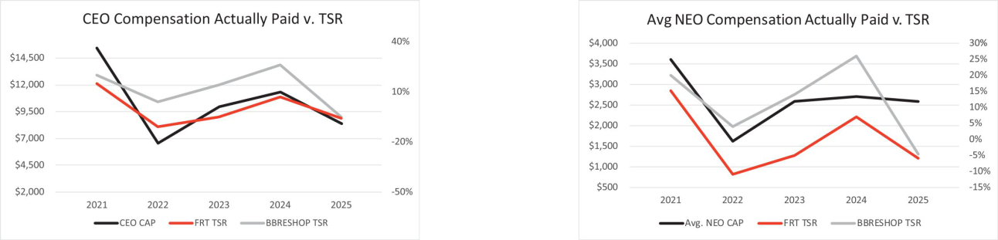

- Compensation actually paid is shown in thousands.

Federal Realty 2026 Proxy Statement 38

Table of Contents

The following charts show the relationship of the compensation actually paid to our CEO and the average compensation actually paid to our other NEOs as compared to our GAAP reported net income and our NAREIT FFO per diluted share.
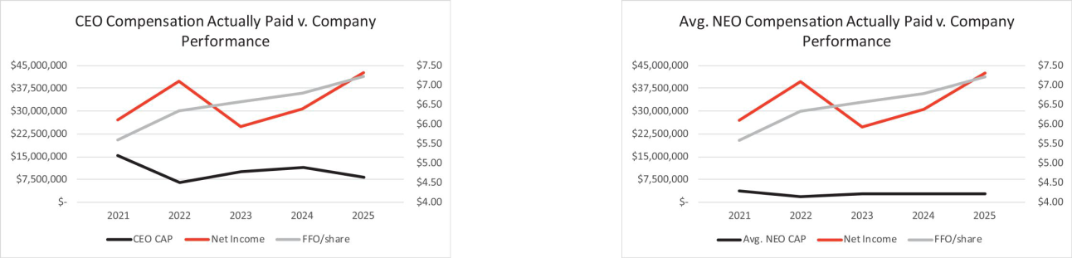

- Net income is shown in ten thousands.

One of our primary compensation objectives is to align the financial interests of our NEOs with our shareholders. The high correlation shown above between the compensation actually paid to our CEO and other NEOs and the total shareholder return for us and the BBRESHOP Index reflects our success in achieving that objective. This is a direct result of the high percentage of our NEOs’ compensation that is paid in the form of Company shares and our equity retention policies which directly align the interests of our NEOs with the interests of our shareholders. There is a less direct correlation between the compensation of our NEOs and our net income because no portion of our compensation program is linked directly to net income. There is also little correlation between the compensation of our NEOs and NAREIT FFO per diluted share because NAREIT FFO per diluted share metric is directly used only for our annual bonus plan which is a relatively modest portion of our NEOs’ total compensation package and is only a component of the calculation that determines only a third of our NEOs’ awards under our long-term incentive plan.

Other Important Financial Performance Measures for Executive Compensation

Following is a list of the most important financial and non-financial measures used to link executive compensation and company performance.

- Return on invested capital

- Relative total shareholder return compared to the BBRESHOP Index

- Relative NAREIT FFO per diluted share multiple premium

- Individual performance including consideration of things such as leasing and occupancy activity, investment activity and advancement of ESG objectives

Please see the Compensation Discussion and Analysis for more information on these measures and how they are taken into account in determining compensation for each of our NEOs.

Federal Realty 2026 Proxy Statement 39

Table of Contents

➣ EQUITY COMPENSATION PLAN INFORMATION

The following table sets forth certain information on the 2020 Plan, our only active equity compensation plan, as of December 31, 2025.

 | Number of securities
 | to be issued upon | Weighted average |  | Number of securities
 | exercise of | exercise price of |  | remaining available
 | outstanding options, |  | outstanding | for future issuance
 | warrants and rights | options, warrants |  | (excluding securities
Plan Category | (Column A) |  | and rights | reflected in Column A)
Equity compensation plans approved by security holders | 3,019 | $ | 98.09 | 1,006,719
Equity compensation plans not approved by security holders | - |  | - | -
Total | 3,019 | $ | 98.09 | 1,006,719

Proposal 3: Ratification of Independent Registered Public Accounting Firm

Shareholders are being asked to ratify in a non-binding vote the selection of Grant Thornton, LLP (“GT”) as our independent registered public accounting firm for the fiscal year ending December 31, 2026. Shareholder ratification of GT is not required by our governance documents; however, the Board is soliciting shareholder views on this matter. GT has served in this role since 2002 and the Board believes it is in the best interests of the Company and our shareholders for GT to continue in this role. If the selection of GT is not ratified, the Audit Committee may (but will not be required to) reconsider whether to retain GT. Even if the selection of GT is ratified, the Audit Committee may change the appointment of GT at any time if it determines such a change would be in the best interests of the Company and our shareholders. A representative of GT will be present at the Annual Meeting and will have the opportunity to make a statement if they so desire and answer appropriate questions from shareholders.

The Audit Committee reviews and approves in advance all audit and permissible non-audit services provided by GT to the Company as required by and in accordance with the rules and regulations of the SEC and the Sarbanes-Oxley Act of 2002.

The following table sets forth the fees for services rendered by GT for the years ended December 31, 2025 and 2024:

 |  | 2025 |  | 2024
Audit Fees⁽¹⁾ | $ | 1,021,650 | $ | 948,975
Audit-Related Fees⁽²⁾ | $ | 60,900 | $ | 83,275
All Other Fees | $ | - | $ | -
Total Fees | $ | 1,082,550 | $ | 1,032,250

- Audit fees include all fees and expenses for services in connection with: (a) the audit of our financial statements included in our annual reports on Form 10-K; (b) Sarbanes-Oxley Section 404 relating to our annual audit; (c) the review of the financial statements included in our quarterly reports on Form 10-Q; and (d) consents and comfort letters issued in connection with securities offerings.
- Audit-related fees primarily include the audit of our employee benefit plan, which are paid by the plan and not the Company, and certain property level audits.

Federal Realty 2026 Proxy Statement 40

Table of Contents

The affirmative vote of a majority of votes cast at the Annual Meeting, in person or by proxy, is required to approve this proposal. An “abstention” or “broker non-vote” will have no effect on the outcome of the vote for this proposal.

  - Our Board recommends a vote FOR the ratification of the appointment of GT as our independent registered public accounting firm for fiscal year 2026

- AUDIT COMMITTEE REPORT

The following Report of the Audit Committee does not constitute soliciting material and should not be deemed filed or incorporated by reference into any other filing by us under the Securities Act of 1933 or the Securities Exchange Act of 1934, except to the extent the Company specifically incorporates this Report by reference therein.

The Audit Committee is made up entirely of trustees who meet all independence requirements under the rules of the SEC and NYSE and have the requisite financial competence to serve on the Audit Committee. The Audit Committee meets at least quarterly and operates pursuant to a written charter that is reviewed at least every three years. That charter can be accessed under the Investors/Corporate Governance section of our website at www.federalrealty.com. In 2025, the Audit Committee met four times and each meeting included an executive session with our independent registered public accounting firm and no members of management present.

The Audit Committee is directly responsible for the appointment, retention and oversight of GT, the independent registered public accounting firm retained to audit our financial statements, and also oversees management of our internal audit firm in performance of their financial functions. Specifically, management is responsible for the financial reporting process, including the system of internal controls, for the preparation of consolidated financial statements in accordance with generally accepted accounting principles in the United States and for reporting on internal control over financial reporting. Management uses Pricewaterhouse Coopers, LLC (“PwC”) to provide its internal audit function, including oversight of the ongoing testing of the effectiveness of our internal controls. The Audit Committee met regularly with PwC in 2025 and one meeting included an executive session with PwC with no members of GT or management present. GT is responsible for auditing the consolidated financial statements of the Company and expressing an opinion on the financial statements and the effectiveness of internal controls over financial reporting.

As part of its oversight function, the Audit Committee:

- Met with management and GT and reviewed and discussed the Company’s December 31, 2025 audited financial statements;

- Worked with GT to oversee the audit of the Company’s financial statements beginning with fiscal year 2025;

Federal Realty 2026 Proxy Statement 41

Table of Contents

- Discussed with GT the matters required to be discussed by the applicable requirements of the Public Company Accounting Oversight Board (“PCAOB”) and the SEC;

- Reviewed and discussed with management and GT, individually and collectively, all annual and quarterly financial statements and operating results prior to their issuance;

- Received the written disclosures and the letter from GT required by applicable requirements of the PCAOB regarding GT’s communications with the audit committee concerning independence, and has discussed with GT its independence;

- Discussed with GT matters required to be discussed pursuant to applicable audit standards, including the reasonableness of judgments and the clarity and completeness of financial disclosures;

- Monitored the non-audit services provided by GT to ensure that performance of such services did not adversely impact GT’s independence; and

- Discussed with management cybersecurity various cybersecurity matters including use of artificial intelligence (“AI”) and the company’s AI policy. The Committee was advised that there were no known material cybersecurity incidents, including third-party incidents, during 2025 and that cybersecurity insurance had been procured.

Based on the Audit Committee’s reviews and discussions with GT, PwC and management, the Audit Committee recommended to the Board of Trustees that the Board approve the inclusion of our audited financial statements in our Annual Report on Form 10-K for the fiscal year ended December 31, 2025 for filing with the SEC.

Submitted by the Audit Committee:

Gail P. Steinel, Chairperson

David W. Faeder
Jospeh D. Fisher (joined the Audit Committee on January 1, 2026)
Elizabeth I. Holland

Anthony P. Nader, III

Federal Realty 2026 Proxy Statement 42

Table of Contents

Beneficial Ownership

➣ OWNERSHIP OF PRINCIPAL SHAREHOLDERS

 | Amount and Nature of | Percentage of Our
Name and Address of Beneficial Owner | Beneficial Ownership | Outstanding Shares⁽¹⁾
The Vanguard Group, Inc^{.(2)} | 12,537,358 | 14.5%
100 Vanguard Blvd.
Malvern, PA 19355
BlackRock, Inc.⁽³⁾ | 7,614,616 | 8.8%
55 East 52nd Street
New York, NY 10055
Norges Bank (The Central Bank of Norway)⁽⁴⁾ | 7,213,760 | 8.4%
Bankplassen 2, PO Box 1179 Sentrum
NO 0107 Oslo Norway
State Street Corporation⁽⁵⁾ | 6,113,255 | 7.1%
One Congress Street, Suite 1
Boston, MA 02114
JP Morgan Chase & Co.⁽⁶⁾ | 4,530,657 | 5.2%
383 Madison Avenue
New York, NY 10179

- The percentage of outstanding shares is calculated by taking the number of shares stated in the Schedule 13G or 13G/A, as applicable, filed with the SEC divided by 86,388,213, the total number of shares outstanding on March 16, 2026.

- Information based on the most recently available Schedule 13G/A filed with the SEC on February 13, 2024 by The Vanguard Group which states that The Vanguard Group, an investment advisor, has shared voting power over 145,649 shares, sole dispositive power over 12,144,222 shares and shared dispositive power over 393,136 shares. The Schedule 13G/A contained information as of December 31, 2023 and may not reflect The Vanguard Group’s current holdings of our shares.
- Information based on the most recently available Schedule 13G/A filed with the SEC on April 24, 2025 by BlackRock, Inc., which states that BlackRock, Inc., a parent holding company, has sole voting power over 7,073,222 shares and sole dispositive power over 7,614,616 shares. The Schedule 13G/A contained information as of March 31, 2025 and may not reflect BlackRock, Inc.’s current holdings of our shares.
- Information based on the most recently available Schedule 13G/A filed with the SEC on February 13, 2024 by Norges Bank (The Central Bank of Norway) which states that Norges Bank (The Central Bank of Norway) has sole voting power and sole dispositive power over 7,213,760 shares. The Schedule 13G/A contained information as of December 31, 2023 and may not reflect Norges Bank’s current holdings of our shares.
- Information based on the most recently available Schedule 13G/A filed with the SEC on October 16, 2024 by State Street Corporation, which states that State Street Corporation, a parent holding company, has shared voting power over 4,381,569 shares and shared dispositive power over 6,112,938 shares. The Schedule 13G/A contained information as of September 30, 2024 and may not reflect State Street Corporation’s current holdings of our shares.
- Information based on the most recently available Schedule 13G filed with the SEC on October 9, 2024 by JP Morgan Chase & Co., which states that JP Morgan Chase & Co., a parent holding company, has sole voting power over 1,298,488, shared voting power over 1,389,113 shares, sole dispositive power over 3,138,895 and shared dispositive power over 1,389,708 shares. The Schedule 13G contained information as of September 30, 2024 and may not reflect JP Morgan Chase & Co.’s current holdings of our shares.

Federal Realty 2026 Proxy Statement 43

Table of Contents

- OWNERSHIP OF TRUSTEES AND EXECUTIVE OFFICERS

The table below reflects beneficial ownership of our Trustees and NEOs as of March 16, 2026 determined in accordance with Rule 13d-3 of the Securities Exchange Act of 1934, as amended. Unless noted in the footnotes following the table, each Trustee and NEO has sole voting and investment power as to all shares listed.

 |  |  |  |  | Percentage of
 |  |  | Unvested | Total Shares | Outstanding
 |  |  | Restricted | Beneficially | Shares
Name and Address of Beneficial Owner⁽¹⁾ |  | Common | Shares | Owned | Owned⁽²⁾
Dawn M. Becker | 172,456 |  | 24,162 | 196,618 | *
David W. Faeder | 27,537 |  | 0 | 27,537 | *
Joseph D. Fisher | 0 |  | 0 | 0 | *
Daniel Guglielmone | 47,090 |  | 33,776 | 80,866 | *
Elizabeth I. Holland | 9,727 |  | 0 | 9,727 | *
Nicole Y. Lamb-Hale | 6,113 |  | 0 | 6,113 | *
Thomas A. McEachin⁽³⁾ | 3,874 |  | 0 | 3,874 | *
Anthony P. Nader, III | 6,113 |  | 0 | 6,113 | *
Gail P. Steinel | 18,017 |  | 0 | 18,017 | *
Donald C. Wood⁽⁴⁾ |  | 450,679 | 132,042 | 582,721 | *
Trustees, trustee nominees and executive officers as a group | 741,606 |  | 189,980 | 931,586 | 1.1%
(10 individuals)

- Less than 1%
- The address for each of the named individuals is 909 Rose Avenue, Suite 200, North Bethesda, Maryland 20852.
- The percentage of outstanding shares owned is calculated by taking the number of shares reflected in the column titled “Total Shares Beneficially Owned” divided by 86,388,213, the total number of shares outstanding on March 16, 2026.
- Includes 2,535 shares owned by Thomas A. McEachin Living Trust in which Mr. McEachin and his wife are sole trustees and beneficiaries.
- Includes 113,879 shares owned by Stacey Wood Revocable Trust, 253,262 shares owned by Donald C. Wood Revocable Trust and 46,500 shares owned by Wood Descendants Trust.

Information about the Annual Meeting

- NOTICE OF ELECTRONIC AVAILABILITY OF PROXY MATERIALS

We are furnishing proxy materials including this proxy statement and our 2025 Annual Report to Shareholders, including our Annual Report on Form 10-K for the year ended December 31, 2025 (“Annual Report”), to each shareholder by providing access to such documents on the Internet. On or about March 27, 2026, we mailed to our shareholders a “Notice of Internet Availability of Proxy Materials” (“Notice”) containing instructions on how to access and review this proxy statement and our Annual Report and how to submit your vote on the Internet or by telephone. You cannot vote by marking the Notice and returning it. If you received the Notice, you will not automatically receive a printed copy of our proxy materials or Annual Report unless you follow the instructions for requesting these materials included in the Notice. This section does not apply if you previously requested to receive these materials by mail. Questions regarding the Notice or voting should be directed to our Investor Relations Department at (800) 937-5449 or by email at IR@federalrealty.com.

- WHY YOU ARE RECEIVING THESE MATERIALS

You are receiving these materials because you owned our shares as of March 16, 2026, the record date established by our Board of Trustees for our Annual Meeting. Everyone who owned our shares as of this date,

Federal Realty 2026 Proxy Statement 44

Table of Contents

whether directly as a registered shareholder or indirectly through a bank, broker or other nominee, is entitled to vote at the Annual Meeting. We had 86,388,213 shares outstanding on March 16, 2026. Each share outstanding on the record date is entitled to one vote. A majority of the shares entitled to vote at the Annual Meeting must be present in person or by proxy for us to proceed with the Annual Meeting.

- ACCESSING MATERIALS

Shareholders can access this Proxy Statement, our Annual Report and our other filings with the SEC on the Investors page of our website at www.federalrealty.com. A copy of our Annual Report, including the financial statements and financial statement schedules (“Form 10-K”) is being provided to shareholders along with this Proxy Statement. The Form 10-K includes certain exhibits, which we will provide to you only upon request addressed to Investor Relations at 909 Rose Avenue, Suite 200, North Bethesda, Maryland 20852. The request must be accompanied by payment of a fee to cover our reasonable expenses for copying and mailing the Form 10-K.

In the future, if you wish to receive paper copies of our proxy materials, without charge, and are a registered shareholder, you may do so by written request addressed to Equiniti Trust Company, LLC. For those of you holding shares indirectly in “street name”, you must write your bank, brokerage firm, broker-dealer or nominee, to obtain paper copies. Any election you make on how to receive your proxy materials will remain in effect for all future annual meetings until you revoke it.

- HOW TO VOTE

If you own your shares directly with our transfer agent, Equiniti Trust Company, LLC (successor to American Stock Transfer and Trust Company) (“Equiniti”), you are a registered shareholder. If you are a registered shareholder and fail to give any instructions on your proxy card on any proposal, the proxies identified on the proxy card will vote in the manner recommended by the Board of Trustees for each proposal. Registered shareholders can vote either in person at the Annual Meeting or by proxy without attending the Annual Meeting through one of the following methods:


If you vote by internet or telephone, you will need the control number on your Notice, proxy card or voting instruction form. Votes must be submitted by the conclusion of the Annual Meeting to be counted for the meeting. You may revoke your proxy at any time before it is voted at the Annual Meeting by notifying the secretary in writing, submitting a proxy dated later than your original proxy, or attending and voting at the Annual Meeting.

If you hold your shares indirectly in an account at a bank, brokerage firm, broker-dealer or nominee, you are a beneficial owner of shares held in “street name”. You will receive all proxy materials directly from your bank, brokerage firm, broker-dealer or nominee and you must either direct them as to how to vote your shares or obtain from them a proxy to vote at the Annual Meeting. Please refer to the notice of internet availability of proxy materials or the voter instruction form used by your bank, brokerage firm, broker-dealer or nominee for specific instructions on methods of voting. If you fail to give your bank, brokerage firm, broker-dealer or nominee specific instructions on how to vote your shares with respect to Proposals 1 or 2, that organization will inform the inspector of election that it does not have the authority to vote on the matter with respect to your shares. This is generally referred to as a “broker non-vote”. Broker non-votes will have no effect on the outcome of these matters. It is important for every shareholder’s vote to be counted on these matters so we encourage you to provide your bank, brokerage firm, broker-dealer or nominee with voting instructions. If you fail to give your bank, brokerage firm, broker-dealer or nominee specific instructions on how to vote your shares on Proposal 3, your bank, brokerage firm, broker-dealer or nominee will generally be able to vote on Proposal 3 as he, she or it determines.

Federal Realty 2026 Proxy Statement 45

Table of Contents

You are urged to vote either by telephone (1-800-PROXIES or 1-800-776-9437) or on the Internet (www.voteproxy.com) by following the instructions on your Notice. If you elect to receive your proxy materials by mail, please make sure to complete, sign, date and return your proxy card promptly to make certain your shares will be voted at the Annual Meeting.

If you do not vote your shares, your shares will not be counted and we may not be able to hold the Annual Meeting. We encourage you to vote by proxy using one of the methods described above even if you plan to attend the Annual Meeting so that we will know as soon as possible whether enough votes will be present.

- HOW TO PARTICIPATE IN THE ANNUAL MEETING

You will be able to join our Annual Meeting as either a shareholder or a guest. All registered shareholders and shareholders that own shares in “street name” will be able to ask questions and vote their shares at the meeting by following the instructions below. Guests will be permitted to join the meeting but will not be permitted to ask questions.

You can access the Annual Meeting by joining through this link: https://edge.media-server.com/mmc/p/h5ru67ve. If you are a registered shareholder owning shares directly in your name and you would like to be able to ask a question or vote at the Annual Meeting, please log in using the control number found on your proxy card or Notice you previously received and the password “federal2026” to enter the meeting. The password is case sensitive. If you hold your shares in “street name” through a bank, brokerage firm, broker-dealer or nominee and you would like to be able to ask a question or vote at the Annual Meeting, you must first obtain a legal proxy from your bank, brokerage firm, broker-dealer or nominee and then submit a request for registration to Equiniti: (1) by email to proxy@equinity.com; (2) by facsimile to 718-765-8730; or (3) by mail to Equiniti, Attn: Proxy Tabulation Department, 1110 Centre Pointe Curve, Suite 101 Mendota Heights, MN 55120. Requests for registration must be labeled as “Legal Proxy” and must be received by Equiniti no later than 5:00 p.m. local time on May 4, 2026. You will receive a confirmation of your registration by email from Equiniti after they receive your registration materials. The email will also include a control number so that you can ask a question or vote at the Annual Meeting by logging in using your control number and the password “federal2026”. Shareholders who hold shares in “street name” will not be able to vote their shares or ask questions without first completing this registration process. Once you are in the meeting, you can vote your shares by clicking on the Vote My Shares tab at the top right of the screen. You may also continue to vote using the instructions provided in the Proxy Materials until the Annual Meeting concludes.

If you do not want to vote your shares during the meeting or ask a question, you can join the meeting as a guest using the same link above by clicking on the “Join as a Guest here” button at the bottom on the log in page. You will not need to have your control number or complete the registration process described above to participate as a guest. Electronic check in begins at 8:30 a.m. local time on May 6, 2026, the day of the Annual Meeting, so that we may address any technical difficulties before the Annual Meeting webcast begins. If you encounter any difficulties accessing the Annual Meeting webcast during the check-in or meeting time, please refer to the “Application Help” link available on the log in page.

- ELIMINATING DUPLICATIVE PROXY MATERIALS

We have adopted a procedure approved by the SEC called “householding” under which multiple shareholders who share an address and do not participate in electronic delivery will receive only one copy of the annual proxy materials or Notice unless we receive contrary instructions from one or more of the shareholders. If you would like to opt out of householding and continue to receive multiple copies of the proxy materials or Notice at the same address, or if you have previously opted out of householding and would now like to participate, you can do so by notifying us in writing, by telephone or by email at: Investor Relations, 909 Rose Avenue, Suite 200, North Bethesda, Maryland 20852, (800) 937-5449, IR@federalrealty.com.

Federal Realty 2026 Proxy Statement 46

Table of Contents

- SOLICITATION OF PROXIES

We will bear the cost of soliciting proxies from beneficial owners of our shares. Our trustees, officers and employees, acting without special compensation, and other agents may solicit proxies by telephone, internet, or otherwise. Copies of solicitation materials will be furnished to brokerage firms, fiduciaries, and other custodians who hold our shares of record for beneficial owners for forwarding to such beneficial owners. We may also reimburse persons representing beneficial owners of our shares for their reasonable expenses incurred in forwarding such materials. Beneficial owners of our shares who authorize their proxies through the internet should be aware that they may incur costs to access the internet, such as usage charges from telephone companies or internet service providers and these costs must be borne by the shareholder.

- SHAREHOLDER PROPOSALS FOR THE 2027 ANNUAL MEETING

This solicitation is made by the Company on behalf of the Board. Proposals of shareholders intended to be presented at the 2027 Annual Meeting of Shareholders or nominations for persons for election to the Board of Trustees, must be delivered to us at 909 Rose Avenue, Suite 200, North Bethesda, Maryland 20852, Attention: Secretary and received by us no later than November 27, 2026 and no earlier than October 28, 2026, unless the date of the 2027 Annual Meeting of Shareholders is changed by more than 30 days from the date of the 2026 Annual Meeting of Shareholders, in which case such proposal or nomination must be received within a reasonable time before we begin to print and mail our proxy materials. All shareholder proposals and nominations must comply with the requirements set forth in our Bylaws and applicable state and federal laws. Shareholder proposals must comply with Rule 14a-8 under the Exchange Act in order to be included in the Company’s proxy statement and proxy card for the 2027 Annual Meeting of Shareholders. Pursuant to our proxy access Bylaw provision, a shareholder, or a group of up to 20 shareholders, that has continuously owned for three years at least 3% of the Company’s outstanding common shares, may nominate and include in the Company’s annual meeting proxy materials up to the greater of two trustees or 20% of the number of trustees serving on the Board, if the shareholder(s) and the nominee(s) meet the requirements specified in Article II, Section 13 of our Bylaws. Our Bylaws are available by written request made to the Secretary, 909 Rose Avenue, Suite 200, North Bethesda, Maryland 20852.

In addition to satisfying the foregoing requirements under our Bylaws, to comply with the universal proxy rules, shareholders who intend to solicit proxies in support of nominees other than the Company’s nominees to the Board of Trustees must satisfy the requirements of Rule 14a-19 under the Exchange Act, including by providing notice and the information required thereunder no later than March 7, 2027 (except that, if the date of the meeting has changed by more than 30 days from the previous year, then such notice must be provided by the later of 60 calendar days prior to the date of the annual meeting or the 10th day following the day on which we first publicly announce the date of the annual meeting).

For the Trustees,
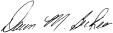

Dawn M. Becker

Executive Vice President—Chief Legal
Officer and Secretary

Federal Realty Investment Trust

909 Rose Avenue, Suite 200
North Bethesda, Maryland 20852

YOUR PROXY IS IMPORTANT REGARDLESS OF THE NUMBER OF SHARES YOU OWN. PLEASE SUBMIT IT TODAY.

Federal Realty 2026 Proxy Statement 47

Table of Contents

Appendix A—Reconciliation of Non-GAAP Financial Measures

Funds From Operations

Nareit Funds From Operations (“Nareit FFO” or “NAREIT FFO”) is a supplemental non-GAAP financial measure of real estate companies’ operating performance. The National Association of Real Estate Investment Trusts (“Nareit”) defines FFO as follows: net income, computed in accordance with U.S. GAAP, plus real estate related depreciation and amortization, and excluding gains and losses on the sale of real estate or changes in control, net of tax, and impairment write-downs of certain real estate assets and investments in entities when the impairment is directly attributable to decreases in the value of depreciable real estate held by the entity. We compute Nareit FFO in accordance with the Nareit definition, and we have historically reported our Nareit FFO available for common shareholders in addition to our net income and net cash provided by operating activities. It should be noted that Nareit FFO:

- does not represent cash flows from operating activities in accordance with GAAP (which, unlike FFO, generally reflects all cash effects of transactions and other events in the determination of net income);

- should not be considered an alternative to net income as an indication of our performance; and

- is not necessarily indicative of cash flow as a measure of liquidity or ability to fund cash needs, including the payment of dividends.

We consider Nareit FFO available for common shareholders a meaningful, additional measure of operating performance primarily because it excludes the assumption that the value of the real estate assets diminishes predictably over time, as implied by the historical cost convention of GAAP and the recording of depreciation. We use Nareit FFO primarily as one of several means of assessing our operating performance in comparison with other REITs. Comparison of our presentation of Nareit FFO to similarly titled measures for other REITs may not necessarily be meaningful due to possible differences in the application of the Nareit definition used by such REITs.

An increase or decrease in Nareit FFO available for common shareholders does not necessarily result in an increase or decrease in aggregate distributions because our Board of Trustees is not required to increase distributions on a quarterly basis. However, we must distribute at least 90% of our annual taxable income to remain qualified as a REIT. Therefore, a significant increase in Nareit FFO will generally require an increase in distributions to shareholders although not necessarily on a proportionate basis.

Core Funds From Operations (“Core FFO”) is a supplemental non-GAAP financial measure of performance that adjusts Nareit FFO to exclude the impact of certain items that management considers are not indicative of the Company’s ongoing operating and financial performance. These adjustments include, when applicable, (1) gains or losses on early extinguishment of debt, (2) new market tax credit transaction income, (3) executive transition costs, (4) collection of prior period rents which were contractually deferred or payments renegotiated related to the COVID-19 pandemic, and (5) other items as determined by management. Management believes Core FFO provides enhanced comparability across periods and additional insight into the Company’s underlying operating results, by excluding items that may reflect short-term fluctuations in net income and Nareit FFO. Core FFO is not intended to be a substitute for net income or Nareit FFO. Comparison of our presentation of Core FFO to similarly titled measures for other REITs may not be meaningful due to possible differences in the way Core FFO is defined or applied by other REITs.

Federal Realty 2026 Proxy Statement A-1

Table of Contents

The reconciliation of net income attributable to common shareholders to Nareit FFO and Core FFO is as follows:

 |  |  | Year Ended December 31,
 |  |  | 2025 |  | 2024 |  | 2023
 |  |  | (In thousands, except per share data)
Reconciliation of net income attributable to common shareholders to Nareit FFO
Net income | $ |  | 423,648 | $ | 304,334 | $ | 247,217
Net income attributable to noncontrolling interests |  |  | (12,571) |  | (9,126) |  | (10,232)
Gain on sale of real estate |  |  | (150,111) |  | (54,040) |  | (9,881)
Impairment charge |  |  | 7,425 |  | - |  | -
Depreciation and amortization of real estate assets |  |  | 320,311 |  | 302,455 |  | 285,689
Amortization of initial direct costs of leases |  |  | 42,671 |  | 33,377 |  | 31,208
Funds from operations |  |  | 631,373 |  | 577,000 |  | 544,001
Dividends on preferred shares⁽¹⁾ |  |  | (7,500) |  | (7,500) |  | (7,500)
Income attributable to downREIT operating partnership units |  |  | 2,463 |  | 2,743 |  | 2,767
Income attributable to unvested shares |  |  | (2,080) |  | (2,004) |  | (1,955)
Funds from operations available for common shareholders |  | $ | 624,256 | $ | 570,239 | $ | 537,313
Weighted average number of common shares, diluted⁽¹⁾⁽²⁾ |  |  | 86,498 |  | 84,286 |  | 82,044
Funds from operations available for common shareholders, per diluted share
 |  | $ | 7.22 | $ | 6.77 | $ | 6.55
Reconciliation of Nareit FFO to Core FFO
Nareit FFO | $ |  | 624,256 | $ | 570,239 | $ | 537,313
Adjustments:
New market tax credit transaction income, net⁽³⁾ |  |  | (13,004) |  | - |  | -
Executive transition costs |  |  | - |  | 3,687 |  | -
Collection of prior period rents deferred during COVID |  |  | (261) |  | (3,218) |  | (5,136)
Core FFO |  | $ | 610,991 | $ | 570,708 | $ | 532,177
Core FFO per diluted share⁽²⁾
Core FFO per diluted share⁽²⁾ |  | $ | 7.06 | $ | 6.77 | $ | 6.49

- For the years ended December 31, 2025, 2024 and 2023, dividends on our Series 1 preferred stock were not deducted in the calculation of FFO available to common shareholders, as the related shares were dilutive and included in “weighted average number of common shares, diluted.”
- The weighted average common shares used to compute FFO per diluted common share includes shares issuable upon the assumed redemption of outstanding downREIT operating partnership units that were excluded from the computation of diluted EPS. The assumed issuance of shares upon redemption of these operating partnership units is dilutive in the computation of FFO per diluted common share but is anti-dilutive for the computation of diluted EPS for 2024 and 2023.

- The $13.0 million net new market tax credit transaction income for the year ended December 31, 2025 is due to the sale of new market tax credits related to Freedom Plaza. (See Note 7 to the consolidated financial statements in our Form 10-K filed with the SEC on February 12, 2026 for additional information.)

Federal Realty 2026 Proxy Statement A-2

Table of Contents
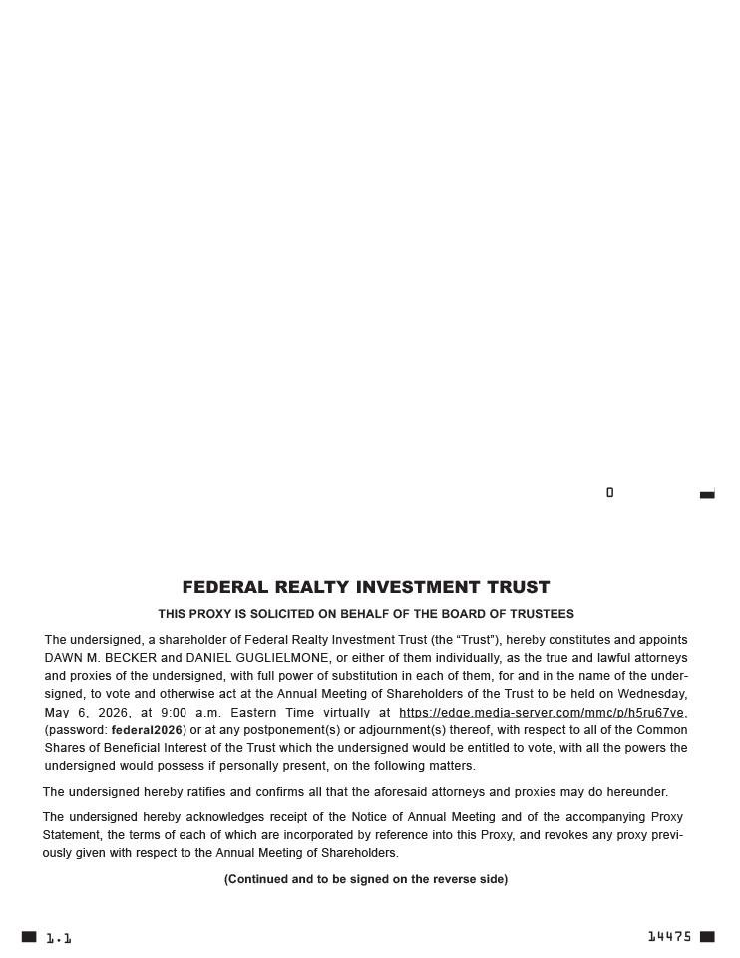

Table of Contents
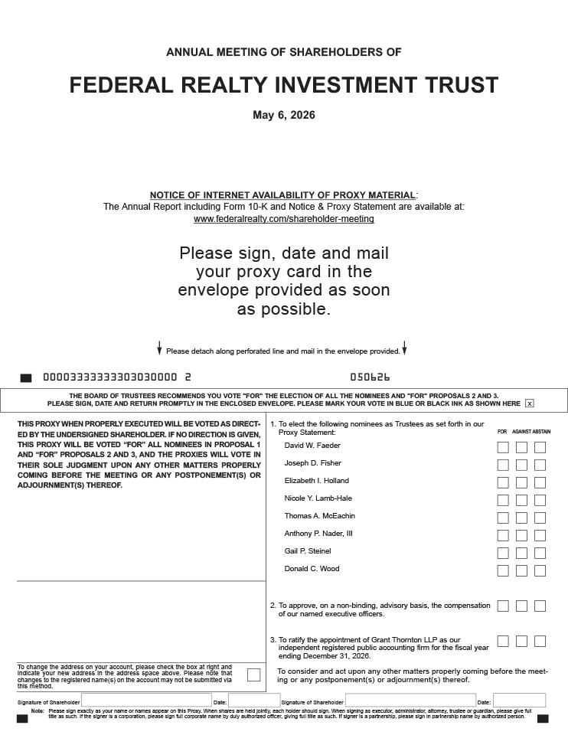

Table of Contents

Table of Contents


