UNITED STATES

SECURITIES AND EXCHANGE COMMISSION
Washington, D.C. 20549

SCHEDULE 14A INFORMATION

Proxy Statement Pursuant to Section 14(a) of the

Securities Exchange Act of 1934
(Amendment No. )

Filed by the Registrant ☒ Filed by a Party other than the Registrant ☐

Check the appropriate box:

- Preliminary Proxy Statement

- Confidential, for Use of the Commission Only (as permitted by Rule 14a-6(e)(2))

- Definitive Proxy Statement

- Definitive Additional Materials

- Soliciting Material under Rule 14a-12

FEDERAL REALTY INVESTMENT TRUST

(Name of registrant as specified in its charter)

(Name of person(s) filing proxy statement, if other than the registrant)

Payment of Filing Fee (Check the appropriate box):

- No fee required

- Fee computed on table below per Exchange Act Rules 14a-6(i)(4) and 0-11

  - Title of each class of securities to which transaction applies:

  - Aggregate number of securities to which transaction applies:

  - Per unit price or other underlying value of transaction computed pursuant to Exchange Act Rule 0-11 (set forth the amount on which the filing fee is calculated and state how it was determined):

  - Proposed maximum aggregate value of transaction:

  - Total fee paid:

- Fee paid previously with preliminary materials.

- Check box if any part of the fee is offset as provided by Exchange Act Rule 0-11(a)(2) and identify the filing for which the offsetting fee was paid previously. Identify the previous filing by registration statement number, or the Form or Schedule and the date of its filing.

  - Amount Previously Paid:

  - Form, Schedule or Registration Statement No.:

  - Filing Party:

  - Date Filed:

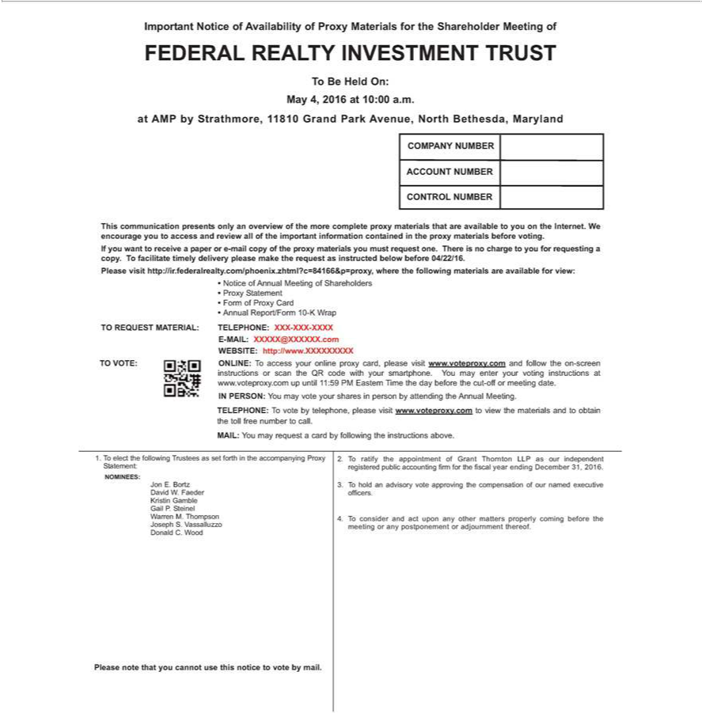

FEDERAL REALTY INVESTMENT TRUST To Be Held On: May 4, 2016 at 10:00completea..atAMP by Strathmore, 11810 Grand Park Avenue, North Bethesda, Maryland COMPANY NUMBER ACCOUNT NUMBER
informationCONTROL containedNUMBERinThisthe communicationproxymaterials presentsbeforevoting.onlyanIf overviewyouwant ofto thereceivemorea paper federalrealtyorproxy-mailcopymaterialsofthethatproxyare availablematerials toyouyoumuston therequestInternet.one. WThereencourageisnochargeyou toto accessyouforandrequestingreview allcopy.oftheTimportantfacilitate timely delivery please make the request as instructed below before 04/22/16. Please visit http://ir. .com/phoenix.zhtml?c=84166&p=proxy, where the following materials are available for view: • Notice of Annual
Meeting of Shareholders • Proxy Statement • Form of Proxy Card • Annual Report/Form 10-K Wrap TO REQUEST MATERIAL: TELEPHONE: XXX-XXX-XXXX E-MAIL: XXXXX@XXXXXX.com WEBSITE:
yourhttp://www.XXXXXXXXXvotinginstructionsatwww.voteproxy.comTO?VOTE:ONLINE:up untilToaccess11:59yourPM EasternonlineproxyTime card,thedaypleasebeforevisitthewww.voteproxy.comcut-offormeetingdate.and followINPERSON:theon-screenYoumayinstructionsvoteyourorsharesscan inthepersonQRcodeby attendingwithyour thesmartphone.AnnualMeeting.Youmay enter

NOMINEES:TELEPHONE:JonT E.voteBortzby telephone,DavidW. Faederplease Kristinvisitwww.voteproxy.comGambleGailP.SteineltoviewWarrenthematerialsM.ThompsonandtoJosephobtain S.theVassalluzzotollfreenumberDonaldto C.call.WoodMAIL:PleaseYounotemaythatrequest cannotcard byusefollowingthisnoticethetoinstructionsvotebymail.above.registeredStatement:t.public
accounting firm for the fiscal year ending December 31, 2016. 3. To hold an advisory vote approving the compensation of our named executive officers. 4.youT consider and act upon any other matters properly coming before the meeting or any postponement or adjournment thereof.

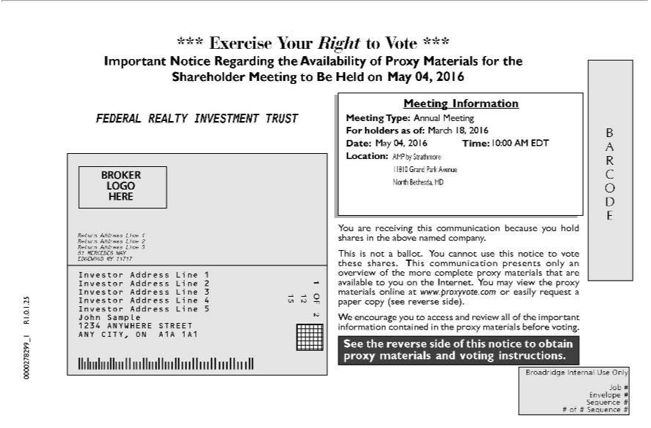

*** Exercise Your Right to Vote *** Important Notice Regarding the Availability of Proxy Materials for the Shareholder Meeting to Be Held on <mtgdate>. May 04, 2016 FEDERAL REALTY INVESTMENT TRUSTBROKERLOGOHEREReturnAddressLine1ReturnAddressLine2ReturnAddressLine351MERCEDESWAYEDGEWOODNY11717InvestorAddressLineInvestorAddressLine2InvestorAddressLine3 Investor Address Line 4 Investor Address Line 5 John Sample 1234 ANYWHERE STREET ANY CITY, ON A1A 1A1 1 OF 2 12 15 Meeting Information Meeting Type: Annual <mtgtype> Meeting For holders as of:Mch<recdate>18,2016Date:May04,2016Time:10:00<mtgtime>AMEDTLocation:AMPbyStrathmore1810GrandParkAvenueNorthBethesda,MDYouarereceivingthiscommunicationbecauseyou shares holdintheabovenamedcompany.Thisisnotaballot.Youcannotusethisnoticetovotetheseshares.Thiscommunicationonlyanoverviewofthemorecompleteproxymaterialsthatareavailabletoyouon

the Internet. You may view the proxy materials online at www.proxyvote.com or easily request a paper copy (see reverse side)presents.Wencourage you to access and review all of the important information contained in the proxy materials before voting. See the reverse side of this notice to obtain proxy materials and voting instructions. B A R C O D E Broadridge Internal Use Only Job # Envelope # Sequence # # of # Sequence # 0000278299_1 R1.0.1.25

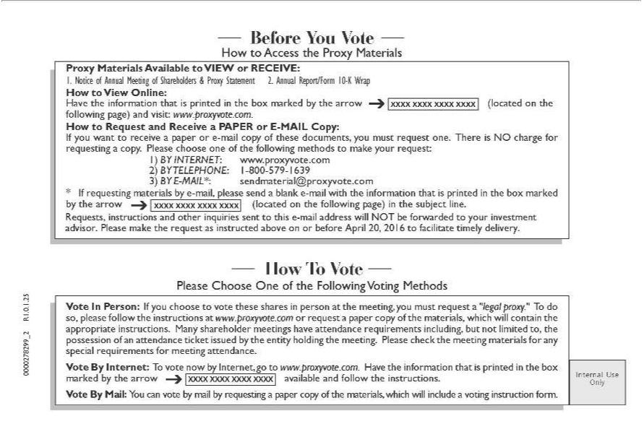

Online:BeforeYou Vote How to Access the Proxy Materials Proxy Materials Available to VIEW or RECEIVE: 1. Notice of Annual Meeting of Shareholders & Proxy Statement 2. Annual Report/Form 10-K Wrap How to View
Have the information that is printed in the box marked by the arrow ? (located on the following page) and visit: www.proxyvote.com. How to Request and Receive a PAPER E-MAIL Copy: If you want to
www.proxyvote.comreceiveapaperore-mail2)BYcopyTELEPHONE:ofthesedocuments,1-800-579you-1639must 3)requestBYEone.-MAIL*:Theresendmaterial@proxyvote.comisNOchargeforrequestinga*copy.IfrequestingPleasechoosematerialsoneaddressbyofthe-mail,followingplease methodssendforwardedblanktomake-mailyourwithrequest:theinformation1)BYINTERNET:thatisprinted in the box

asmarkedinstructedbythe arrowon? or(locatedbeforeonAprilthe 20,following2016topage)facilitateinthetimelysubjectdelivery.line.Requests,HowT instructionsVotePlease andChooseotherOneinquiriesofthe sentFollowingtothis Voting-mail MethodswillVoteNOTInPerson:be If you choosetoyour toinvestmentvotetheseadvisor.shares inPleasepersonmakeatthethemeeting,request
you must requestabove “legal proxy.” To do so, please follow the instructions at www.proxyvote.com or request a paper copy of the materials, which will contain the appropriate instructions. Many shareholder meetings have _{attendance} requirements including, but not limited to, the possession of an attendance ticket issued by the entity holding the meeting. Please check the meeting materials for any special requirements for meeting
. Vote By Internet: T^{copy}vote now by Internet, go to www.proxyvote.com. Have the information that is printed in the box marked by the arrow ? available and follow the instructions. Vote By Mail: You can vote
by mail by requesting a paper of the materials, which will include a voting instruction form. Internal Use Only 0000278299_2 R1.0.1.25

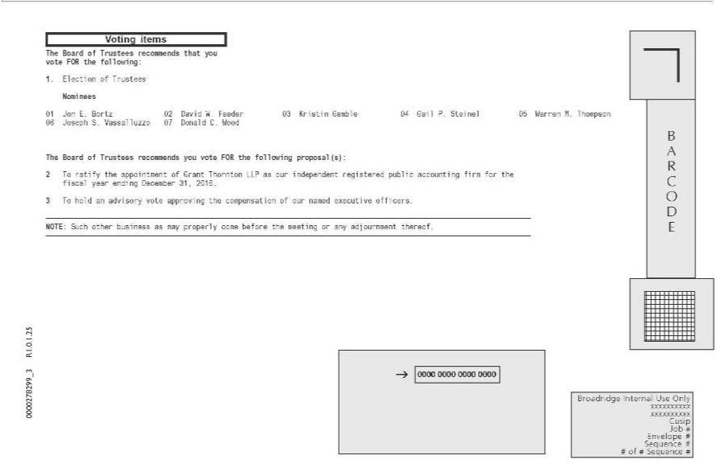

JosephVoting itemsS.VassalluzzoTheBoard07ofDonaldTrusteesC. recommendsWoodTheBoardthat youofTrusteesvoteFOR_{recommends}thefollowing:you 1.voteElectionFORtheof TrusteesfollowingNomineesproposal(s):01 Jon2_{our}TE.ratifyBortzthe02appointmentDavidW.FaederofGrant03 KristinThorntonGambleLLPas04ourGailindependentP.Steinel05registeredWarren M.publicThompson 06

accounting firm for the fiscal year ending _{December} 31, 2016. 3 T hold an advisory vote approving the compensation of named executive officers. NOTE: Such other business as may properly come before the meeting or any adjournment thereof. B A R C O E Broadridge Internal Use Only xxxxxxxxxx xxxxxxxxxx Cusip Job # Envelope # Sequence # # of # Sequence # 0000278299_3 R1.0.1.25

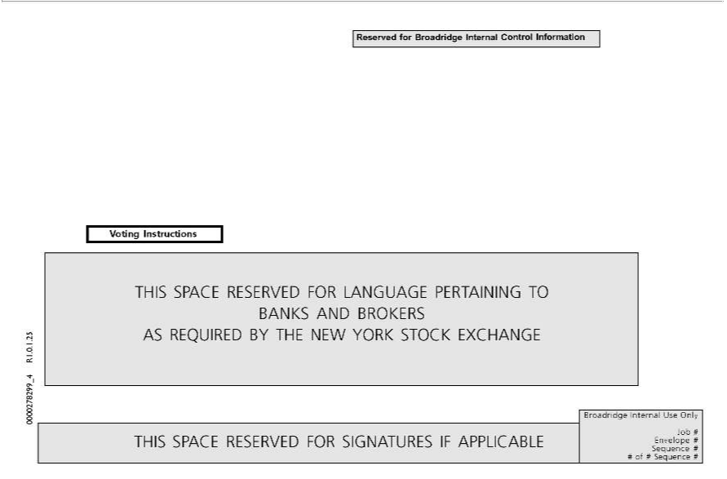

Reserved for Broadridge Internal Control Information Voting Instructions THIS SPACE RESERVED FOR LANGUAGE PERTAINING TO BANKS AND BROKERS AS REQUIRED BY THE NEW YORK STOCK EXCHANGE THIS SPACE RESERVED FOR SIGNATURES IF APPLICABLE Broadridge Internal Use Only P99999-010 12 Job # Envelope # Sequence 15 # # of # Sequence # OF## 0000278299_4 R1.0.1.25

