UNITED STATES

SECURITIES AND EXCHANGE COMMISSION
Washington, D.C. 20549

SCHEDULE 14A INFORMATION

Proxy Statement Pursuant to Section 14(a) of the

Securities Exchange Act of 1934
(Amendment No. )

Filed by the Registrant ☐ Filed by a Party other than the Registrant ☐

Check the appropriate box:

- Preliminary Proxy Statement

- Confidential, for Use of the Commission Only (as permitted by Rule 14a-6(e)(2))

- Definitive Proxy Statement

- Definitive Additional Materials

- Soliciting Material under Rule 14a-12

FEDERAL REALTY INVESTMENT TRUST

(Name of registrant as specified in its charter)

(Name of person(s) filing proxy statement, if other than the registrant)

Payment of Filing Fee (Check the appropriate box):

- No fee required

- Fee computed on table below per Exchange Act Rules 14a-6(i)(4) and 0-11

  - Title of each class of securities to which transaction applies:

  - Aggregate number of securities to which transaction applies:

  - Per unit price or other underlying value of transaction computed pursuant to Exchange Act Rule 0-11 (set forth the amount on which the filing fee is calculated and state how it was determined):

  - Proposed maximum aggregate value of transaction:

  - Total fee paid:

- Fee paid previously with preliminary materials.

- Check box if any part of the fee is offset as provided by Exchange Act Rule 0-11(a)(2) and identify the filing for which the offsetting fee was paid previously. Identify the previous filing by registration statement number, or the Form or Schedule and the date of its filing.

  - Amount Previously Paid:

  - Form, Schedule or Registration Statement No.:

  - Filing Party:

  - Date Filed:

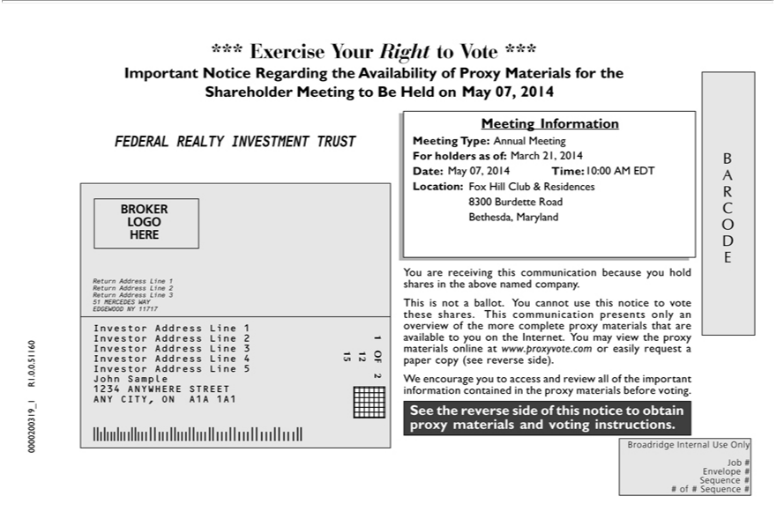

*** Exercise Your Right to Vote ***
Important Notice Regarding the Availability of Proxy Materials for the Shareholder Meeting to Be Held on May 07, 2014
FEDERAL REALTY INVESTMENT TRUST
Information
Meeting Type: Annual Meeting
For holders as of: March 21, 2014
Date: May 07, 2014 Time: 10:00 AM EDT
Location: Fox Hill Club & Residences
8300 Burdette Road
ethesda, Maryland
A C O D E
BROKER
LOGO | 1
HERE | 1
Return Address Line | 2
Return Address Line | 3
51 MERCEDES WAY
EDGEWOOD NY 1₁₇₁₇
 | 2
 | 3
 | 4
Investor Address Line 5
John Sample
1234 ANYWHERE STREET
ANY CITY, ON A1A 1A1
OF 2
2
15
You are receiving this communication because you hold shares in the above named company.
This is not ballot. You cannot use this notice to vote these |  | . This communication pres nts only an overview of the more complete proxy materials that are available to you on the Internet. You may view the
proxy materials online at www.proxyvote.com or easily requestsharespaper copy (see reverse side).
^{See}
W encouragethereverseyousidetoofaccessthisnoticeandreviewtoobtainall proxyofthe importantmaterials andinformationvotinginstructions.containedin the proxy materials before voting.
Envelope #
Sequence #
# of # Sequence #
0000200319_1 R1.0.0.51160

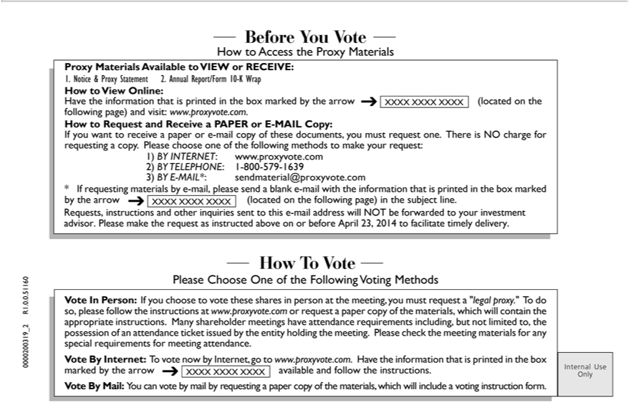

- Before You Vote -
How to Access the Proxy Materials
Proxy Materials Available to VIEW or RECEIVE:
1. Notice & Proxy Statement 2. Annual Report/Form 10-K Wrap
 | to View Online:
ave the information that is printed in the box marked by the arrow XXXX XXXX XXXX (located on the following page) and visit: www.proxyvote.com.
How to Request and Receive a PAPER or E-MAIL Copy:
If you want to receive a paper or |  |  |  | -mail copy of these documents, you must request one. There is NO charge for requesting a copy. Please choose one of the following methods to make your request:
1) | INTERNET www.proxyvote.com |  |  |  | .com
3) BY TELEPHONE:-MAIL*: |  |  | 1-800-579-1639 |  | .com
2)
* If requesting materialssendmaterial@proxyvoteby-mail,pleasesend a blank e-mail with the information that is printed in the box marked by the arrow XXXX XXXX XXXX (located on the following page) in the subject line.
Requests, instructions and other inquiries sent to this e-mail address will NOT be forwarded to your investment advisor. Please make the request as instructed above on or before April 23, 2014 to facilitate timely
delivery. |  | Vote -
- How T |  | Vote -
Please Choose One of the Following Voting Methods
Vote In Person: If you choose to vote these shares in person at the meeting, you must request a “legal proxy.” To do so, please follow the instructions at www.proxyvote.com or request a paper copy of the materials,
which will contain the appropriate instructions. Many shareholder meetings have attendance requirements including, but not limited to, the possession of an attendance ticket issued by the entity holding the meeting.
Please check the meeting materials for any special requirements for meeting attendance.
Vote By |  | Internet: To vote now by Internet, go to www.proxyvote.com. Have the information that is printed in the box marked by the arrow XXXX XXXX XXXX available and follow the instructions.
 |  | Mail: You can vote by mail by requesting a paper copy of the materials, which will include a voting instruction form.
Internal Use Only
0000200319_2 R1.0.0.51160

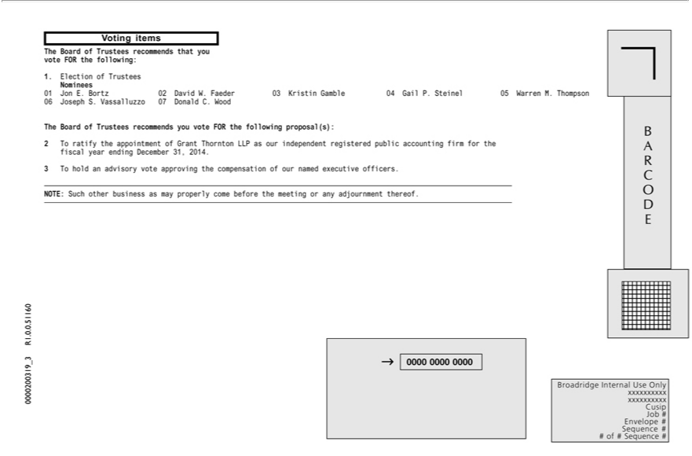

Voting items
The Board of Trustees recommends that you vote FOR the following:
Nominees11.Election of Trustees
_{06 Joseph}E. Bortz 02 David W. Faeder 03 Kristin Gamble 04 Gail P. Steinel 05 Warren M. Thompson S. Vassalluzzo 07 Donald C. Wood
The Board of Trustees recommends you vote FOR the following proposal(s):
2 _{To} ratify the_{advisory}appintment of Grant Thornton LLP as our independent registered public accounting firm for the fiscal year ending December 31, 2014.
3 hold an vote approving the compensation of our named executive officers.
NOTE: Such other business as may properly come before the meeting or any adjournment thereof.
B A R C O D E
0000 0000 0000
xxxxxxxxxxBroadridgeInternal Use Only
Cusip
Job #
Envelope #
Sequence #
# of # Sequence #
0000200319_3 R1.0.0.51160

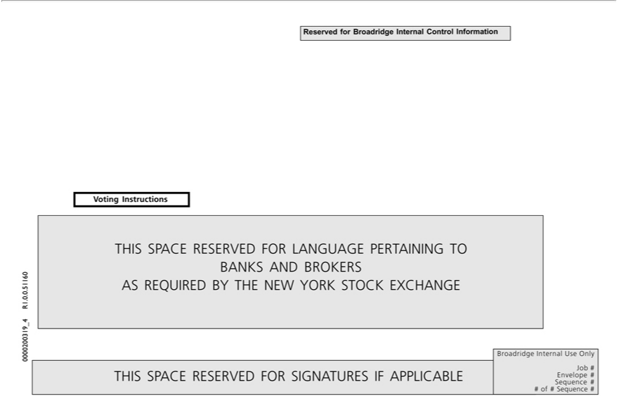

VotingReservedInstructionsforBroadridge Internal Control Information
ASTHISREQUIREDSPACERESERVEDBYTHENEWFOR YORKLANGUAGESTOCKPERTAININGEXCHANGETO BANKS AND BROKERS
BroadridgeTHISSPACEInternalRESERVEDUseOnlyFOR SIGNATURES IF APPLICABLE
Job #
Envelope #
Sequence #
# of # Sequence #
0000200319_4 R1.0.0.51160

